Disclaimer
The information in this publication is, according to the Ministry for the Environment’s best efforts, accurate at the time of publication. The Ministry will make every reasonable effort to keep it current and accurate. However, users of this publication are advised that:
- the information does not alter the laws of New Zealand, other official guidelines, or requirements
- it does not constitute legal advice, and users should take specific advice from qualified professionals before taking any action based on information in this publication
- the Ministry does not accept any responsibility or liability whatsoever whether in contract, tort, equity, or otherwise for any action taken as a result of reading, or reliance placed on this publication because of having read any part, or all, of the information in this publication or for any error, or inadequacy, deficiency, flaw in, or omission from the information in this publication
- all references to websites, organisations or people not within the Ministry are for convenience only and should not be taken as endorsement of those websites or information contained in those websites nor of organisations or people referred to.
Acknowledgements
This report was prepared by Beverley Clarkson, Karen Denyer and Scott Bartlam on behalf of the Ministry for the Environment.
The authors thank Jack Warden (Rural Design Ltd), Owen Spearpoint (Greater Wellington Regional Council), Philip Grove (Environment Canterbury) and Jeroen Lurling (Tasman District Council) who field tested the pasture exclusion guidelines. Members of the wider ecology reference group and environmental consultancies (including Bioresearches and Boffa Miskell) also made important contributions.
The field testing would not have been possible without the generous landowners who granted permission to access their land for field trials. These include the Turney and Mourits families of Ohaupo, Stokes family of Taupiri, Hannon family of Te Miro, Waikoha Station, Te Pahu, Te Rimu Trust, Te Araroa, and Awarua Farm Trust, Patetonga.
The authors thank Olivia Burge for reviewing the report and Anne Austin for editing.

This document may be cited as: Ministry for the Environment. 2022. Pasture exclusion assessment methodology. Wellington: Ministry for the Environment.
Originally published in December 2022 and Appendix 2 updated in January 2024 by the
Ministry for the Environment
Manatū Mō Te Taiao
PO Box 10362, Wellington 6143, New Zealand
ISBN: 978-1-991077-08-0
Publication number: ME 1716
© Crown copyright New Zealand 2022
This document is available on the Ministry for the Environment website: environment.govt.nz.
The following information is included for Manaaki Whenua – Landcare Research records.

Manaaki Whenua – Landcare Research contract report number: LC4229

Author(s)
Beverley Clarkson (Manaaki Whenua – Landcare Research )
Karen Denyer (National Wetland Trust )
Scott Bartlam (Manaaki Whenua – Landcare Research)

Report approved by:
Gary Houliston
Portfolio Leader – Enhancing Biodiversity
Manaaki Whenua – Landcare Research

Sent to the Ministry for the Environment:
31 October 2022

Contents
Executive summary 6
1. Introduction 7
2. Objective 8
3. Background 9
Pasture exclusion 9
Pasture species 9
Assessment steps 10
4. Rapid assessments 11
5. Field assessment overview 13
Key field steps 16
6. Detailed field assessment steps 18
6.1 Planning 18
6.2 Site determination 18
6.3 Potential wetland identification 19
6.4 Vegetation type delineation 20
6.5 Rapid tests 21
6.6 Plot sampling 22
6.7 Plot data form 27
6.8 Soil and hydrology assessments 28
6.9 Wetland delineation and mapping 31
6.10 Uncertain situations 33
Appendix 1: Pasture species 34
Appendix 2: New Zealand wetland delineation data form: Pasture test 37
Appendix 3: Field trials 38
Glossary 48
References 50

Tables
Table 1: Key field assessment steps – Quick guide 16

Figures
Figure 1: Rapid assessment to identify potential wetlands on farmland 11
Figure 2: Determining if a potential wetland on pastoral land passes the pasture exclusion test 14
Figure 3: Determining if an area is a wetland as defined by the RMA 1991 15
Figure 4: Potential wetland in pasture 19
Figure 5: Sketch map of the vegetation types present in a pastoral wetland 20
Figure 6: Transect and stratified randomly placed plots within vegetation zones across an area of potential wetland 23
Figure 7: Example of a nested plot 24
Figure 8: Adjusted shape (1 m x 4 m) herb stratum plot deployed in a narrow strip of willow-weed 25
Figure 9: Collecting a soil sample for testing using an auger 30

Executive summary
This guide presents the New Zealand national pasture exclusion assessment tool. The tool was developed to identify wetlands in areas of pasture used for grazing that do not meet the definition of ‘natural inland wetland’ under the National Policy Statement for Freshwater Management (NPS-FM) and associated regulations.
The pasture exclusion tool uses the methodology of the wetland vegetation tool (Clarkson 2014) and a nationally derived list of exotic pasture species (Cosgrove et al. 2022) to determine if areas qualify as ‘wet pasture’ and are therefore exempted from the NPS-FM and National Environmental Standards for Freshwater (NES-F) provisions.
Rapid assessments can be done on farmland to identify sites that are clearly wetlands with no or minimal pasture species, or are clearly dryland areas dominated by pasture species. Plant communities in indeterminate areas (potential wetlands) are assessed using plots representative of the vegetation type of interest. All vegetation tiers are assessed, via three strata (herb, shrub/sapling and tree) independently measured as nested plots. Small (4 m² plots) are used to assess vegetation in the herb (non-woody) stratum, medium (5 m radius) circular plots are used to sample vegetation in the shrub/sapling (dbh < 10 cm) stratum, and large (10 m radius) circular plots are used to assess the tree (dbh > 10 cm) stratum. Each species is independently assessed for its total per cent cover as a vertical projection (absolute per cent cover). At least one plot should be deployed per vegetation type.
Plots in which the sum of percent cover values of specified exotic pasture species is more than 50 per cent of the total vegetation cover (all strata summed) are deemed to meet the pasture exclusion and are not natural inland wetlands.
Where the plot fails the pasture exclusion test (ie, does not qualify for the pasture exclusion), the plot data should then be used to determine if the site has hydrophytic vegetation, using the dominance test and prevalence index of the wetland vegetation tool. Wetland soil and hydrology assessments should be applied in situations where ‘natural inland wetland’ status is uncertain using the vegetation tests.

1. Introduction
The identification and delineation of ‘natural inland wetlands’ are required to apply the provisions of the:
- National Policy Statement for Freshwater Management 2020 (NPS-FM)
- Resource Management (National Environmental Standards for Freshwater) Regulations 2020 (NES-F)
- Resource Management (Stock Exclusion) Regulations 2020.
For more information on the NPS-FM and NES-F provisions for natural inland wetlands, see the guidance information on the Ministry for the Environment website.
Under the NPS-FM (s3.21), ‘natural inland wetlands’ are sites that meet the Resource Management Act 1991 (RMA) definition of wetland but exclude the following five categories:
Natural inland wetland means a wetland (as defined in the Act) that is not:
- In the coastal marine area; or
- a deliberately constructed wetland, other than a wetland constructed to offset impacts on, or to restore, an existing or former natural inland wetland; or
- a wetland that has developed in or around a deliberately constructed water body, since the construction of the water body; or
- a geothermal wetland; or
- a wetland that:
- is within an area of pasture used for grazing and
- has vegetation cover comprising more than 50% exotic pasture species (as identified in the National List of Exotic Pasture Species using the Pasture Exclusion Assessment Methodology (see clause 1.8)); unless
- the wetland is a location of a habitat of a threatened species identified under clause 3.8 of this National Policy Statement, in which case the exclusion in (e) does not apply.
Manaaki Whenua – Landcare Research used internationally accepted methods to develop national tools to identify wetlands (as defined in the RMA), based on the presence of hydrophytic (wetland) vegetation (Clarkson 2014), hydric (poorly drained) soils (Fraser et al. 2018) and wetland hydrology (Ministry for the Environment 2021a). These protocols do not consider wetland condition, indigenous dominance or ecological significance. They are based solely on the presence of wetland indicators, including of plant species either dependent on (obligate) or tolerant of (facultative) wetland conditions. The NPS-FM requires local authorities to consider these wetland delineation protocols when uncertainty or dispute about the existence of a natural inland wetland occurs.
Having confirmed the existence of a wetland as defined in the Act, the NPS-FM exclusions must be applied to determine if the given site is a ‘natural inland wetland’.
Exclusion (e), also known as the ‘pasture’ exclusion, is currently difficult to assess in the field, due to several areas of ambiguity around assessing “…has vegetation cover comprising more than 50% exotic pasture species…” in practice. These areas of ambiguity include:
- defining a scale the 50 per cent pasture exclusion should apply to
- assessing multiple overlapping tiers of vegetation cover
- species included within the definition of ‘exotic pasture species’.
A simple methodology for best practice assessment of pasture sites in the field is required to assess if an area is excluded from the ‘natural inland wetland’ definition in the NPS-FM.
This pasture exclusion tool addresses these areas of ambiguity, includes the National list of exotic pasture species and outlines the key steps to assessing and delineating areas of wet grazing land excluded from the definition of ‘natural inland wetland’ under the NPS-FM (see clause 3.21).

2. Objective
Develop a standard methodology suitable to assess the pasture exclusion in practice.

3. Background

Pasture exclusion
The purpose of the NPS-FM pasture exclusion clause is to support the continuing use of pasture for grazing purposes.
The exclusion is not targeted at pasture being converted for urban development or for other land uses. It does not apply to wetlands in other areas of grassland that are not grazed, (such as in parklands, golf courses, landscaped areas and areas of farmland not used for grazing purposes).
The key distinction between wet pasture and natural inland wetland is the proportionate cover of pasture versus non-pasture plant species present. For this reason, practitioners applying the pasture exclusion protocol must be able to correctly identify native and exotic plant species occurring in pasture and wetland sites.
The term ‘pasture’ is not defined in the NPS-FM. The dictionary definition of ‘pasture’ is used.
The pasture exclusion does not apply to a wetland providing habitat for any threatened species. Threatened species (defined in the NPS-FM) means:
“any indigenous species of flora or fauna that:
- relies on water bodies for at least part of its life cycle; and
- meets the criteria for nationally critical, nationally endangered, or nationally vulnerable species in the New Zealand Threat Classification System Manual (see clause 1.8).”
This means that even if an area has vegetation that would otherwise satisfy the pasture exclusion but also meets the threatened species criteria above, the pasture exclusion does not apply.

Pasture species
Cosgrove et al. (2022) developed a list of pasture species to which these protocols apply and is presented in appendix 1.
Exotic pasture species are plant species that:
- are currently or were historically sown to form pasture areas, and
- are any other exotic species with wetland indicator status ratings of FAC (facultative), FACU (facultative upland) or UPL (upland) known to be common in pasture areas AND are palatable to livestock/contributing to pasture used for grazing, including when not deliberately sown.
Exotic pasture species do not include:
- any exotic species with ratings of OBL (obligate wetland) or FACW (facultative wetland), including Mercer grass (Paspalum distichum), creeping bent (Agrostis stolonifera), Juncus effusus (and its varieties) and all Glyceria species.
- any exotic species, regardless of their indicator rating, common in pasture or wetland areas but non-productive (unpalatable or toxic to livestock) and therefore not encouraged in well-managed pasture (for example, creeping buttercup (Ranunculus repens))
- any exotic species uncommon in pasture
- native species, including native grasses (eg, swamp millet Isachne globosa), native rushes (eg, Juncus edgariae J. sarophorus, and J. usitatus) and native sedges (eg, Carex geminata, C. virgata, and Isolepis prolifera), even though some are common in pasture areas.
Cosgrove et al. (2022) include two categories of pasture plant species: commercial and non-commercial.
- Commercial pasture species are non-native herbaceous species which are or have historically been commonly established for the purpose of livestock production and which have been the subject of cultivar development ... While many of these commercial species are unsuitable for wet soil habitats and thus unlikely to be found in wetlands (ie, UPL or FACU habitat ratings), they are included on the basis that they may form a component of mixed species pastures established on sites where soil moisture status varies spatially and temporally. Cosgrove et al. (2022) list 53 commercial pasture species. Those more likely to occur in wetlands include Yorkshire fog (Holcus lanatus), tall fescue (Lolium arundinaceum), lotus (Lotus pedunculatus) and phalaris (Phalaris aquatica).
- Non-Commercial pasture species are non-native herbaceous species commonly found in pastures and considered palatable to livestock but without known cultivars. These were typically established historically as sown mixtures (eg, “bush burn”) and have subsequently spread as adventives. In recent times they have not deliberately been sown but are certainly managed as productive pastures via grazing and the application of fertiliser and lime. Hence, they make a substantive contribution to livestock productivity in some environments. Cosgrove et al. (2022) list 24 non-commercial species. Those more likely to be encountered in or near the transition to wetlands include sweet vernal (Anthoxanthum odoratum) and kikuyu (Cenchrus clandestinus).

Assessment steps
The pasture exclusion protocol comprises three key steps:
1. rapid tests
2. field assessments
3. wetland delineation.

4. Rapid assessments
Wetlands in pastoral settings exist along a hydrological continuum (figure 1). At one end are sites dominated by wetland species (OBL, FACW) and/or that show clear signs of a high water table or regular inundation. At the other end are areas that are clearly dryland, where obligate or facultative wetland species are usually not present at all. In between are areas difficult to quickly identify as either natural inland wetlands or dryland pasture. These uncertain areas of damp pasture (potential natural inland wetlands) should be tested in the field using vegetation plots to determine if the pasture exclusion applies.
Figure 1: Rapid assessment to identify potential wetlands on farmland
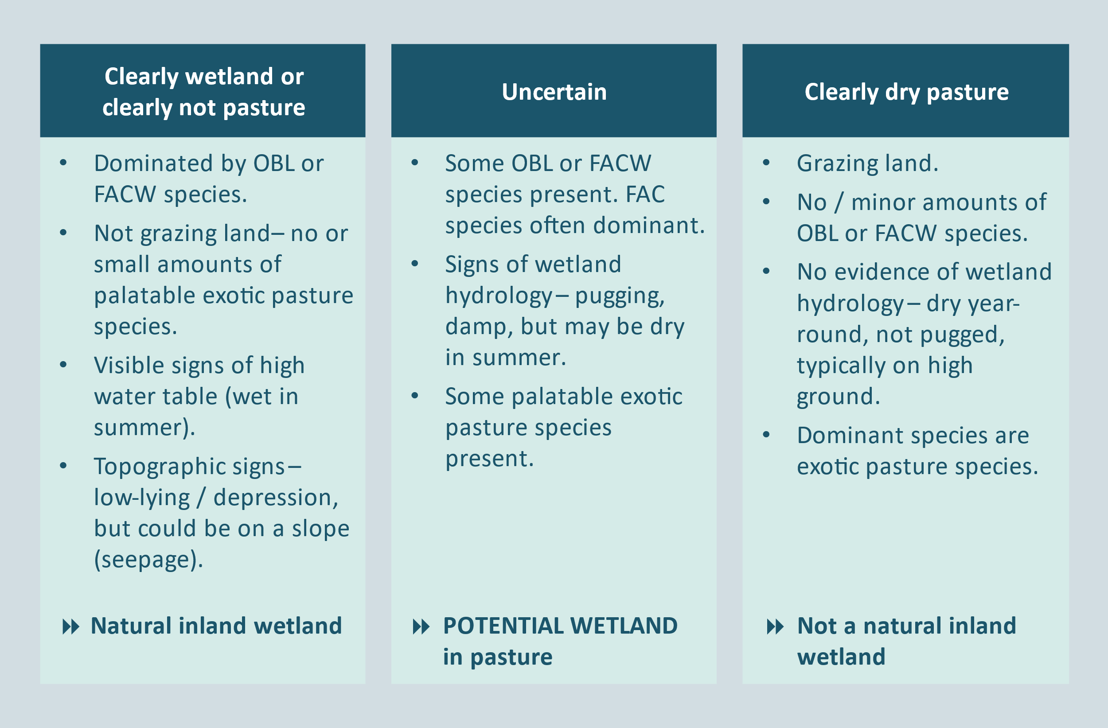
Rapid tests (quick visual assessments) can be done to quickly identify areas that are very clearly natural inland wetlands, or are very clearly drylands. Some may be able to be clearly determined as natural inland wetlands or as drylands offsite using existing recent information, and therefore do not require field assessment. They may be identified using the following.
- Aerial photos – green areas in summer may indicate potential wetland; also note texture, colour, position in the landscape, presence of drains and natural waterways.
- Google Earth time series – seasonal changes of deciduous species (such as willow or raupō).
- Retrolens – historic presence of wetlands (these can be difficult to see in old photos with low resolution) (https://retrolens.co.nz/).
- Topographic maps, FENZ, LCDB and other reputable wetland maps – to show current and previous wetlands.
- LIDAR and topographic contours.
- S-map – soil maps available for much of New Zealand – to indicate hydric soils, eg, gley and organic soils (https://smap.landcareresearch.co.nz/).
- Other information, such as recent reputable reports.
Rapid assessments should be documented, including a map of the area assessed, the date of assessment (including the date of any remotely sensed data or existing reports used for the assessment), the data source relied on for the assessment and justification for the determination.
However, in most cases, an onsite field assessment will be required.
In the field, rapid tests are done in relatively simple plant communities, in which a qualitative visual assessment of dominant species (see Glossary) is often adequate and may be more efficient than intensive transect/plot sampling. This option is most often applicable to plant communities consisting of nearly uniform or monotypic stands with low species diversity, low spatial heterogeneity, and abrupt boundaries between different vegetation communities or zones. In these situations, dominant species can be selected visually without invoking the 50/20 rule (see vegetation tool – Clarkson 2014) except as a general guide. For example, in a pasture dryland zone dominated by rye grass, which borders on a potential wetland plant community type, non-area plots representative of the pasture community may be used. List the dominant species and their approximate per cent covers on the field data forms (appendix 2) to provide evidence of application of the Rapid Test.
A site meets the Rapid Wetland Test if all dominant species across all strata are rated OBL and/or FACW.
A site meets the Rapid Pasture Test if all dominant species across all strata are pasture species as defined in appendix 1.

5. Field assessment overview
A new version of the assessment form has been developed to assess potential wetlands in pasture areas. This combines the pasture exclusion test with assessments of wetland vegetation and, where needed, soils and wetland hydrology. The pasture exclusion data form is in appendix 2 of this methodology document and on the Ministry for the Environment website. Worked examples from field testing the tool are in appendix 3.
Figure 2 shows the key steps to assess if a potential wetland area on pastoral land meets the pasture exclusion test.
Figure 3 shows the key steps in the wetland delineation protocols to determine if a potential wetland not meeting the pasture exclusion is a wetland under the RMA.
If any part of an area of pasture fails the pasture exclusion test (but meets the natural inland wetland definition), the NES provisions will apply. It may then be necessary to delimit the boundaries of natural inland wetland areas. In some cases, there may be a mosaic of patches of natural inland wetland in a pastoral matrix, particularly where small variations in topography result in wet depressions and dry humps. While the NPS does not set minimum size limits to which the NES provisions apply to wetlands, patches smaller than 4 m² cannot be assessed using the plot-based pasture-exclusion protocol. For further information on assessing mosaic scenarios, see section 6.9 on wetland/non-wetland mosaics.

Figure 1: Determining if a potential wetland on pastoral land passes the pasture exclusion test
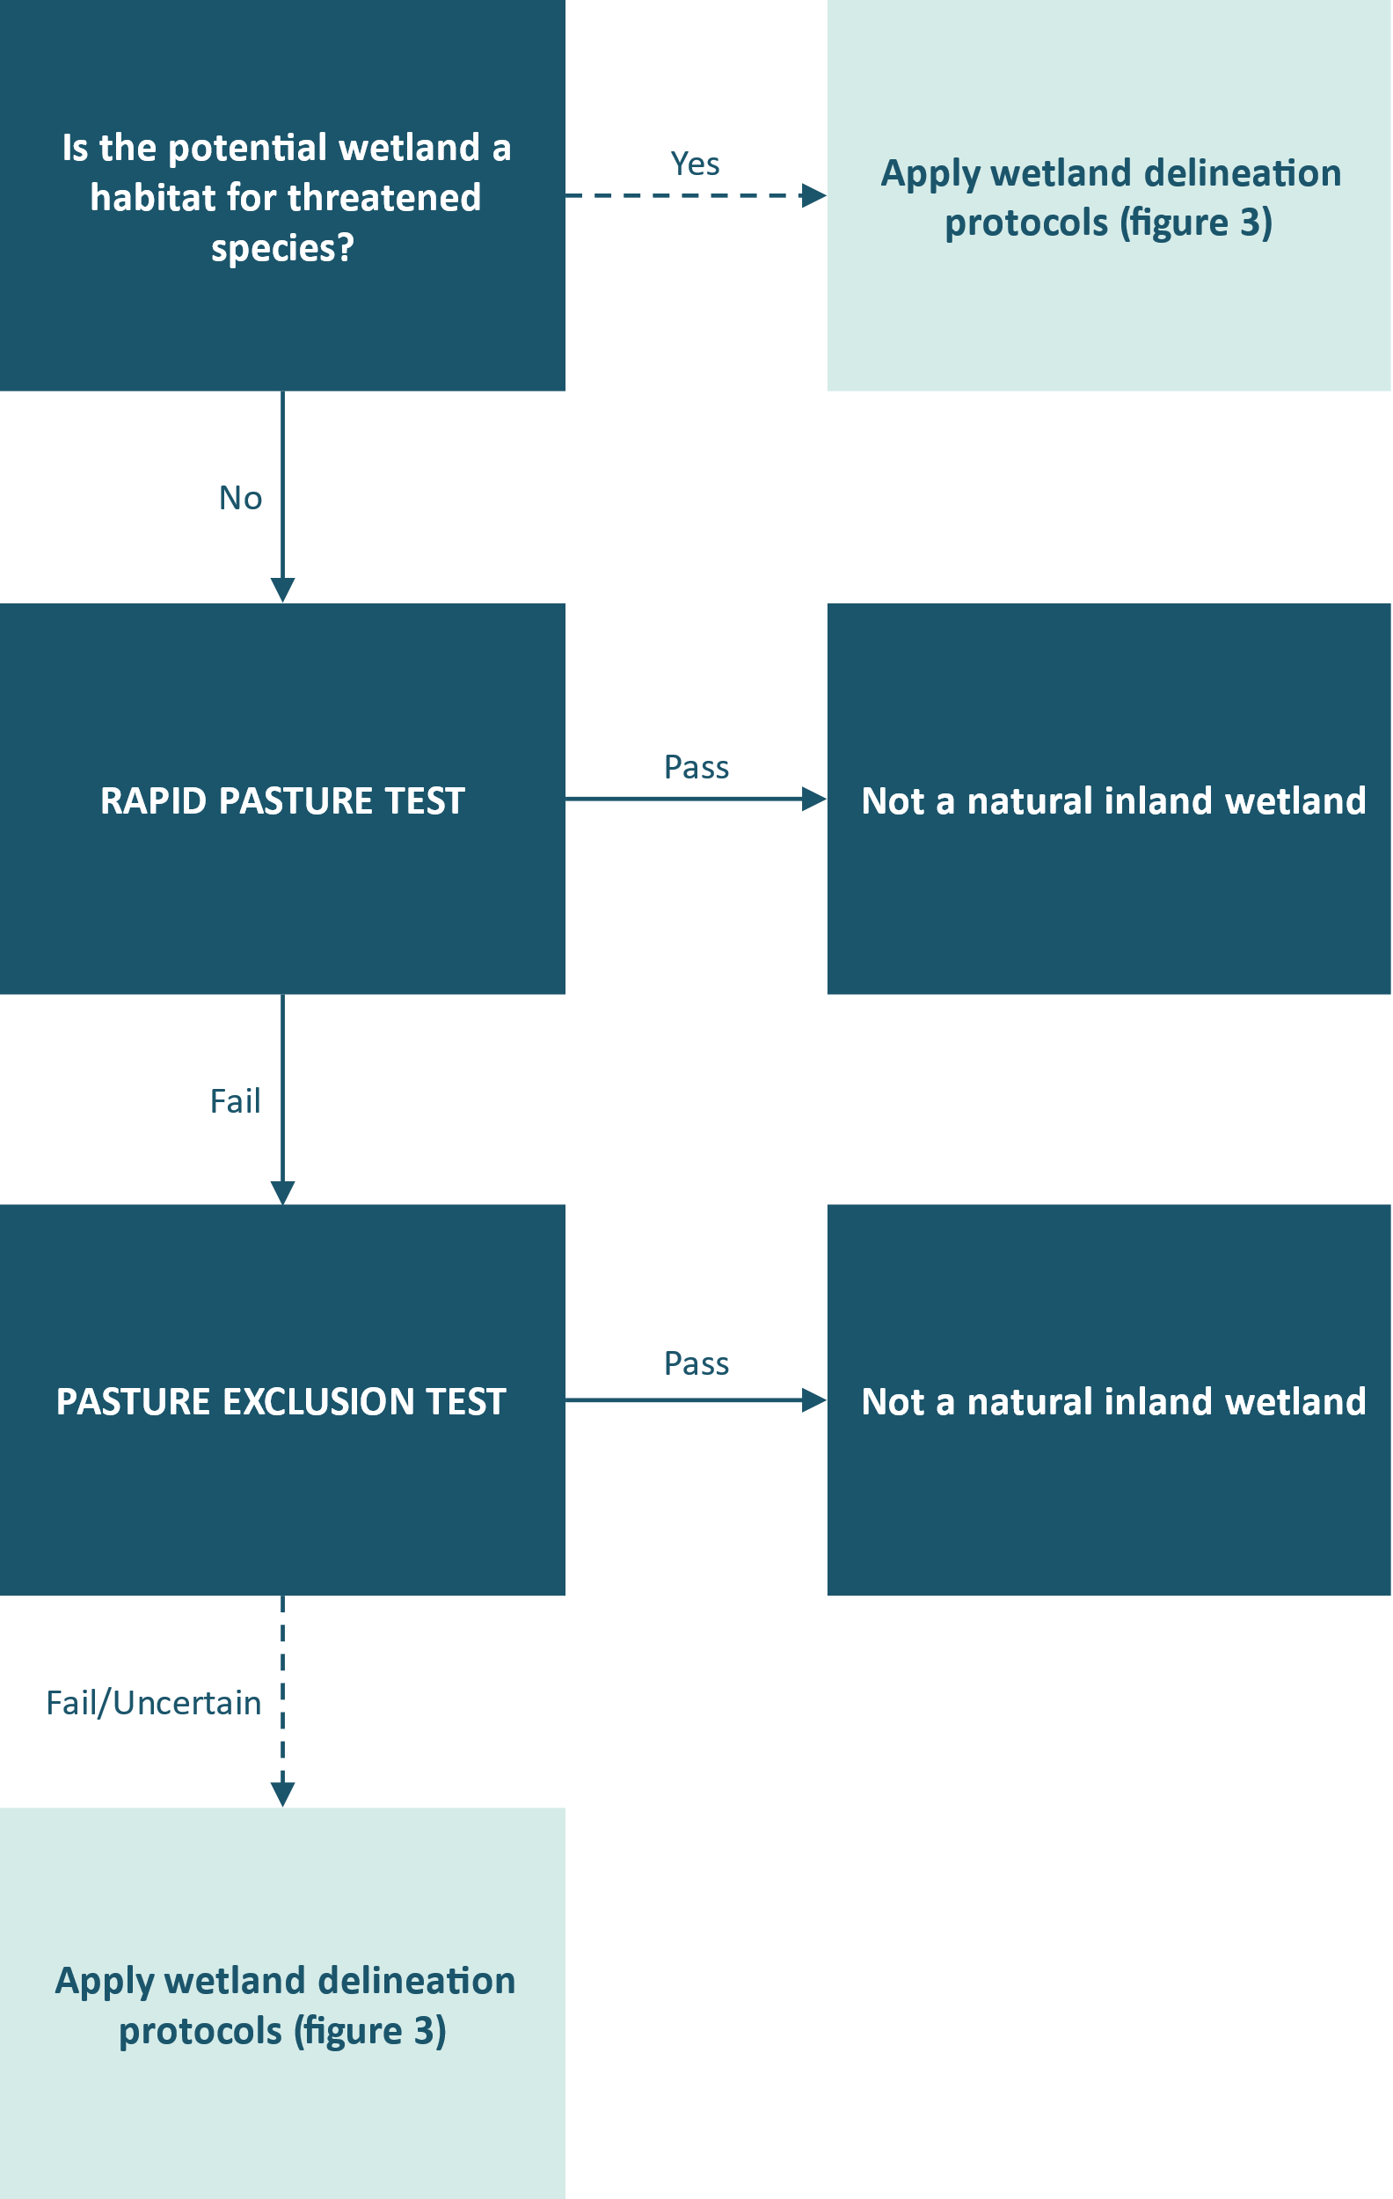

Figure 3: Determining if an area is a wetland as defined by the RMA 1991
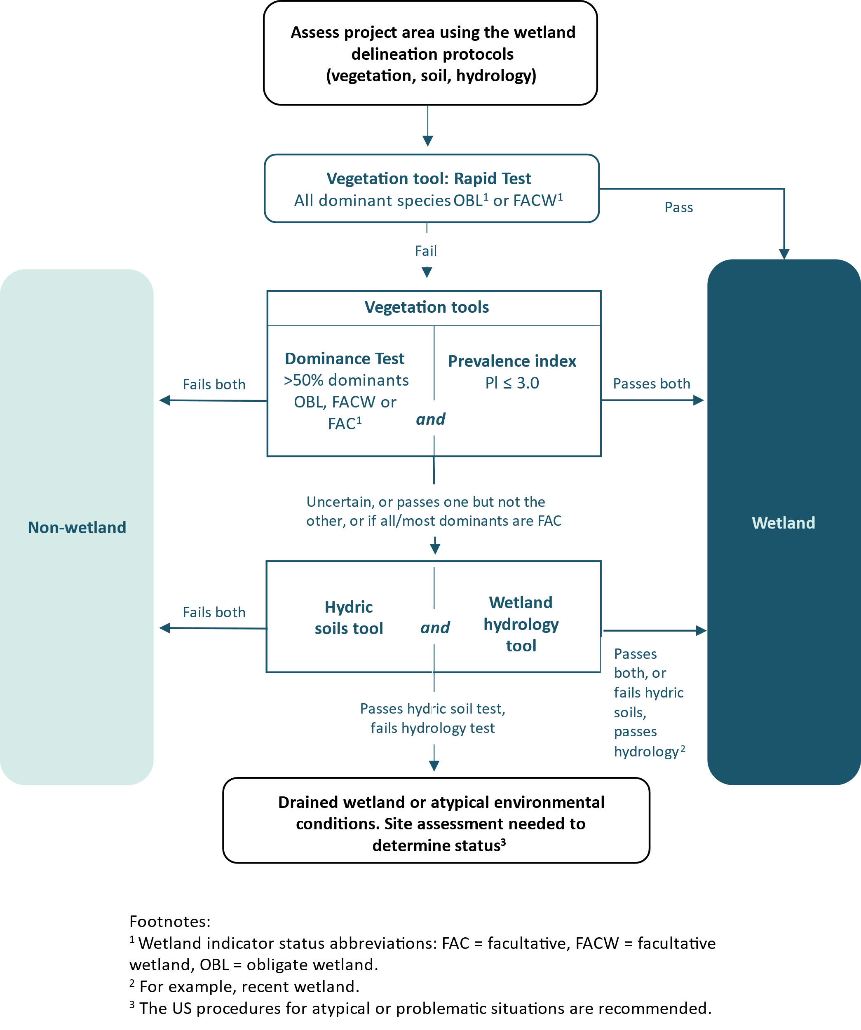

Key field steps
Table 1 presents a quick guide to the field application of the pasture exclusion protocol. Read the full details in the following sections and use table 1 as a checklist in the field.
These two pages can be printed and laminated for a field reference card.
Table 1: Key field assessment steps – Quick guide
Activity | Details
1. Plan field assessment | - Field assessments should be done:  a) during the growing season (see Wetland Hydrology Tool, Ministry for the Environment 2021a) for the relevant region, and  b) under ‘normal’ circumstances (see section 6.1 Planning and Glossary sections for details).
2. Determine area of interest / site | - Can be at the paddock, landform, ecological unit (vegetation type and landform), sub-catchment or other appropriate scale. Larger areas usually require more sampling (see vegetation tool – Clarkson 2014).  - Complete section A “Site Information” of the New Zealand wetland delineation data form: Pasture Test for the assessment (see appendix 2).
3. Identify potential natural inland wetlands | - Use aerial photos, maps, other information and/or high points to locate areas of potential wetland in pasture settings (grazed areas) using visual clues (topography, vegetation, stock access, etc).  - Note vegetation patterns and distribution and try to visually determine where the hydrology changes from dry to wet.  - Exclude potential wetlands clearly subject to any non-pasture related exclusions (refer to ‘natural inland wetland’ definition in the NPS-FM).
4. Broadly map vegetation types in potential wetland area | - Draw a sketch map of the potential natural inland wetland extent and its vegetation types, eg, on suitable aerial photograph and/or summarise on page 2 of the data form. Attach any additional information to data form.  - Use clues such as changes in topography, vegetation composition and structure, and soil and hydrologic conditions.  - In mosaics, ignore areas less than 4 m² (the minimum plot dimension).
5. Apply rapid assessment tests to areas that are clearly pasture or clearly wetland | - Rapid Pasture Test  - Areas with all dominant species being pasture species of Cosgrove et al. (2022) pass the Rapid Pasture Test and need no further assessment.  - Rapid Wetland Test (visit the wettest areas first)  - Areas with all dominant species being OBL or FACW are natural inland wetlands and need no further assessment (apart from refining the wetland boundaries if needed).  - Record results on data form to provide evidence of calculation of rapid tests.  - Any remaining areas/vegetation types with some pasture species and some wet-tolerant species need to be assessed by deploying vegetation plots.
Deploy vegetation plots to assess sites that fail the Rapid Pasture Test
6. Sample vegetation plots | A: Lay transects  - Run a metric tape across areas of wetland that might meet the pasture exclusion. In most cases this will be across the vegetation type zones perpendicular to the topographic (and hydrologic) gradient.  - In larger and more complex project areas, multiple transects may be needed (see vegetation tool – Clarkson 2014).  B: Determine plot number and location.  - Deploy at least one plot per distinctive vegetation type. To avoid bias in selecting plot locations, it is essential plots are randomly placed in each vegetation type.  - Select a random distance along the transect within each vegetation type. The plot must not extend into another vegetation type. If it does, generate another random number.  - Use a coin flip or odd/even random number to randomly choose whether the plot should lie along the left or right-hand side of the transect tape.  C: Determine plot size.  - Select the appropriate plot size and shape for the vegetation type the plot falls within. Standard plot sizes are 2 m x 2 m (herb stratum); 5 m radius (shrub stratum); 10 m radius (tree stratum).  - If an area of vegetation is too narrow to fit a standard plot size, eg, linear zones along waterways, adjust the shape but not the area of the plot if possible: 4 m² for herb strata; 78 m² for shrub strata; 314 m² for tree strata.  D: Assess plot.  - For species names and wetland indicator status, use the latest national wetland plant list (eg, 2021 list at https://doi.org/10.7931/g0bz-2618).  - Estimate % cover of live foliage cover value (min 0.5% max 100%) for every vascular and sphagnum moss species rooted in or overhanging the plot (but growing in same vegetation type). Exclude epiphytes.  - Repeat for each stratum in the plot.
7. Complete data form | - Complete section B (see appendix 2).  - Sum all cover values per plot to calculate the total vegetation cover (TVC).  - Use the pasture status column to determine if exotic pasture species comprise > 50% of the TVC. If the plot passes the pasture exclusion test, then the plot (and the homogenous vegetation type it represents) is not a natural inland wetland and no further wetland assessment is needed.  - If the plot fails the pasture exclusion test, perform the dominance and prevalence tests to determine if the site is wetland, and hence ‘natural inland wetland’.  - Complete Section C if soil and hydrology tests are needed (see step 8).  - Complete ‘Summary of Findings’ in section A.
Confirming ‘natural inland wetland’ status – further testing if required (see figure 3)
8. Apply soil and hydrology tests | - If the plot has failed the pasture exclusion test, and either:  - the dominance and prevalence tests are inconclusive, eg, if they don’t agree, or if the prevalence test is slightly under/over the 3.0 threshold, and/or other wetland indicators are present or absent, or  - all or most dominant species are FAC, or  - any further uncertainty remains about if the site is a ‘natural inland wetland’,  do soil and hydrology tests. See figure 3 for detail on this step.
9. Map natural inland wetland boundaries | - Use a GPS and the vegetation boundaries to map the extent of areas that are natural inland wetlands and do not meet the pasture exclusion test. These areas may be subject to the regulations and policies in the NPS-FM, NES-F and Stock Exclusion Regulations.
10. If unusual circumstances apply | - See Uncertain Situations section 6 (10).

6. Detailed field assessment steps

6.1 Planning
The pasture exclusion assessment should be done during the growing season, as defined in the wetland hydrology tool (Ministry for the Environment 2021a), and consistent with wetland delineation protocols. Growing seasons will vary throughout the country, typically becoming shorter with increasing latitude and altitude. Approximate duration and dates of the growing seasons for regions in New Zealand are provided in map and table form in the wetland hydrology tool report (pp. 12–14, Ministry for the Environment 2021a).
Assessments should also be applied under ‘normal’ circumstances, for instance not during atypical situations (such as extreme drought or flood events) or immediately following recent disturbance (such as fire, clearance, intensive grazing, or infilling). See “Uncertain situations” (section 6.10) for guidance on how to deal with sites falling outside the normal circumstances requirement.
Grasses and grass-like species (such as sedges and rushes) and some herbs are often difficult to identify. Flowers and/or seeds, present in at least part of the growing season greatly help in recognising species. Similarly, assessments immediately after heavy grazing of vegetation should be avoided where possible. Allow the vegetation to recover sufficiently before sampling so distinguishing characteristics such as ligules, auricles, hairs, leaf shape, colour and reproductive structures are visible.
Take the following field equipment:
- Aerial photograph of the property.
- Field data forms (see appendix 2).
- Several 30 m and/or 50 m retractable transect tapes.
- Four 2 m long plot boundary poles and 10 m or 20 m measuring tape for delineating plot boundaries. Or use a 2 m x 2 m fibreglass or similar folding quadrat.
- Soil auger.
- GPS.
- Stationery.
- Standard PPE/field wear/provisions.

6.2 Site determination
Delimit the area of interest (site). Each site assessed for the pasture exclusion test requires you to complete at least one data form. At the broadest scale, the site is a property. On larger farms, there may be multiple sites at finer scales, such as sub catchment, paddock, or ecological unit (vegetation type plus landform). Larger areas with many wet areas are likely to require sampling of multiple sites (see vegetation tool – Clarkson 2014 and Environment Laboratory 1987).
Complete section A (Site Information) of the New Zealand wetland delineation data form that incorporates the Pasture Exclusion Test for the assessment (appendix 2).

6.3 Potential wetland identification
View the site from above using an overlook and/or recent aerial photos to look for areas of potential natural inland wetland in grazing land (see example in figure 4).
Get a sense of the lay of the land – water movement, slope, topography, texture, vegetation. Wetlands frequently occur in depressions and gullies. They can also occur as seepages on slopes. Wet areas will often appear greener in summer and have a different texture to surrounding dryland pasture.
Look for:
- areas of wet-tolerant plants and vegetation such as rushes
- water pepper (Persicaria species)
- areas of visible surface water among emergent vegetation
- areas remaining wet in summer, or that are heavily pugged
- indications of grazing land, eg, lack of fencing, presence of water troughs, stock, dung, etc.
Ignore any areas clearly meeting natural inland wetland exclusions other than the pasture exclusion (refer to the NPS-FM definition).
Figure 4: Potential wetland in pasture
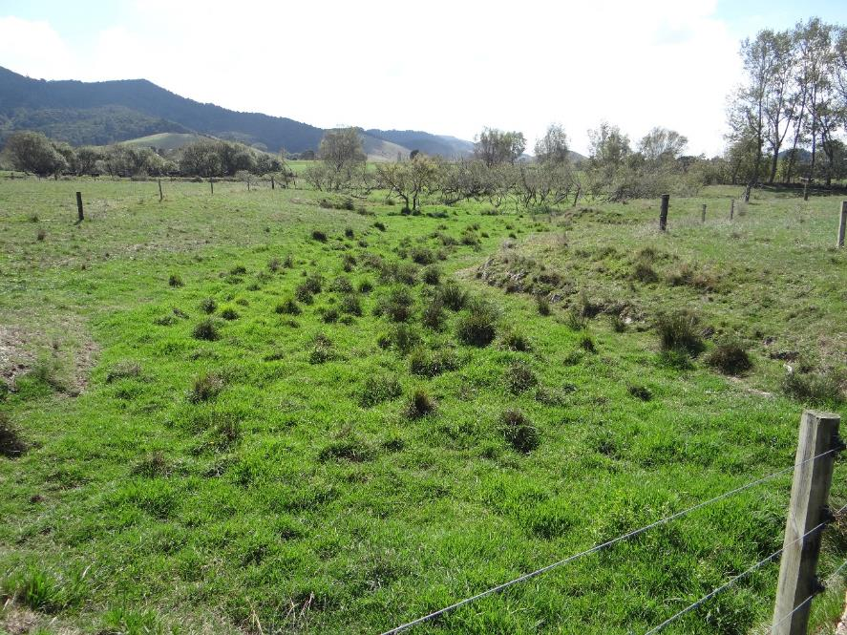 Visual clues include change in topography, change in vegetation colour, presence of indicator species (willow and rushes), grazed vegetation (cropped short).

6.4 Vegetation type delineation
The first step is to distinguish distinctive vegetation types. Deploy plots entirely within a vegetation type, and don’t span or include overhanging foliage from different vegetation types. A vegetation type will have similar structure and species distribution across its range. It will likely also be demarcated by changes in topography.
Make a sketch or map of the types of vegetation in areas likely to meet the RMA wetland definition (see figure 5). Take care to distinguish grass species with different wetland or pasture status values, as these may look superficially similar but may significantly affect the pasture exclusion outcomes. As the minimum plot size is 4 m², discount wet patches smaller than that dimension within a dryland matrix.
Figure 5: Sketch map of the vegetation types present in a pastoral wetland
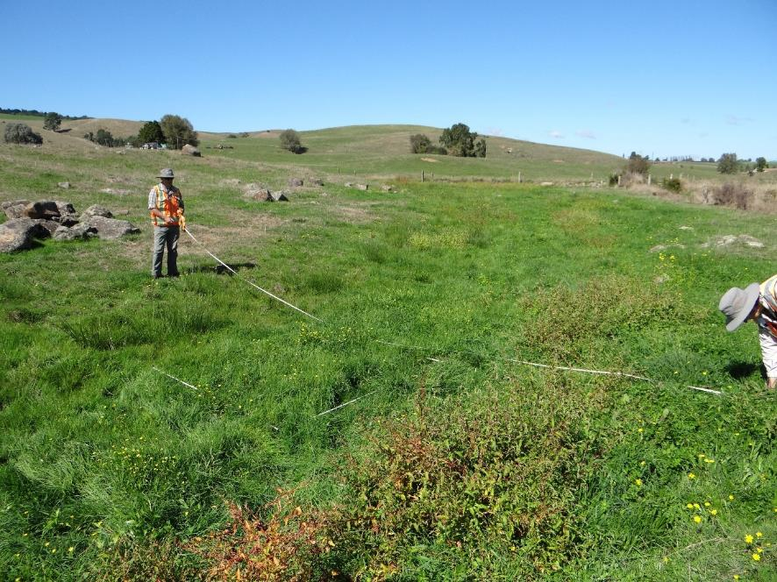 A transect has been placed across the hydrological gradient to intercept each vegetation type. A plot has been placed in the Glyceria grassland and will also be placed in the other vegetation zones.
Persicaria herbfield
Glyceria grassland
Juncus rushland

6.5 Rapid tests
Areas of relatively homogenous and clearly demarcated vegetation (with strong visual indicators of hydrology and few dominant species) may be able to be assessed using a rapid test (see figure 1).
These are quick, non-area plots representative of the vegetation community. List the dominant species (see Glossary) and their approximate per cent cover on the wetland delineation data form: Pasture test. Mark the location of the assessment to provide evidence the rapid test applies.
- Rapid Pasture Test
- Areas with all dominant species being exotic pasture species (as listed in appendix 1) pass the Rapid Pasture Test and need no further assessment.
- Rapid Wetland Test
- Areas with all dominant species being OBL or FACW are natural inland wetlands and need no further assessment (apart from refining the wetland boundaries if needed).
- Look for the wettest site in areas of pasture. If the wettest areas fail the Rapid Wetland Test, the rest of the site will likely also fail.
- If a site passes the Rapid Wetland Test, walk around the site with a GPS-enabled device to map the wet areas and boundaries of each vegetation type.
Deploy vegetation plots for vegetation types that:
- do not pass the Rapid Wetland Test but shows signs of being a wetland, or
- have some pasture species and some wet-tolerant species but cannot be assessed via a rapid test (eg, there are no clearly dominant species).
Document your rapid test by collecting geo-referenced photographs and recording the length of time spent making the assessment and a map of the area to which the rapid assessment applies.
As a minimum, for each rapid assessment record:
- site name
- date of assessment
- assessor’s name
- time spent on assessment
- extent and map of area assessed
- co-ordinates
- key species present and rough percentage cover
- justification for the rapid assessment determination
- photographic evidence.

6.6 Plot sampling
Run a metric tape across the wetland in the most efficient manner to encapsulate areas of potential wetland that might meet the pasture exclusion. This is typically across vegetation type zones perpendicular to the topographic (and hydrologic) gradient. In larger and more complex project areas, multiple transects may be needed. The suggested minimum number of transects ranges from three for wetlands up to 1.5 km in length, to at least eight in wetlands longer than 6.5 km long (Wetland Training Institute 2012).

Plot placement
Deploy at least one plot per vegetation type along each transect.
Apply a stratified random placement along the transect within each vegetation type, randomising the distance along the tape and the left:right of line plot placement (eg, see figure 6).
- Estimate the width of each vegetation type the transect bisects.
- Use a random number generator (available online) to select a random number in the width of each vegetation type.
- Place the first corner of your plot on the random number along the transect tape. The plot must not extend into another vegetation type; if it does, generate another random number.
- Use a coin flip or odd/even random number to randomly choose if the plot should lie along the left or right-hand side of the transect tape.
Figure 6: Transect and stratified randomly placed plots within vegetation zones across an area of potential wetland
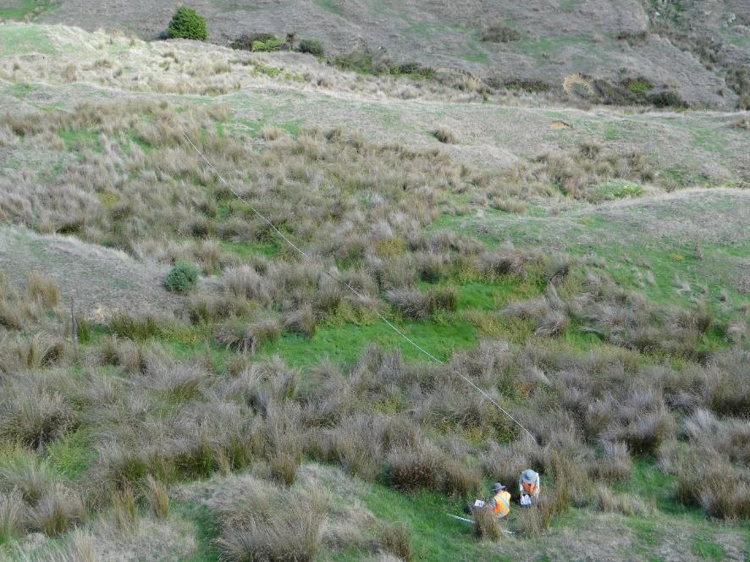

Too small for plot so excluded

Metric tape

Plot dimensions
As in the vegetation tool, there are three vegetation tiers or strata: Tree, sapling/shrub and herb. In practice, woody plants are sparse in grazing land, so most of the pasture exclusion assessments will use the herb stratum only. If shrubs or saplings occur in a 5 m radius of the central point of the randomly placed herb stratum quadrat, then they (not the herbs) need to be assessed in this 5 m radius plot. The same approach applies for trees in 10 m radius of the central point.
The plot dimensions are:
- 2 m x 2 m quadrats (4 m²) for non-woody vegetation – herb stratum
- 5 m radius circle (approx. 78 m²) for woody plants with dbh < 10 cm – sapling/shrub stratum
- 10 m radius circle (approx. 314 m²) for woody plants with dbh > 10 cm – tree stratum.
The tree and shrub strata plots are anchored at the centre of the 2 m × 2 m quadrat using a tape measure. The other end (5 m radius for saplings/shrubs, 10 m for trees) circumscribes the plot. Each stratum is therefore nested in the same plot, radiating out from the centre of the herb quadrat (figure 7).
Every sample plot must be located in the same plant community. If your site cannot fit the above dimensions without transgressing into a different vegetation type, re-arrange the plot shape but retain the area. For instance, you can change a 2 m x 2 m herb stratum plot to a 1 m x 4 m plot in narrow strips of herbaceous vegetation (see example figure 8). If a vegetation type contains trees but is too small to fit a 314 m² plot, deploy the largest plot you can without encroaching on a different vegetation type.
Figure 7: Example of a nested plot
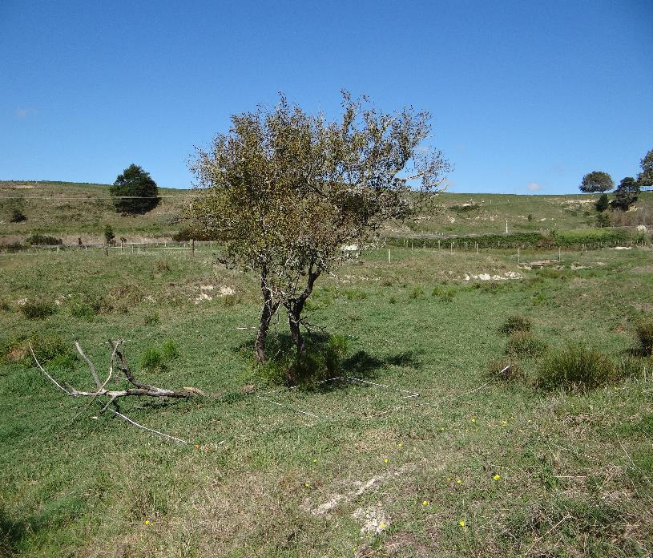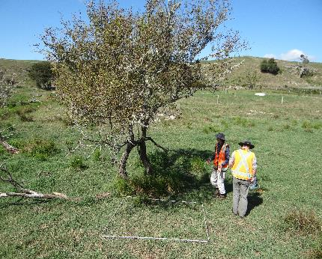 The randomly placed 2 m x 2 m herb stratum included a willow shrub, necessitating deployment of a shrub plot. The site was too small for a 5 m radius shrub plot so a 78 m² equivalent (13 m x 6 m) quadrat was deployed around the herb stratum to record shrub cover.
Figure 8: Adjusted shape (1 m x 4 m) herb stratum plot deployed in a narrow strip of willow-weed
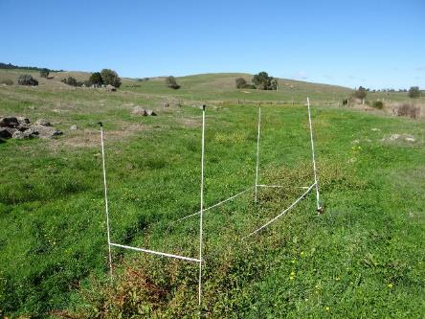

Estimating percentage cover values
Areas dominated by pasture species will typically comprise one vegetation tier, ie, the Herb Stratum of the vegetation tool. However, there will be cases where pasture species are overtopped by shrubs or trees. To keep the protocols consistent with the vegetation tool, all strata, ie, herb, shrub/sapling and tree are incorporated into the assessment. The use of absolute cover for each species for each stratum accounts for any overlap of vegetation, either within or between strata.
Absolute cover is a vertical projection (natural spread) of the above-ground live biomass for each species, recorded as the percentage cover of the total area of the plot, irrespective of the position of other species. Species are assessed independently in each vegetation stratum. The percentage cover value of each species cannot exceed 100 per cent within a stratum, but the total vegetation cover can exceed 100 per cent within a plot where species overtop each other.
The Pasture Exclusion Test is assessed as the total pasture species cover (P) divided by the total (all strata) vegetation cover (TVC), multiplied by 100, ie,
P/TVC x 100 =_____%
The Pasture Exclusion Test is passed if this value is > 50 per cent, and thus the sampled area is excluded from being a natural inland wetland.
Sampling tips:
- Use the latest version of the national wetland plant list for species names and wetland indicator status ratings (Clarkson et al. 2021; Excel spreadsheet available at https://doi.org/10.7931/g0bz-2618).
- Minimise trampling of plots as that can affect the percentage cover estimates.
- Estimate percentage cover values, preferably as a consensus with a field partner.
- List all species in each plot (native and exotic vascular species and sphagnum moss). Include species that overhang the plot boundary whether rooted in the plot or not, provided they are growing in similar soils and hydrologic conditions. Epiphytes not rooted in the ground are excluded.
- Start with the Herb Stratum. For each species in turn, estimate a single per cent of live foliage cover value from a vertical projection/bird’s-eye-view perspective (min 0.5 per cent to include all rare occurrences, max 100 per cent per species). Imagine all other species disappear, then estimate the proportion of the plot the target species covers. Check underneath taller species that may obscure the target species.
- Start with the easiest ones first, those with very small amounts or those that cover a large area of the plot.
- Use mental ‘mini-plots’ to count percentage cover of scattered or clumped species. In a 2 m x 2 m quadrat, 1 per cent is 20 cm by 20 cm. This works particularly well for tussock-forming rushes and sedges, or larger scattered herbs such as willow-weed.
- You can also mentally ‘draw together’ the target species into one corner of the plot to help determine if they cover more or less than half, more or less than a quarter of the plot etc to refine the cover value.
- Use ligules to distinguish grass species, particularly in heavily grazed areas or outside the flowering season.
- Repeat for all species in the plot, and all strata if shrub and/or tree strata are present.
The most challenging species to assess in pastoral wetlands are usually grasses and rushes, which might be difficult to distinguish without a hand-lens examination of small features such as ligules, seed capsules and/or cross walls. To apply the protocol, it is essential each species be identified. For instance, native swamp millet (Isachne globosa) (OBL) and sweet vernal (Anthoxanthum odoratum) (FACU/pasture species) may be difficult to visually separate, but accurate values will be needed to correctly apply the protocol. In such circumstances, the point intercept method could be used. Randomly select 20 points across the plot in the zone where the problematic species occur, use a metal peg or similar to intercept a plant, and use a hand lens to correctly identify the grass/rush species your peg first touches. Note the number of times each species is intercepted, and use the proportions to improve your percentage cover estimate for each lookalike species.

6.7 Plot data form
Complete a single wetland delineation data form: pasture exclusion for every plot (appendix 2). Some of the site information will be repeated for multiple plots on the same property.

Section A: Site information
Fill in the information for the site or project area (see appendix 3 for examples). If the project area is very large, separate the areas into manageable and recognisable units, eg, Station Name A, B…, or East/ West…, and/or local name. Land use, landform, local relief, and land cover descriptors follow the New Zealand Soil Description Handbook (Milne et al. 1995) and New Zealand Soil Classification (Hewitt et al. 2010). Some of the main ones are included in the list below.
- Land Management at whole-site / property scale: Beef cattle, dairy cattle, sheep, etc.
- Landform at whole-site scale: Hill country (steep, gently rolling, etc.), gully, floodplain, valley, terrace, oxbow, old river channel, sand dune, moraine, etc.
- Local relief at the sampling point/plot scale: flat, depression, bank, gentle/steep slope/toe slope, etc.
- Land cover dominant species/taxa and vegetation structure: eg, exotic grassland, kahikatea forest, grey willow treeland, mānuka shrubland, herbaceous freshwater vegetation, etc.

Other categories
- Is the site drained? Within or likely affecting the vegetation type the plot is located in. Looks for drains, diversions, stop banks, etc, which would lower water table. If unknown or uncertain, expand in remarks.
- Normal circumstances: Undisturbed conditions: typical soils and hydrology in or likely affecting the vegetation type the plot is located in (see also section 6.10: Uncertain situations, and Glossary)

Section B
Complete section B of the New Zealand wetland delineation data form: Pasture exclusion (see appendix 3 for a completed example)
- For each stratum:
- List each species and its absolute percentage cover value. Species occurring in more than one stratum are assessed more than once (for example if there are sapling and tree sized willow trees present, saplings are assessed in the shrub/sapling plot, trees in the tree plot.
- Apply pasture test:
- For each stratum sum percentage cover values for all species to derive a single total plot percentage cover value – note this may exceed 100 per cent in areas with overlapping foliage of different species.
- For all exotic pasture species, repeat their percentage cover values in the far column and add them together. If they collectively comprise 50 per cent or more of the total vegetation cover (TVC), the plot meets the pasture exclusion clause.
- If the plot fails the Pasture Exclusion Test, and if you suspect it is a natural inland wetland, apply the wetland vegetation tests (Dominance Test and Prevalence Index) to assess for wetland presence as follows.
- Apply wetland delineation protocols:
- For each stratum divide the total cover by half and by five to calculate the 50 per cent and 20 per cent of total cover values.
- Indicate ’Y’ for the Dominant Species, ie, those comprising more than 50 per cent of the TVC, then add any other species that comprise more than 20 per cent of the total cover, following the 50:20 rule.
- Write the wetland indicator status (OBL, FACW etc) and apply the dominance and prevalence tests to confirm if the site is a wetland. If the results are unclear, eg, if they don’t agree, or if the prevalence test is slightly under/over the 3.0 threshold, and/or other wetland indicators are present or absent, apply the soil and hydrology test.
If the plot does not meet the Wetland Test, it is not a natural inland wetland. However, if dominance and prevalence scores are uncertain, apply the hydric soil and hydrology tests.

Section C
See summary in section 6.8 and the wetland delineation hydrology tool (Ministry for the Environment, 2021a) and hydric soil tools (Fraser et al, 2018) for full guidance.

Summary of findings
Once all the relevant assessments have been completed, fill out the ‘Summary of findings’ component at the end of section A.

6.8 Soil and hydrology assessments
To add further rigour to the pasture exclusion assessment, and particularly if the vegetation scores are uncertain, use soil and hydrology indicators.
Collect a soil sample using an auger to at least 30 cm depth below the root mass. Wet the sample before checking colouration and looking for mottles (figure 9). See Fraser et al. (2018) for full details of the hydric soil assessment, and Ministry for the Environment (2021a) for the hydrology tool.
Complete the relevant sections of the New Zealand wetland delineation data form: Pasture test (appendix 2) to capture this information.
Figure 9: Collecting a soil sample for testing using an auger
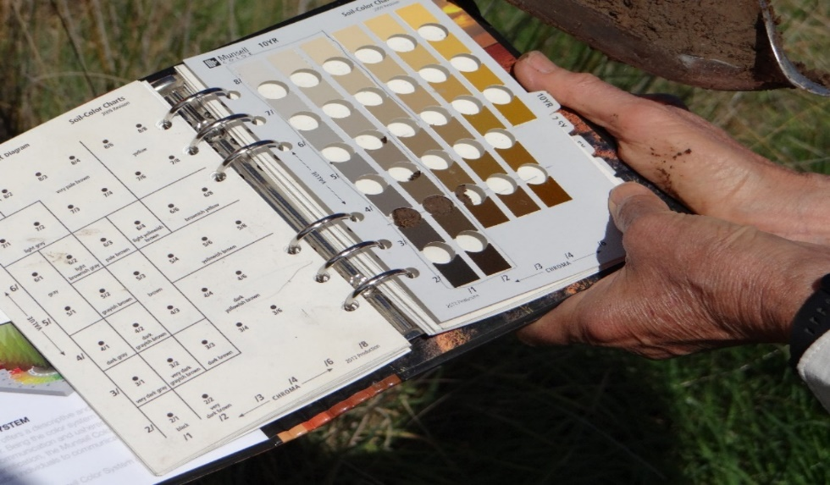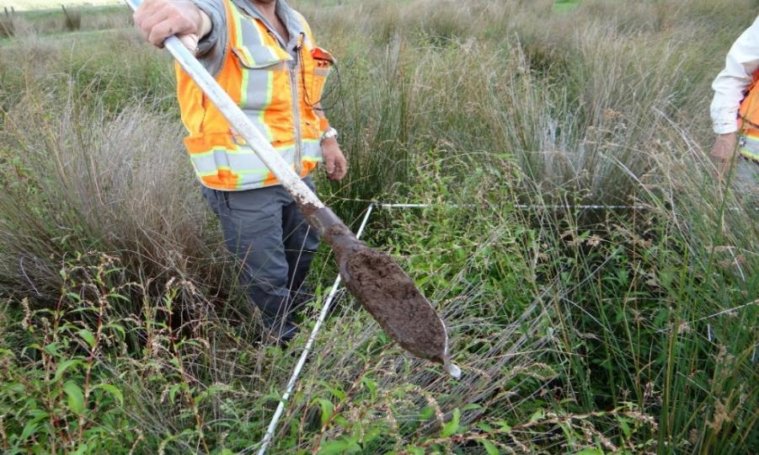 An auger is used to extract a sample to at least 30 cm depth and wetted for accurate colour representation. Soil colour charts help identify the soil type. Mottles, gleyed soil and low chroma colours (inside the yellow box on the Munsell 10YR hue page) indicate hydric soils.

6.9 Wetland delineation and mapping

Minimum size
The NES-F and NPS-FM do not set a minimum size to which the regulatory provisions apply. The Resource Management (Stock Exclusion) Regulations 2020 apply a minimum size of 500 m² (0.05 hectares) beyond which certain stock must be excluded from a natural inland wetland on low slope land or from smaller wetlands containing threatened species habitat. In addition, regional councils are required to map natural inland wetlands larger than 0.05 ha (500 m²) or smaller wetlands that contain threatened species habitat, excluding those located on public conservation lands or waters.
If a single sampling area (plot) meets the wetland test and does not meet the pasture exclusion definition, then at least some part of the site is a natural inland wetland (unless it meets other exclusions in the ‘natural inland wetland’ definition) and the NES provisions will apply. In this case the area of natural inland wetland will need to be delineated.

Mapping wetlands on farms
For farm plans, a minimum mapping size of 0.05 ha (or smaller if threatened species habitat is present) would be a useful starting point. However, at farm and paddock scales, many wetlands are smaller than 0.05 ha, and while the stock exclusion rules may not apply, the NES provisions including controls on vegetation clearance, drainage and discharge activities (discharge of water to water- the NES-F does not regulate contaminant discharges) will apply if the sites are natural inland wetlands. We note the definition of ‘vegetation clearance’ in the NPS-FM excludes standard grazing. Such wetlands sometimes cover only a few square metres in area, and occasionally occur within fine mosaics of wetland and dryland. These can be difficult to map at broad scales, eg, 1: 50 000, and even at finer scales, eg, 1: 10 000, 1: 5000.
Case study: Pragmatic minimum size
A pragmatic approach to minimum wetland size has been adopted by some councils. For example, Greater Wellington Regional Council provide guidance that the smallest area that could be determined as a natural inland wetland would need to be at least 3 m in diameter (area = 7 m² (Greater Wellington Regional Council 2021). This accommodates the 2 m x 2 m vegetation plot, which is 2.8 m across its diagonal length. However, when mapping large wetlands, smaller satellite wet areas are mapped as part of the main wetland if the distance to the main wetland is less than the length of the longest axis of the satellite; unless there is evidence to show it is hydrologically separate. Another exception is where wetland vegetation is present as narrow zones, eg, in the bottom of damp gullies. In these cases, if the vegetation community is wide enough that one cannot comfortably step across it and qualifies as natural inland wetland, it should be mapped.

Mapping scale
Wetlands can be mapped at a range of scales depending on their size and distribution, and the detail of information required (Ward & Lambie 1999).
As a guide, a homogenous vegetation type of dimensions 10 metres by 10 metres will be 1 mm² on a map at 1: 10 000 scale and 4 mm² on a map at 1: 5000. A wetland of dimensions 50 metres by 10 metres, ie, the 0.05 ha (500 m²) minimum required to be mapped by councils will be 5 mm² and 20 mm² on maps at 1: 10 000 and 1: 5000 scales, respectively.
The scale for mapping would vary according to the purpose of the mapping exercise and the best resolution that underlying imagery would allow for. Wetlands and/or significant features too small to map at an appropriate scale should be marked as reference points on a map or entered as another level in a GIS overlay. The NPS-FM requires regional councils to map natural inland wetlands if they are:
- 0.05 hectares or greater in extent; or
- of a type that is naturally less than 0.05 hectares in extent (such as an ephemeral wetland) and known to contain threatened species.

Mapping mosaics
Mosaics occur where wetlands and non-wetlands (and/or natural inland wetlands and pasture exclusions) are highly interspersed on a landscape and not easily delineated or mapped separately. These areas often have complex microtopography, with repeated small changes in elevation occurring over short distances, eg, small ridges and troughs. The recommended sampling approach is to estimate the percentage of natural inland wetland in the mosaic. This involves identifying all contiguous areas of either wetland or non-wetland on the site large enough to be delineated and mapped separately. The remaining area should be mapped as ‘wetland/non-wetland mosaic’ and the approximate percentage of wetland within the area determined by the following procedure (US Army Corps of Engineers, 2010):
- Lay out one or more (parallel) transects across the mosaic areas with random origins along one edge of the site. Measure the total length of the transects. Determine the total distance along each transect occupied by wetland and by non-wetland (including all pasture exclusions). Sum the distances across all transects and determine the percentage of wetland and pasture exclusion in the wetland/non-wetland mosaic.
- An alternative approach involves point-intercept sampling at fixed intervals along transects across the wetland/non wetland mosaic. This method can be carried out by pacing rather than stretching a measuring tape across the site. The investigator uses a compass or GPS to follow a transect line (with origins as above), and determines wetland, pasture exclusion, or non-wetland status at a fixed number of paces (eg, every two steps). Calculate the percentage of wetland and pasture exclusion as above.
At least one ‘ridge’, ‘trough’, and/or pasture exclusion plot representative of its respective plant community should be documented with completed field data forms. If additional vegetation types/plant communities are present, each different one should also have its own data form. Note that plot size and shape must be adjusted to fit the microtopographic features on the site, and not overlap different features or vegetation types (see figure 6).
Case study: Mapping mosaics
Tasman District Council aims to map areas of wetland greater than 10 m² within a mosaic (J. Lurling pers. comm., 12 April 2022). If the patchwork is of a finer scale, the predominant category (ie, wetland or dryland (including pasture wetland)) prevails. So, if hydrologically connected patches less than 10 m² occur within an area with overall more than 50% of the area being wetland, the overall area is mapped as wetland. Conversely, the overall area is not mapped as wetland if patches are less than 10 m² — and overall less than 50 per cent of the area is wetland. There is no specific scale for the ‘overall’ area. This change from mostly wetland to mostly dryland usually occurs on the boundary of an undulating patch of wetland. Where wetland areas are very marginal or degraded, like Carex geminata or willow weed in a paddock, a larger area of up to 20 m² would typically be used for mapping.

6.10 Uncertain situations
Several situations can be considered ‘atypical’ or ‘problematic’ when applying the tool. Often indicators of one or more of the three criteria (vegetation, hydrology, soils) may be absent. In these situations, the site is not considered to be subject to ‘normal circumstances’ and the usual routine approach does not apply. In these cases, more information and quantitative data is required (see Environmental Laboratory, 1987, and subsequent updates).
In areas with problematic hydrophytic vegetation, the key steps are:
- apply the soil and hydrology test to determine if the site is a wetland
- assess the vegetation in a nearby reference site
- gather more information, eg, recent farm management practices and data, eg, evidence of pre-disturbance conditions.

Extensively pugged areas
Large herbivores can cause soil compaction, alter soil permeability & infiltration rates (ie, pugging) and change the plant community. In situations with extreme pugging, for example where stock congregate around water troughs, gates, and along stock races, vegetation cover is often absent or extensively modified, eg, invaded by wet-tolerant, unpalatable weeds such as Persicaria hydropiper, and the soil often wet during rainy periods. Such conditions are not normal circumstances. For such sites, the recommended approach is to assess the vegetation on a nearby untrampled reference site having similar soils and hydrologic conditions. Assume the same plant community would exist on the grazed/trampled site in the absence of grazing. If the reference site is not a natural inland wetland, then the areas subject to extreme pugging, grazing or trampling are not natural inland wetlands.

Other examples
More examples on how to assess areas of problematic hydrophytic vegetation (including those affected by grazing, managed plant communities, aggressive invasive weeds, sparse and patchy vegetation, and temporal shifts in vegetation) are provided in the Wetland Delineation Regional Supplement for the Western Mountains, Valleys, and Coast Region, US (US Army Corps of Engineers, 2010).

Appendix 1: Pasture species
List of pasture species extracted from Cosgrove et al. (2022). Additional information, eg, cultivar status, is provided on the Ministry for the Environment website.
Full name | Rating | Synonym | Common name
Achillea millefolium L. | FACU |  | Yarrow
Agrostis capillaris L. | FACU |  | Browntop
Alopecurus pratensis L. | FAC |  | Meadow foxtail
Anthoxanthum odoratum L. | FACU |  | Sweet vernal
Arrhenatherum elatius (L.) P.Beauv. ex J.Presl & C.Presl |  |  | Tall oat-grass
Astragalus cicer L. |  |  | Cicer milk vetch
Bromus catharticus Vahl. | UPL | Bromus unioloides, Bromus willdenowii | Prairie grass, Rescue grass
Bromus cebadilla Steud. |  | Bromus stamineus, Bromus valdivianus | Grazing brome
Bromus coloratus Steud. |  |  | Coloured brome
Bromus hordeaceus L. |  |  | Soft brome
Bromus inermis Leyss. | UPL |  | Smooth brome
Bromus sitchensis Trin. |  |  | Upland brome
Bromus valdivianus |  | noted as a synonym of B. cebadilla | Pasture brome
Cenchrus clandestinus (Hochst. ex Chiov.) Morrone | FACU | Pennisetum clandestinum | Kikuyu
Cichorium intybus L. | FACU |  | Chicory
Cynosurus cristatus L. | UPL |  | Crested dogstail
Dactylis glomerata L. | FACU |  | Cocksfoot, Orchardgrass
Festuca rubra L. | FACU |  | Chewings fescue
Holcus lanatus L. | FAC |  | Yorkshire fog
Lolium arundinaceum (Schreb.) Darbysh. | FAC | Schedonorus arundinaceus, Festuca arundinacea | Tall fescue
Lolium multiflorum Lam. |  |  | Italian ryegrass
Lolium perenne L. | FACU |  | Perennial ryegrass
Lolium pratense (Huds.) Darbysh. |  |  | Meadow fescue
Lolium rigidum Gaudin |  |  | Annual ryegrass
Lolium x boucheanum Kunth |  | Lolium x hybridum | Hybrid ryegrass
Lotus angustissimus L. |  |  | Slender birdsfoot trefoil
Lotus corniculatus L. | FACU |  | Birdsfoot trefoil
Lotus hirsutus L. |  | Dorycnium hirsutum | Hairy canary clover
Lotus pedunculatus Cav. | FAC | Lotus uliginosus | Lotus
Lotus pentaphyllum L. |  | Dorycnium pentaphyllum
Lotus rectus L. |  | Dorycnium rectum
Lotus subbiflorus Lag. |  | Lotus suaveolens | Hairy birdsfoot trefoil
Lotus tenuis Walds. & Kit. ex Willd. |  |  | Narrow-leaved birdsfoot trefoil
Lupinus albus L. |  |  | white lupin
Lupinus angustifolius L. |  |  | Narrow-leafed lupin, blue lupin
Lupinus polyphyllus Lindl. |  |  | Perennial lupin
Medicago lupulina L. |  |  | Black medic
Medicago polymorpha L. |  | Medicago nigra | Burr medic
Medicago sativa L. | UPL |  | Lucerne, Alfalfa
Melilotus albus Medik. |  |  | Sweet clover
Melilotus officinalis (L.) Lam. |  |  | Yellow sweet clover
Onobrychis viciifolia Scop. |  |  | Sainfoin
Ornithopus compressus L. |  |  | Yellow serradella
Ornithopus pinnatus (Mill.) Druce | UPL |  | Yellow serradella
Paspalum dilatatum Poir. | FACU |  | Paspalum
Phalaris aquatica L. | FAC |  | Phalaris
Phalaris arundinacea L. | FACW |  | Reed canary grass
Phleum pratense L. | FACU |  | Timothy
Plantago lanceolata L. | FACU |  | Narrow-leaved plantain, ribgrass
Poa pratensis L. | FACU |  | Kentucky bluegrass
Poa trivialis L. | FACU |  | Rough-stalked meadow grass
Rumex acetosella L. | FACU |  | Sheeps sorrel
Sanguisorba minor subsp. muricata (Spach) Briq. |  |  | Sheeps burnet
Securigera varia (L.) Lassen |  | Coronilla varia | Crown vetch
Sporobolus africanus (Poir.) Robyns & Tournay | FACU |  | Rat's-tail
Sulla coronaria (L.) |  | Hedysarum coronarium | Sulla
Thinopyrum intermedium (Host) Barkworth & D.R.Dewey |  | Elytrigia intermedia | Pubescent wheat grass
Trifolium ambiguum M.Bieb. |  |  | Caucasian clover
Trifolium arvense L. | UPL |  | Hare's-foot clover
Trifolium dubium Sibth. | UPL |  | Suckling clover
Trifolium fragiferum L. | FACU |  | Strawberry clover
Trifolium glanduliferum Boiss. |  |  | Gland clover
Trifolium glomeratum L. |  |  | Clustered clover
Trifolium hybridum L. |  |  | Alsike clover
Trifolium incarnatum L. |  |  | Crimson clover
Trifolium medium L. |  |  | Zig-zag clover
Trifolium michelianum var. balansae (Boiss.) Azn. |  | Trifolium balansae | Balansa clover
Trifolium micranthum Viv. |  |  | Lesser suckling clover
Trifolium pratense L. | FACU |  | Red clover
Trifolium repens L. | FACU |  | White clover
Trifolium resupinatum L. | FACU |  | Persian clover
Trifolium striatum L. |  |  | Striated clover
Trifolium subterraneum L. |  |  | Subterranean clover
Trifolium vesiculosum Savi |  |  | Arrowleaf clover
Vicia hirsuta (L.) Gray | UPL |  | Hairy vetch
Vicia lathyroides L. |  |  | Spring vetch
Vicia sativa L. |  |  | Common vetch
x Festulolium Asch. & Graebn. |  |  | Festulolium

Appendix 2: New Zealand wetland delineation data form: Pasture test
The New Zealand wetland delineation data form and the Quick reference guide for New Zealand wetland delineation data form are available on the Ministry for the Environment website.

Appendix 3: Field trials

Example 1
Name, Location | Hannon Farm, Te Miro
Land use | Dairy support
Site name | A1
Site description | Shallow gully, relatively steep slope at upper end, grazed
Outcome | Natural inland wetland
Reason | Dominant species is native swamp millet, Isachne globosa

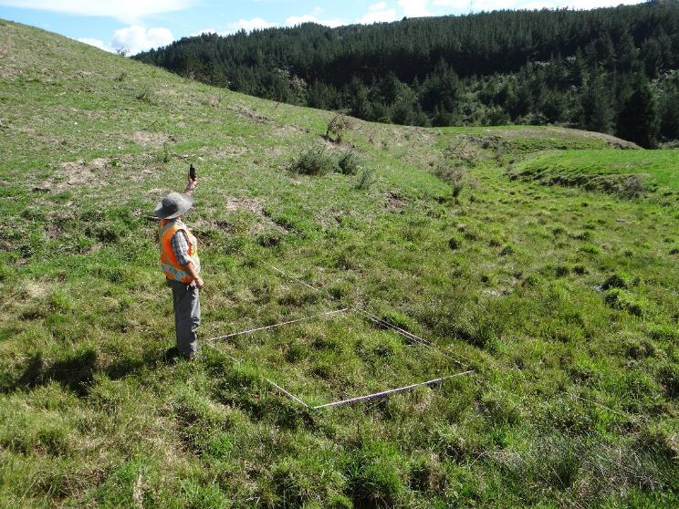
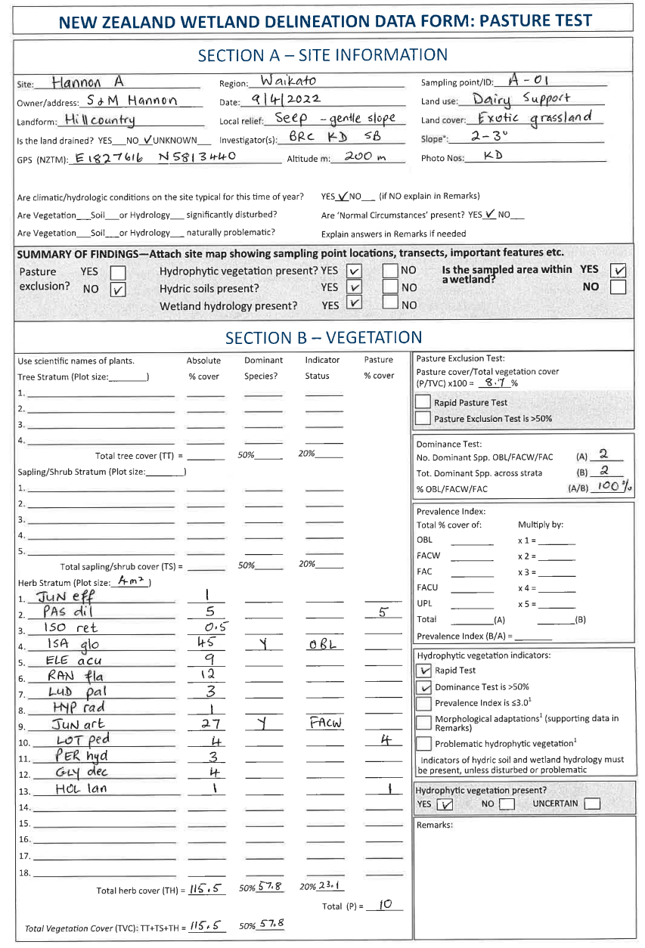

Example 2
Name, Location | Mourits Farm, Ohaupo
Land use | Dairy
Site name | A
Site description | Shallow gully, relatively steep slope at upper end, grazed
Outcome | Probably not natural inland wetland as vegetation tests uncertain, but requires hydric soil and hydrology tests to confirm
Reason | Dominated by creeping buttercup (FAC), not an exotic pasture species

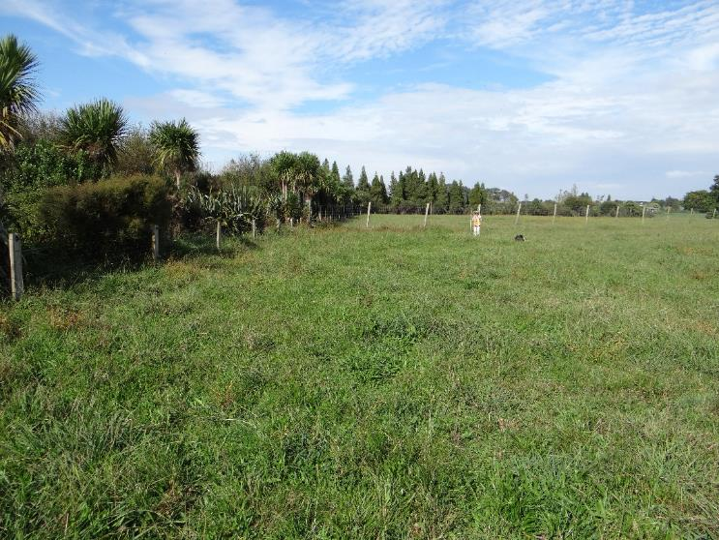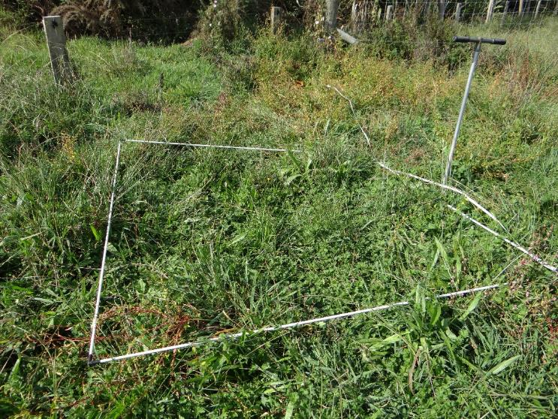
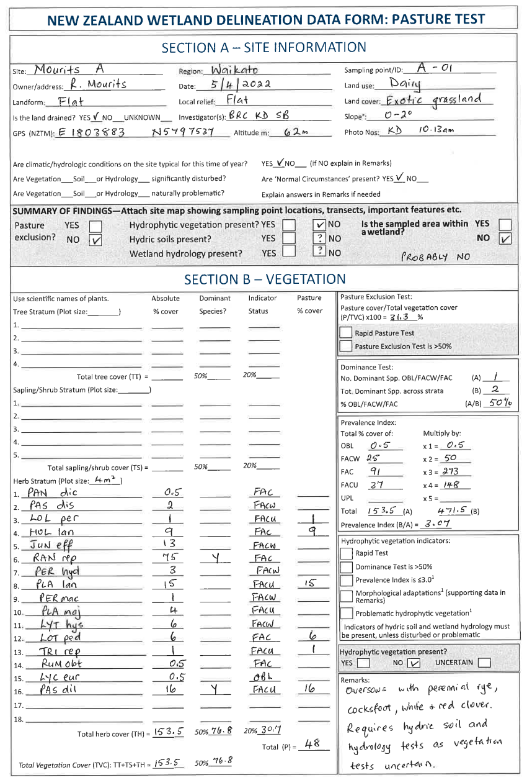

Example 3
Name, Location | Mourits Farm, Ohaupo
Land use | Dairy
Site name | B
Site description | Flat to gentle hillslope with pugged patches of water pepper, grazed
Outcome | Meets pasture exclusion test
Reason | Dominated by pasture species, especially ryegrass Lolium perenne

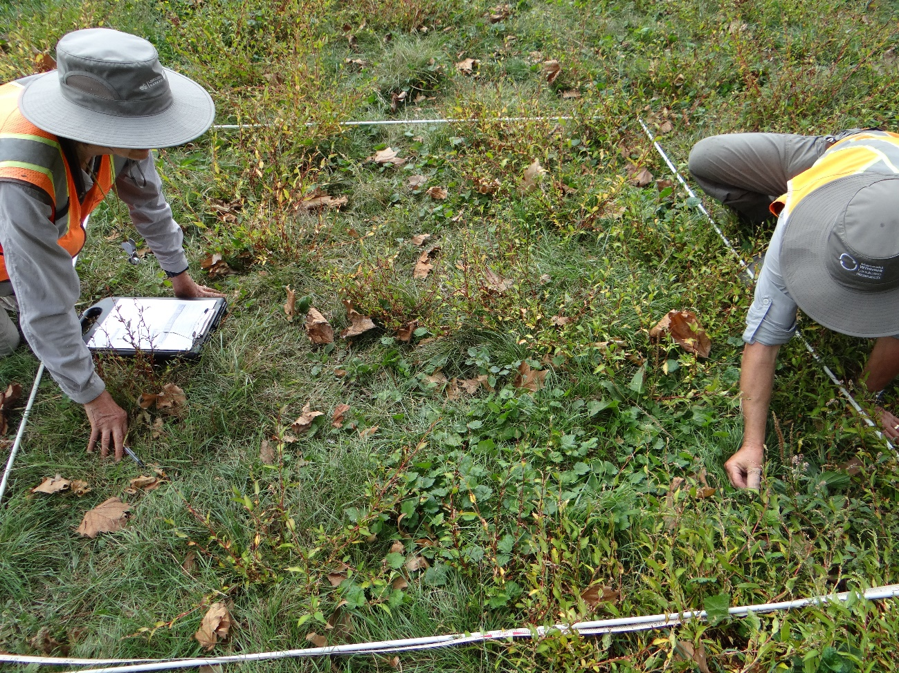

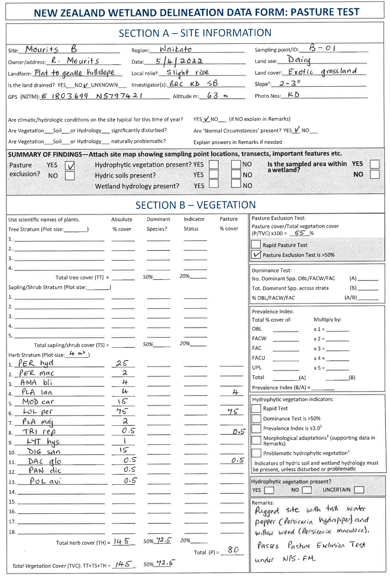

Example 4
Name, Location | Te Miro Trust, Te Araroa
Land use | Extensive grazing
Site name | G17
Site description | Swale between river levees, mostly flat, grazed
Outcome | Meets Pasture Exclusion Test
Reason | Dominated by pasture species, kikuyu, Cenchrus clandestinus
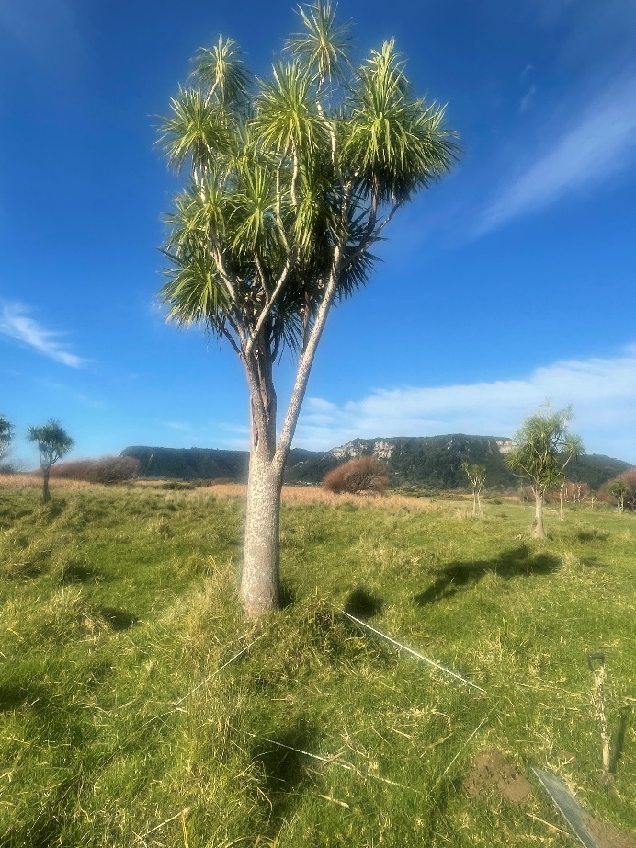
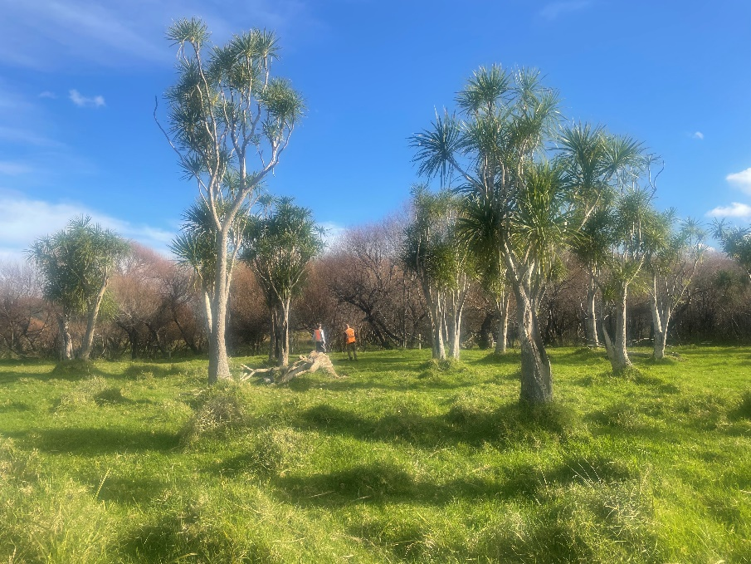

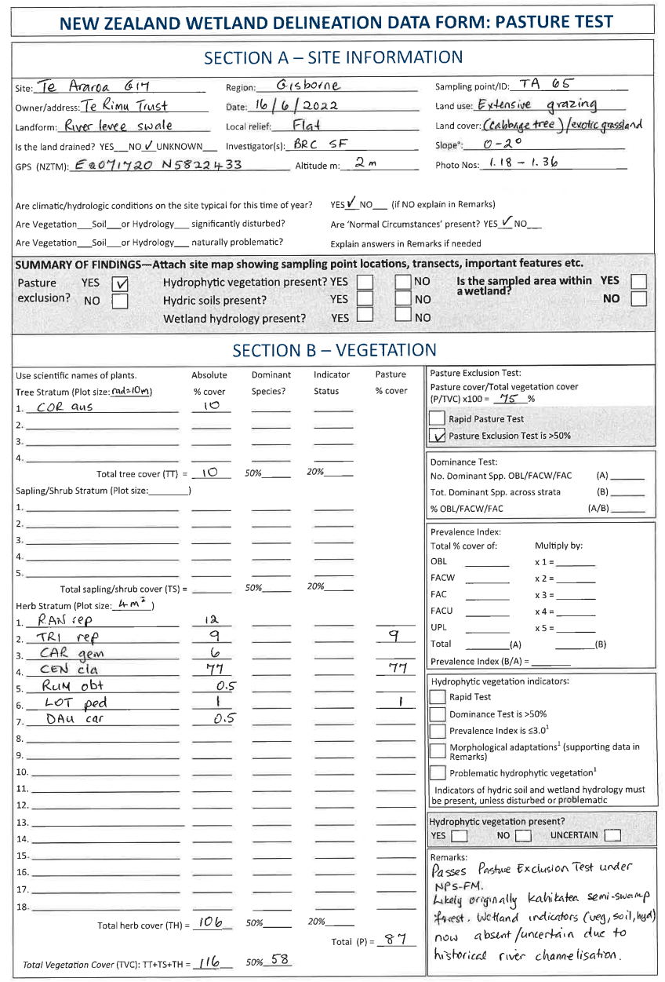

Example 5
Name, Location | Awarua Farm, Patetonga, Matamata-Piako District
Land use | Dairy, agricultural education
Site name | A
Site description | Piako River floodplain. Grazed pasture with scattered kahikatea trees
Outcome | Meets Pasture Exclusion Test
Reason | Dominated by pasture species, particularly rye grass Lolium perenne

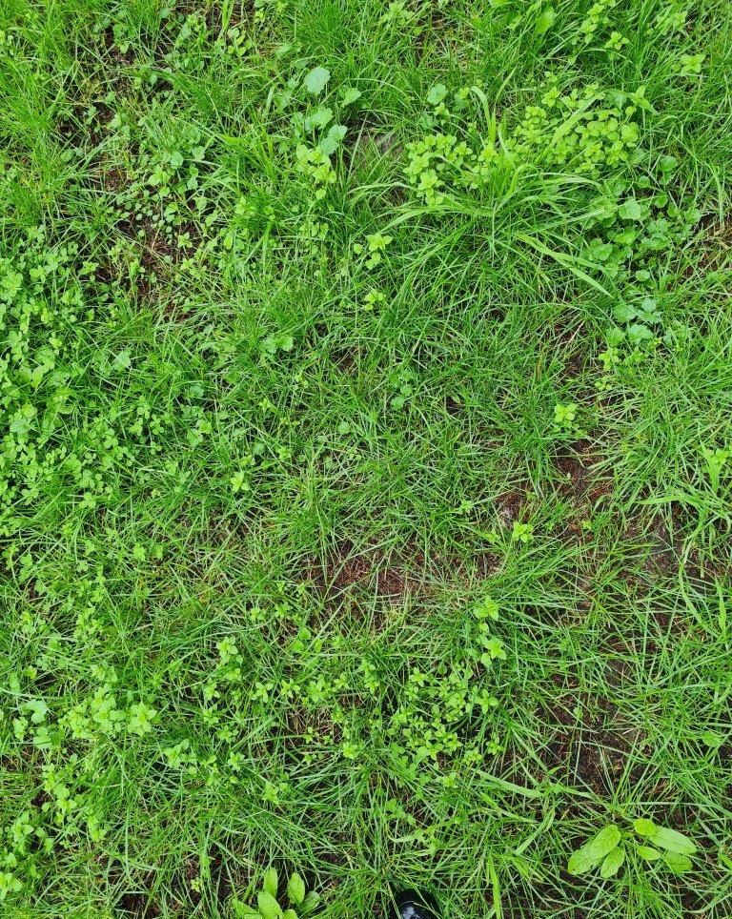
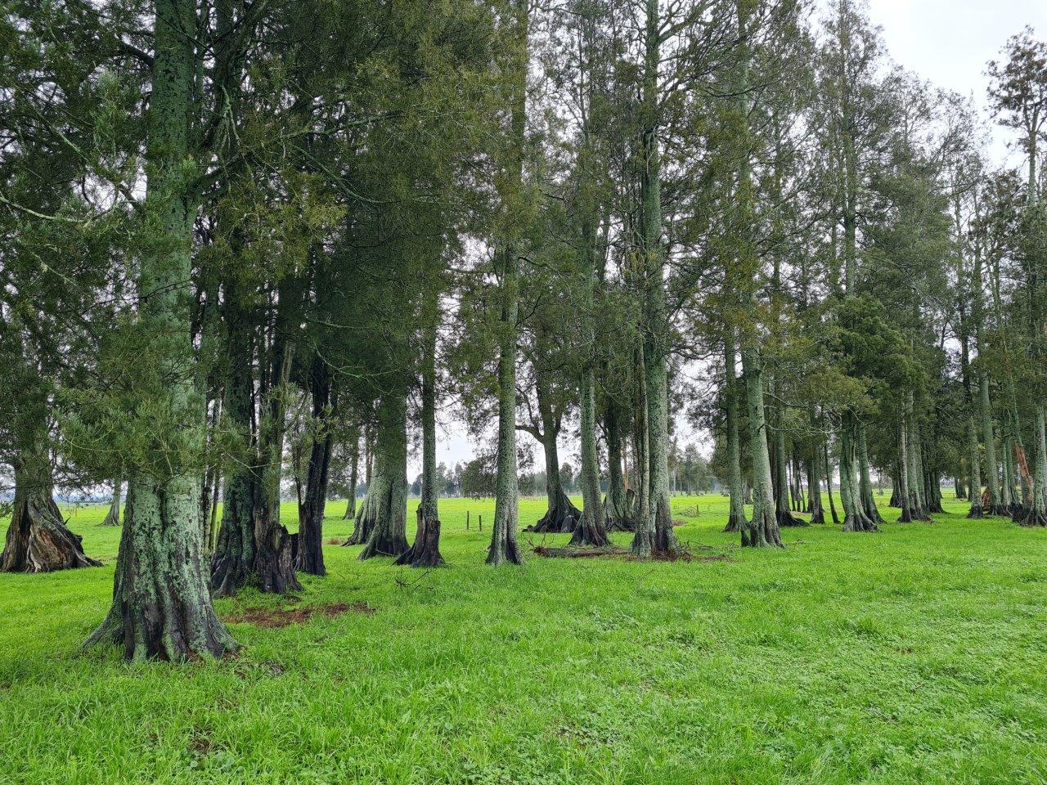

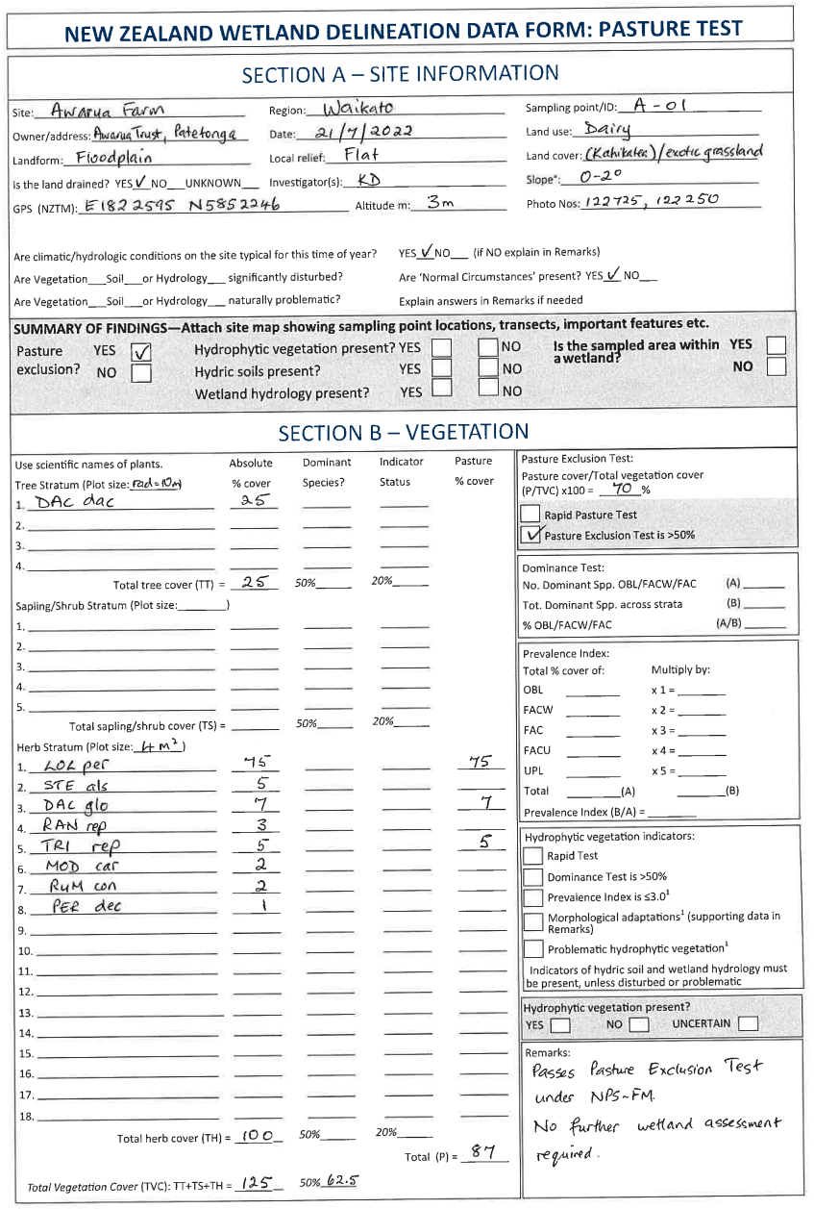

Glossary
Absolute cover | In vegetation sampling, the percentage of the ground surface covered by the aerial portions (leaves and stems) of a plant species when viewed from above. Due to overlapping plant canopies, the sum of absolute cover values for all species in a community or stratum may exceed 100 percent.
Atypical situations | Where ‘normal circumstances’ do not apply and one or more of the three criteria (vegetation, hydrology, soils) may be absent. Atypical situations include abnormal environmental conditions (eg, drought, flood) or recent disturbances such as landslides, or mechanical disturbance of vegetation (eg, clearance, mowing), or wetlands that have recently been filled, drained or cleared. In these situations, more comprehensive information and data, including evidence of conditions that existed immediately before the disturbance, are required and the US procedures for these situations are recommended (sections E–G in Environment Laboratory 1987, and subsequent updates).
Dominant species | The most abundant plant species (when ranked in descending order of abundance, eg, in a plot, and cumulatively totalled) that immediately exceed 50% of the total cover for the stratum, plus any additional species comprising 20% or more of the total cover for the stratum. This is known as the 50/20 rule, and is calculated for each stratum (tree, sapling/shrub, and herb).
Growing season | The portion of the year when soil temperatures at 30 centimetres below the soil surface are higher than biologic zero (5 degrees Celsius), approximated as the period between the last frost day and the first frost day. New Zealand growing season tables and maps are provided on pages 12–14 of the wetland hydrology tool (Ministry for the Environment 2021a).
Hydric soils | Soils formed under conditions of saturation, flooding or ponding long enough during the growing season to develop anaerobic (low oxygen) conditions in at least the upper 30 cm of the soil.
Hydrophytic vegetation | Plants capable of growing in soils often or constantly saturated with water during the growing season.
Nested plots | A series of different-sized plots all placed at the same location with a common centre point.
Normal circumstances | The long-term or stable condition of a site including any legal alterations, such as highways, dams and other relatively permanent development. The concept also includes the soil and hydrologic conditions normally present, in cases where the vegetation has been altered or removed.
Prevalence Index (PI) | A plot-based algorithm derived from the unique combination of OBL–UPL plants and their cover. The vegetation is considered to be hydrophytic (wetland) if PI ≤ 3.0, but values around 3.0 (slightly over or under) should be used alongside other wetland indicators.
Problematic wetland situations | Areas in which one or more of the three criteria (vegetation, hydrology, soils) is/are absent. In these cases, more information and quantitative data will be required (see Comprehensive Method of Environmental Laboratory 1987 and subsequent updates).
Rapid test | A simple first step for assessing obviously-wetland vegetation (eg, raupō reedland) that can be conducted onsite or offsite (with suitable imagery or information).
Rapid Pasture Test | A visual assessment to quickly determine if a site is pasture based on dominance by exotic pasture species. Is met when all dominant species across all strata are pasture species as defined in Appendix 1.
Rapid Wetland Test | A visual assessment to quickly determine if a site is wetland based on dominance by obligate or facultative wetland species. Is met when all dominant species across all strata are rated OBL and/or FACW.
Vegetation type | An area or zone with characteristic species composition and vegetation structure growing in a uniform habitat having similar topographic, hydrologic and soil conditions. Vegetation types are assessed using the canopy layer (bird’s eye view) and combine the composition of the dominant species and the main growth form, following Atkinson (1985). Examples include raupō reedland, mānuka shrubland, rye grass-white clover grassland, swamp millet grassland.
Wetland boundary | This is the point on the ground at which a shift from wetlands to non-wetlands or aquatic habitats occurs. These boundaries usually follow contours.

References
Atkinson IAE. 1985. Derivation of vegetation mapping units for an ecological survey of Tongariro National Park, North Island, New Zealand. New Zealand Journal of Botany 23: 361–378.
Clarkson BR. 2014. A vegetation tool for wetland delineation in New Zealand. Landcare Research Contract Report LC1793. Hamilton, NZ: Manaaki Whenua – Landcare Research.
Clarkson BR, Fitzgerald NB, Champion PD, Forester L, Rance BD. 2021. New Zealand wetland plant list 2021. Manaaki Whenua – Landcare Research Contract Report LC3975 for Hawke’s Bay Regional Council.
Cosgrove G, Dodd M, James T. 2022. National list of exotic pasture species. Prepared for the Ministry for the Environment by AgResearch Ltd. Wellington: Ministry for the Environment.
Environmental Laboratory. 1987. Corps of Engineers Wetlands Delineation Manual. Wetlands Research Program Report Y-87-1. Vicksburg, USA: Environmental Laboratory.
Fraser S, Singleton P, Clarkson B. 2018. Hydric soils – field identification guide. Landcare Research Contract Report LC3233. Hamilton, NZ: Manaaki Whenua – Landcare Research.
Greater Wellington Regional Council. 2021. Technical guidance for the determination of natural wetlands under Greater Wellington’s proposed Natural Resources Plan. GWRC, Wellington.
Hewitt AE 2010. New Zealand Soil classification. 3rd ed. Landcare Research science series No1. Lincoln, New Zealand: Manaaki Whenua Press.
Milne JDG, Clayden B, Singleton PL, Wilson AD. 1995. Soil Description Handbook. Lincoln NZ: Manaaki Whenua Press.
Ministry for the Environment. 2022. Wetland delineation protocols. Wellington: Ministry for the Environment.
Ministry for the Environment. 2021a. Wetland delineation hydrology tool for Aotearoa New Zealand. Wellington: Ministry for the Environment.
Ministry for the Environment. 2021b. Defining ‘natural wetlands’ and ‘natural inland wetlands’. Wellington: Ministry for the Environment.
U.S. Army Corps of Engineers 2010. Regional Supplement to the Corps of Engineers Wetland Delineation Manual: Western Mountains, Valleys, and Coast Region (Version 2.0). ERDC/EL TR-08-28. Vicksburg, MS: U.S. Army Engineer Research and Development Center, Environmental Laboratory.
Ward, JC, Lambie JS. 1999. Monitoring changes in wetland extent: an environmental performance indicator for wetlands. Coordinated monitoring of New Zealand wetlands. A Ministry for the Environment SMF Project. Lincoln: Lincoln Environmental, Lincoln University, Canterbury.
Wetland Training Institute 2012. Wetland Delineation Lecture Notes. Based on the Corps of Engineers 1987 Manual and Regional Supplements. Presented 6–10 August 2012, San Diego, California. Wetland Training Institute Inc, Glenwood, NM, USA.

Comprises commercial and non-commercial species categories in Cosgrove et al. (2022)
Cosgrove et al. (2022) note that seeds of pasture species have been imported into New Zealand for more than 160 years and possibly, up to 200 years.
Exotic pasture species are a defined list presented in appendix 1. Threatened species are as defined in the NPS-FM. The dashed arrows indicate the subsequent steps to determine if the area is a wetland under the RMA via the process outlined in figure 3.
Select plant species from the ranked list in descending order until the cumulative coverage immediately exceeds 50 per cent of the total cover for the stratum. If two or more species are equal in cover, they should be selected as a group. Then add any other species that comprise at least 20 per cent of the total cover in the stratum. All these species are considered to be dominant species (Clarkson 2014).

