

**Disclaimer**

The information in this publication is, according to the Ministry for the Environment’s best efforts, accurate at the time of publication and the Ministry makes every reasonable effort to keep it current and accurate. However, users of the publication are advised that:

* The information provided has no official status and so does not alter the laws of New Zealand and other official guidelines or requirements.
* It does not constitute legal advice, and users should take specific advice from qualified professional people before undertaking any action as a result of information obtained from this publication.
* The Ministry for the Environment does not accept any responsibility or liability whatsoever whether in contract, tort, equity or otherwise for any action taken as a result of reading, or reliance placed on the Ministry for the Environment because of having read any part, or all, of the information in this publication or for any error, or inadequacy, deficiency, flaw in or omission from the information provided in this publication.
* All references to websites, organisations or people not within the Ministry for the Environment are provided for convenience only and should not be taken as endorsement of those websites or information contained in those websites, nor of organisations or people referred to.

This guide may be cited as:

Ministry for the Environment. 2016. *Good Practice Guide for Assessing and Managing Odour*. Wellington: Ministry for the Environment.

Published in November 2016 by the  
Ministry for the Environment   
Manatū Mō Te Taiao  
PO Box 10362, Wellington 6143, New Zealand

ISBN: 978-0-908339-74-7  
Publication number: ME 1278

© Crown copyright New Zealand 2016

This document is available on the Ministry for the Environment website: www.mfe.govt.nz.



# Contents

Acknowledgements 5

1 Introduction 6

1.1 Purpose of this good practice guide 6

1.2 Target audience 7

1.3 Legislative context 7

1.4 Relationship management 12

2 Odour sources, properties and effects 12

2.1 What is odour? 14

2.2 Odour perception 14

2.3 Effects of odour 17

2.4 FIDOL factors 18

2.5 Sensitivity of receiving environment 18

2.6 Classification of odour effects as chronic and acute 21

3 Assessment criteria and consent conditions 23

3.1 Assessment criteria 23

3.2 Consent conditions 23

4 Odour assessment 29

4.1 Complaint investigation and analysis 30

4.2 Odour surveys 39

4.3 Measuring odour 43

4.4 Assessing odour by dispersion modelling 49

5 Odour management and control 54

5.1 Management options for regulators 54

5.2 Management options for industry 58

Appendix 1: Odour management plans 68

Appendix 2: Odour assessment tools 70

Appendix 3: Complaint investigation form 73

Appendix 4: Reduced response protocol for vexatious complainants 78

Appendix 5: Odour diary record sheet 81

Glossary 84

References 86

# Figures

Figure 1: Example spatial analysis of odour complaints from a wastewater treatment plant 32

Figure 2: Example odour complaints summary 33

Figure 3: Factors to consider when determining adverse effect from odour 35

Figure 4: Industry/odour treatment schematic example: sewage treatment plant 54

# Tables

Table 1: Odour intensity scale 16

Table 2: General hedonic tone (offensiveness) 16

Table 3: Description of the FIDOL factors 18

Table 4: Types of land use and the general sensitivity of the receiving environment 19

Table 5 Assessment tools for types of activities 29

Table 6: Complaint investigation and recording procedure 34

Table 7: Assessment of odour effect 35

Table 9: Recommended odour-modelling guideline values 51

Table A2.1: Selecting odour assessment tools for preparing or evaluating resource consents for an existing industrial or trade activity 70

Table A2.2: Selecting odour assessment tools for preparing or evaluating resource consents for proposed modifications to existing industrial or trade activity 71

Table A2.3: Selecting odour assessment tools for preparing or evaluating resource consents for new industrial or trade activity 72

# Acknowledgements

The *Good Practice Guide for Assessing and Managing Odour* has been updated by Emission Impossible Ltd under contract to the Ministry for the Environment. The Ministry would like to thank the following people and organisations for contributing to the development of this guide:

Ashok Nangia (Watercare)

Brian Cheyne (Taranaki Regional Council)

Camilla Needham (Beca)

Charles Kirkby (The Air We Breathe)

Dave Wright (Fonterra Co-operative Group Limited)

David Sinclair (Auckland District Health Board)

David Stagg (Waikato Regional Council)

David Wong (Light Metals Research Centre, University of Auckland)

Deborah Ryan (Jacobs)

Donovan Van Kekem (AECOM)

Doug Boddy (MWH New Zealand Limited)

Duncan Backshall (Air Quality NZ Ltd)

Emission Impossible Ltd

Glenn Riddell (Auckland Council)

Jared Osman (Auckland Council)

Jason Pene (Beca)

Jeff Bluett (Golder Associates)

Jenny Barclay (Independent Consultant)

Jimmy Wong (Canterbury District Health Board)

John Whitmore (Auckland District Health Board)

Jonathan Green (Fulton Hogan Ltd)

Jonathan Harland (Watercare)

Jon Trewin (Northland Regional Council)

Jozua Taljaard (Ecotech Pty Ltd)

Ken Holyoake (Armatec Environmental Ltd)

Kerryn McLellan (M2PP Alliance)

Kevin Mahon (Mahon Consulting)

Kim Kelleher (Lyttelton Port of Christchurch)

Leif Pigott (Tasman District Council)

Malcolm Walker (Canterbury District Health Board)

Marijana Jovanovic (Auckland Council)

Mathew Noonan (Beca)

Matt Willoughby (Canterbury District Health Board)

Melissa Radden (Ektimo)

Michael LeRoy-Dyson (Fulton Hogan Ltd)

Michele Dyer (Beca)

Mike Harvey (Auckland Council)

Murray Mackenzie (Ravensdown)

Nick Browne (Air Matters Ltd)

Noel Watson (Hawke’s Bay District Health Board)

Obi Khanal (Northland Regional Council)

Owen West (Environment Southland)

Paul Crimmins (Auckland Council)

Richard Purdon (Environment Canterbury)

Rob van de Munckhof (Tonkin & Taylor)

Roger Cudmore (Golder Associates)

Sally Gray (NIWA)

Shane Iremonger (Bay of Plenty Regional Council)

Shanju Xie (Auckland Council)

Steffan Cavill-Fowler (Canterbury District Health Board)

Stephen Palmer (Hutt Valley District Health Board)

Stephen Sing (Watercare Services Limited)

Trudy Richards (Greater Wellington Regional Council)

Vaughan Turner (Auckland Council)

Verity Halkett (Environment Canterbury)

Wayne Wright (Hawke’s Bay Regional Council)

Xenia Meier (Waste Management NZ Ltd)

# 1 Introduction

## 1.1 Purpose of this good practice guide

Odours have the potential to cause significant adverse effects on people’s lives and well-being. Complaints about odour emissions are one of the most frequent environmental pollution incidents reported to regulatory authorities.

Odour is complex. The range of adverse effects it can cause varies significantly, as does people’s sensitivity, which can cause conflict around perception and severity of effects. It is, therefore, important to provide an objective and consistent framework to assess and manage odour.

This guide outlines good practice in assessing and managing odours that cause offensive and objectionable effects in New Zealand. It contains expert opinion for those involved in managing odour, including council staff, councillors, consultants and industry. It is also a helpful resource for members of the public who may be affected by adverse odour effects. The key recommendations for good practice are summarised in boxes at the end of the relevant sections.

This guide provides information on:

* what odour is, and how it can affect people
* who is responsible for responding to and resolving odour complaints
* how to undertake odour investigations and to assess the effects of odour, including how to determine when odour has caused ‘an offensive or objectionable effect’
* how to monitor and manage the effects of odour through community surveys, odour diaries, and odour management plans
* when to use dispersion modelling and how to interpret the results
* how to measure and manage odour emissions.

This guide updates the Ministry for the Environment’s previous *Good Practice Guide for Assessing and Managing Odour In New Zealand* (Ministry for the Environment, 2003).

The recommendations in this guide provide a practical and reasonable approach to managing odorous discharges to air. This guide is one of a series of good practice guides for air quality developed by the Ministry for the Environment. For a full list of the guides see: [www.mfe.govt.nz/air/improving-air-quality/good-practice-guides-councils](http://www.mfe.govt.nz/air/improving-air-quality/good-practice-guides-councils).

There is a strong relationship between the guides. For example, if an assessment requires an assessment of the effects of dust, this guide will refer you to the [*Good Practice Guide for Assessing and Managing Dust*](http://www.mfe.govt.nz/publications/air/good-practice-guide-assessing-and-managing-dust) (Ministry for the Environment, 2016a). The aim is that the good practice guide series, taken together, will help provide for comprehensive and consistent management of air quality in New Zealand.

Because this guide covers assessment and management of all sources of odour in New Zealand, it is somewhat generic. Readers requiring industry-specific guidance for odorous emissions (eg, wastewater treatment plants) are referred to:

* (Australia) **NSW EPA Local Government air quality toolkit** – Part 3: air quality guidance notes for specific activities or operations, at [www.epa.nsw.gov.au/air/aqt.htm](http://www.epa.nsw.gov.au/air/aqt.htm)
* **European Integrated Pollution Prevention and Control Bureau (EIPPCB)** – best available techniques reference documents (BREFs) for a wide range of industrial sectors, at <http://eippcb.jrc.ec.europa.eu/reference/>
* (UK) **Department for Environment, Food & Rural Affairs** (Defra) extensive range of process guidance (PG) notes for specific industries at [www.defra.gov.uk/environment/quality/industrial/las-regulations/guidance/](http://www.defra.gov.uk/environment/quality/industrial/las-regulations/guidance/).

These guides, however, are not specific to New Zealand and do not take precedence over guidance in this document.[1]

## 1.2 Target audience

This guide is primarily aimed at practitioners making assessments of odour effects. These are mainly council officers and consultants. The guide will also be of interest to other stakeholders such as planners and resource managers, lawyers, business, industry and the general public.

Odour can affect anyone, and often the people trying to prevent offensive and objectionable effects from odours are industrial site managers (eg, from landfills, manufacturing or intensive farming). With this additional audience in mind, some sections include ‘hands on’ practical information and tools that can be tailored to particular situations and communities. The intent is to provide a consistent approach to managing odours across the country.

## 1.3 Legislative context

The recommendations in this guide are not legislative requirements under the RMA or any other legislation. However, they are based on expert opinion and consultation with practitioners involved in odour assessment, and regulators charged with managing offensive odours. As such they should be taken into account in decision-making processes.

### 1.3.1 Roles and responsibilities

Under the RMA, the primary responsibility for managing air quality lies with regional councils and unitary authorities. Regional councils also have responsibilities under the Resource Management (National Environmental Standards for Air Quality) Regulations 2004.

Territorial authorities do not have a specific air quality management function under the RMA. Territorial authorities do, however, have the main responsibility for land use, which includes the location of activities that may discharge odours, such as:

* activities involving agrichemical application
* industry
* intensive farming
* transport infrastructure (roads, ports, airports).

District councils also have primary responsibility for managing the location of activities that are sensitive to discharges to air (eg, residential zones). Through managing land use therefore, district plan provisions manage the air quality effects of activities on sensitive land uses.

A unitary authorityis a territorial authority that also has all the responsibility of a regional authority – unifying both roles in one local government body which covers one geographical area.

People with activities that discharge to air (dischargers) must comply with the requirements of:

* the RMA, including section 17 (general duty to avoid, remedy or mitigate adverse effects)
* any relevant regional (and district) plan
* resource consent conditions.

### 1.3.2 Resource Management Act 1991

The purpose of the RMA as specified in section 5(1) is “to promote the sustainable management of natural and physical resources”. Section 5(2)(c) provides for “avoiding, remedying, or mitigating any adverse effects of activities on the environment”.

‘Effect’ is defined in section 3 of the RMA as including:

(a) any positive or adverse effect; and

(b) any temporary or permanent effects; and

(c) any past, present, or future effect; and

(d) any cumulative effect which arises over time or in combination with other effects—

regardless of the scale, intensity, duration or frequency of the effect, and also includes—

(e) any potential effect of high probability; and

(f) any potential effect of low probability which has a high potential impact.

Section 2 of the Act defines “environment” as including:

(a) Ecosystems and their constituent parts, including people and communities; and

(b) All natural and physical resources; and

(c) Amenity values; and

(d) The social, economic, aesthetic, and cultural conditions which affect the matters stated in paragraphs (a) to (c) of this definition or which are affected by those matters.

The term “amenity values” is also defined in section 2 of the RMA, as:

those natural or physical qualities and characteristics of an area that contribute to people's appreciation of its pleasantness, aesthetic coherence, and cultural and recreational attributes.

#### Section 9

Section 9 of the RMA allows a person to use land in any manner they like, provided it does not contravene a rule in a plan. If the activity does contravene a rule, then a resource consent is required (unless existing use rights already apply). Odour emissions from a land use may, therefore, be controlled if the plan restricts the use of land, and its associated effects, that cause the odour emission, and/or amenity requirements.

#### Section 15

The compounds that cause odour effects are air contaminants, so their discharge is controlled under section 15 of the RMA. Under section 15(1), discharges from industrial or trade premises are only allowed if they are authorised by a rule in a regional plan, a resource consent, or regulations (such as a national environmental standard). If the activity is prohibited under the plan, then no resource consent can be obtained.

Under sections 15(2) and 15(2A), the opposite presumption applies to discharges from any other source. Unless these sources are controlled by a national environmental standard or a rule in a plan, discharges are allowed as of right and consent is not required.

In essence, if there are discharges of odour to air from an industrial or trade premises, the discharge will need to be either:

* a permitted activity in a regulation or plan, or
* authorised by a resource consent.

If the discharges of odour to air are not from an industrial or trade premises then, unless there is a rule or regulation relating to the discharge, a consent is not needed.

#### Section 17

Section 17 of the Act imposes a general duty on every person to avoid, remedy or mitigate any adverse effect on the environment arising from any activities the individual may conduct or have carried out on their behalf. This applies regardless of whether the activity is carried out in accordance with any rule, plan or resource consent.

Section 17(3)(a) allows an enforcement order to be made or served that can be made or served by the Environment Court or and Enforcement Officer.These require a person to cease doing something that is, or is likely to be, noxious, dangerous, offensive or objectionable to such an extent that it has or is likely to have an adverse effect on the environment.

#### Section 88 (and Schedule 4)

The RMA specifies information requirements for resource consent applications under section 88 and Schedule 4. Applicants for resource consent should refer to the [*Good Practice Guide for Assessing Discharges to Air from Industry*](http://www.mfe.govt.nz/publications/air/good-practice-guide-assessing-discharges-air-industry-0) (Ministry for the Environment, 2016b) for further information.

#### Section 108(2)(e)

In accordance with Section 108(2)(e) of the RMA, resource consents may include a condition requiring that the best practicable option is adopted to prevent or minimise any adverse effects caused by a discharge, provided that the inclusion of such a condition is the most efficient and effective means of preventing or minimising any actual or likely adverse effect on the environment. Section 2 of the RMA defines the best practicable option in relation to the discharge of contaminants to air as:

… the best method for preventing or minimising the adverse effects on the environment having regard, among other things, to—

(a) the nature of the discharge or emission and the sensitivity of the receiving environment to adverse effects; and

(b) the financial implications, and the effects on the environment, of that option when compared with other options; and

(c) the current state of technical knowledge and the likelihood that the option can be successfully applied.

#### Enforcement

Under the RMA, the following enforcement tools may be used:

* infringement notice (issued by council)
* abatement notice (issued by council)
* enforcement order (issued by the Environment Court)
* interim enforcement order (issued by the Environment Court)
* prosecution.

Any person may apply for an enforcement order or take a prosecution. Readers are referred to the [*An Everyday Guide to the RMA: Enforcement*](http://www.mfe.govt.nz/publications/rma/everyday-guide-rma-enforcement)(Ministry for the Environment, 2015) for information on these enforcement mechanisms.

### 1.3.3 National environmental standards

National environmental standards (NES) under the RMA are regulations that can prescribe technical standards, methods, or requirements. These regulations are implemented by regional councils (for example, air) and district councils (for example, soil).

In 2004, the Government introduced the Resource Management (National Environmental Standards for Air Quality) Regulations 2004 (the NES for air quality) to set a guaranteed minimum level of health protection for all New Zealanders. Detail of the standards within the NES for air quality can be found on the [New Zealand legislation website](http://www.legislation.govt.nz/regulation/public/2004/0309/latest/whole.html?search=ts_act%40bill%40regulation%40deemedreg_air+quality_resel_25_a&p=1#DLM287044).

Discharges of odour are not addressed by these regulations.

### 1.3.4 Regional policy statements

Regional policy statements (RPS) provide an overview of air quality and other environmental issues in a region. They further specify policies and methods to achieve integrated management of air quality, and other natural and physical resources, in each region.

### 1.3.5 Regional plans

Regional plans specify objectives and policies, and the methods that will be used in managing air quality within a region. These plans may be specific to air quality (eg, a regional air quality management plan) or cover all resources in the region. Regional plans must give effect to the provisions of the regional policy statement, national policy statements, national environmental standards, and the RMA).

Regional plans for air quality management generally include objectives and policies for managing ambient air quality as well as localised effects, eg, dust and odour.

Under section 68 of the RMA, councils can use rules to allow, regulate or prohibit activities. Individual sources or groups of sources are typically controlled by rules in plans that specify whether the activities are permitted (typically with conditions), controlled, restricted discretionary, discretionary, non-complying or prohibited.

Regional air plans generally provide for permitting activities with a low potential for adverse effects, provided certain conditions are met. In some cases the activity may be known to be odorous or dusty, but is deemed acceptable (and classified as a permitted activity) based on its location (eg, field ploughing).

The plans may also include policies and methods for managing identified issues such as such as dust nuisance, odour, smoke from domestic fires, and motor vehicle emissions. In addition to rules, non-regulatory mechanisms may be adopted, such as education and development of industry codes of practice.

Regional air quality management plans are developed through a process of public consultation and review, before the plan becomes ‘operative’. Check the current status of specific plans with the relevant regional council, as there may be more than one plan that needs to be considered.

### 1.3.6 Unitary and district plans

Under section 31 of the RMA, territorial authorities have responsibilities to control land use, and to achieve integrated management of the use, development or protection of land and associated natural and physical resources of the district. This includes effects of land use on air quality and on amenity values.

District rules specify the types of activities, including industries that are allowed in different areas or zones. In assigning zones to particular areas and developing zone provisions, district plans should consider how appropriate separation distances will be maintained between activities that generate odour or dust and sensitive activities, such as residential zones. Further guidance on land-use planning and separation distances is set out in section 5.1.2.

Importantly, district plans provide guidance on differing amenity expectations within different zones. These district plan provisions take precedence over the more general guidance on land-use sensitivity in this guide.

### 1.3.7 Alignment of regional and district council requirements

With respect to odorous emissions, district plans requirements are often similar to those of regional plans. This is because district plans are required to manage the effects of land-use consents that have odorous discharges to air. In some cases district plans have included prescriptive controls on odour-generating activities.

There are two options for exercising local government odour management functions, either:

i. the effects of odour emissions should primarily be controlled at the regional level

ii. a combined approach is taken, where odour emissions associated with any land use are controlled at the district level, and odour emissions associated with any activity requiring consent for discharges to air are controlled at the regional level.

Ideally, duplication between district and regional plans should be avoided. This guide recommends that regional councils and territorial authorities reach agreement as to which approach is used and that this approach follows through into planning documents, consents and enforcement. It is often very useful for regional councils and territorial authorities to work together. For example, where regional council staff are remote from a particular area trained territorial authority officers can greatly assist in gathering information or evidence.

The types of activities that require resource consents vary between individual councils. The only way to be sure whether an activity requires a resource consent is by checking with the relevant regional and district councils, or working through the appropriate plans.

### 1.3.8 The Health Act 1956

Territorial authorities and public health authorities (district health boards) have a duty to improve, promote and protect public health under the Health Act 1956 (the Heath Act). Territorial authorities employ environmental health officers to monitor, and take enforcement action against, conditions likely to be injurious to health or offensive, as well as to abate nuisances. Public health authorities employ health protection officers, who also have the functions of an environmental health officer under the Health Act.District health boards often work collaboratively with regional councils to manage air discharges when there is a *health* issue arising from a discharge. In cases where odours are known or suspected to cause adverse health effects, councils should advise public health officers and/or the medical officer of health.

There is some overlap between the responsibilities of regional councils under the RMA, and the responsibilities of territorial authorities and public health authorities under the Health Act. The first point of contact for air quality issues is the regional councils.

Key points

When assessing the effects for an individual discharge of odour, consider the specific requirements of relevant legislation, policy and plans in detail.

District councils have an important role to play in managing odour effects through land-use planning.

The first point of contact for air quality issues is the regional council.

## 1.4 Relationship management

The starting point for effective odour management is to build a positive relationship with the community affected by the odour. This will help with determining concerns and deciding and prioritising any mitigation. Early community consultation may also avoid the need to undertake the detailed assessments and methods discussed in section 4.

When uncertainty and conflict increase between the discharger and community, usually the time and costs to resolve issues also increases. This guide strongly recommends that dischargers are responsive to community concerns about odour, and work cooperatively to find solutions to adverse odour effects.

The public has the right to expect a reasonable response from regulators and dischargers when making a complaint about odour. Equally, the public need to be genuine in their complaints and not complain for ulterior motives.

Where reasonable and practicable, the public can also take the initiative of attempting to resolve issues directly with the discharger. Members of the public may take common law action if they are not satisfied with the response from a council or discharger. For example, they can apply for an enforcement order under section 314 of the RMA. Alternatively a declaratory judgment can be sought which would set out each parties responsibility.

Management options to mitigate the effects of odour are discussed further in section 5.2.

Key points

Establishing a positive relationship with the community affected by the odour is a good starting point for effective odour management.

Dischargers should be responsive and work with communities to find solutions.

The public has a right to expect a reasonable response from regulators and dischargers when making a complaint about odour.

# 2 Odour sources, properties and effects

## 2.1 What is odour?

Odour is perceived by our brains in response to chemicals present in the air we breathe – it is the effect those chemicals have on us. The effect arises from a two stage process where the brain first senses the chemical stimulus and then interprets it based on previous life experiences; we often give meaning to odour. Natural variation in sensitivity and life experiences can result in individuals having different sensations and emotional responses to the same odour compounds.

Because the response to odour is processed in our brains, other senses such as sight and taste, and even our upbringing, can influence our perception of odour and whether we find it acceptable, or offensive and objectionable. For example, odours that are widely perceived as offensive may be acceptable to those working in the ‘industry’.

Unlike other sensory information, olfactory stimulation is the only sense that reaches the cerebral cortex without first passing through the thalamus. This can lead to intense emotional and behavioural responses to certain odours.

Humans have a sensitive sense of smell and can detect odour even when chemicals are present in very, very low concentrations.

Given that odour is a human perception, it is extremely difficult to measure an odour using a chemical, mechanical or electronic apparatus as is possible for other nuisance impacts such as noise and light. At present, assessment by human nose is the most reliable method for determining an odour (either in the field, or, by a panel as discussed in section 4.3).

## 2.2 Odour perception

How an odour is perceived (sensed and interpreted), and its subsequent effects, is not straightforward. The human perception of odour is governed by complex relationships, and this needs to be considered when assessing potential odour effects.

### 2.2.1 Variability in olfactory perception

Everybody has a different sense of smell. The normal population ranges from those who are insensitive to odour, all the way through to people who are hyper sensitive to odour.

The complexities of odour are such that a person may be sensitive to one odour and insensitive to another odour. However, it is rare to find individuals who have diminished thresholds for all compounds (American Industrial Hygiene Association, 2013).

Odorants can also act as:

* additive agents (eg, 1 + 1 = 2)
* neutralising agents or counteractants (eg, 1 – 1 = 0), such as water sprays to remove ammonia or chewing parsley to neutralise fish (amine) odours on breath
* masking agents (eg, 1 + 1 = 1), such as putting vanilla essence in the refrigerator to mask the odour of raw onion
* synergistic agents (eg, 1 + 1 = 5), such as the use of different fragrances to create a new, pleasant perfume.

Odours can also change downwind as individual components react with other species. All these interactions mean that the perception of a mixture of odorants is very different from how each odorant is perceived independently.

In general, odour detection thresholds, and nasal and eye irritation thresholds appear to be lower for a mixture of odours, than for individual chemical components (American Industrial Hygiene Association, 2013).

Numerous studies have shown:

* no significant gender difference in the detection thresholds of various types of odorants[2]
* a decrease in the ability to detect odours as age increases. Children have lower odour thresholds than adults.[3]

Smokers also show higher odour detection thresholds than non-smokers for almost all odorants; physical and mental state can also influence odour detection.[4]

Individuals can become sensitised to odour through acute exposure events, or as a result of repeated exposure to lower levels of (chronic) odours. This can result in high levels of complaints over the long term, and a general distrust within the community of those perceived to be responsible for the odour. The experience of distrust then also influences the interpretation of the odour and reactions to the odour become more extreme.

Alternatively, repeated exposure to odour can lead to people becoming desensitised so they can no longer detect the odour even though it is constantly present in the air. This is sometimes known as ‘olfactory fatigue’. For example, people working in an environment with a persistent odour are often unaware of its presence and may not be aware that the odour is having an impact on the surrounding community.

Adaptation is a long-term process that can occur when communities become increasingly tolerant of a particular source of odour, and is mainly a psychological response to the situation. For example, where odours are associated with a local industry that is considered to be important for the well-being of the local community, and the industry maintains a good relationship with community members, then adaptation to the odour effects can occur over time.

### 2.2.2 Odour intensity

The perception of intensity of an odour in relation to the odour concentration follows a logarithmic relationship (the same relationship occurs for other human senses, such as hearing and sensitivity to light). This means that if the concentration of an odour increases 10-fold, the perceived increase in intensity will be by a much smaller amount.

The logarithmic nature of odour perception is important for industrial sources. It means that decreasing the concentration of an odour (as determined by olfactometry) by 10-fold will only decrease the intensity by a much smaller amount.

Intensity can be assessed on a seven-point intensity scale from no odour (0) to extremely strong odour (6), as shown in table 1. While this is subjective (different people will perceive odours as different intensities), it still provides a useful quantitative tool for estimating odour intensity. In this way it is similar to the pain index (0–10) used by health professionals. The scale is derived from a German standard and has been widely used throughout New Zealand.

Table 1: Odour intensity scale[5]

| Odour intensity | Intensity level |
| --- | --- |
| Extremely strong | 6 |
| Very strong | 5 |
| Strong | 4 |
| Distinct | 3 |
| Weak | 2 |
| Very weak | 1 |
| No odour | 0 |

### 2.2.3 Odour character

Odour character is what the substance smells like. However, because individuals perceive odour individually, the same chemical may be described quite differently by different people. Odour character can also change with concentration. For example, butyl acetate has a sweet odour at low concentrations, but smells like banana at higher concentrations.

Table 2 gives a scale for rating the ‘offensiveness’, or hedonic tone, of an odour.

Table 2: General hedonic tone (offensiveness)

|  |  |
| --- | --- |
| –4 | Extremely unpleasant |
| –3 |  |
| –2 |  |
| –1 |  |
| 0 | Neutral |
| 1 |  |
| 2 |  |
| 3 |  |
| 4 | Extremely pleasant |

Key points

Perceptions of, and sensitivity to, odour can vary widely between individuals.

The perception of intensity of an odour in relation to the odour concentration follows a logarithmic relationship. This means that decreasing the concentration of an odour by 10-fold will only decrease the intensity by a much smaller amount.

## 2.3 Effects of odour

People have reported effects of odour that include nausea, headaches, retching, difficulty breathing, frustration, annoyance, depression, stress, tearfulness, reduced appetite, being woken in the night, and embarrassment. All of these contribute to a reduced quality of life for the individuals who are exposed to the odour, and underscore the importance of taking odour complaints seriously. However, the descriptions from complainants may differ from the discharger, who might be unaffected by working in the odour on a daily basis.

For some compounds, strong odours can occur even where an odorous compound is present in concentrations well below those that could harm physical health. This reflects the sensitivity of the human nose which can detect an enormous number of chemicals down to extremely low concentrations. This means that people can develop physiological effects from odour even when their exposure is much lower than that typically required to cause direct health effects. This effect is sometimes termed ‘odour worry’ and is due to effects brought on by stress or the perception that if there is a smell it must be doing physical harm. Repeated or prolonged exposure to odour can lead to a high level of annoyance, and the person experiencing this may become particularly sensitive to the presence of the odour.

However, in other cases, odours may be associated with direct health effects, such as eye or nose irritation (eg, exposure to ammonia).[6] In such cases, the direct health effects should be assessed by a qualified medical practitioner, as well as any potential odour impacts.

When assessing the effects of an odour for a resource consent, Schedule 4 of the Resource Management Act 1991 (RMA) requires assessment of cultural impacts. Readers are referred to the *Good Practice Guide for Assessing Discharges to Air from Industry* (Ministry for the Environment, 2016b) for further information.

Key points

The adverse effects of odour can vary greatly between different people.

It may be necessary to assess the potential for direct health effects of contaminants (in addition to their odour effects).

## 2.4 FIDOL factors

Under the Resource Management Act, the primary concern with odour is its ability to cause an effect that could be considered ‘offensive or objectionable’. Whether an odour has an offensive or objectionable effect requires an overall judgement that considers the frequency, intensity, duration, offensiveness/character,[7] and location of the odour event. These are known as the FIDOL factors and are described in table 3.

Table 3: Description of the FIDOL factors

|  |  |
| --- | --- |
| **F**requency | How often an individual is exposed to the odour. |
| **I**ntensity | The strength of the odour. |
| **D**uration | The length of exposure. |
| **O**ffensiveness/character | The character relates to the ‘hedonic tone’ of the odour, which may be pleasant, neutral or unpleasant. |
| **L**ocation | The type of land use and nature of human activities in the vicinity of an odour source. |

Different combinations of these factors can result in adverse effects. For example, odours may occur frequently in short bursts, or for longer, less-frequent periods, and may be defined as having ‘acute’ or ‘chronic’ effects (refer section 2.6).

Depending on the severity of the odour event, one single occurrence may be sufficient to consider that a significant adverse effect has occurred. In other situations, however, the event may be short enough, and the impact on neighbours sufficiently minor, that the events would need to be happening more frequently for an adverse effect to be deemed to have occurred.

## 2.5 Sensitivity of receiving environment

This is the ‘L’ for location in the FIDOL factors. Under the RMA, the sensitivity of the environment must be taken into account, and should be considered as part of any odour assessment. The sensitivity of an area will reflect both the provisions of the district plan, which set out amenity expectations for each land-use type, and the actual land uses that exist in the area.

It is recommended that the assessor visit the site in question to determine and/or confirm the land use, before undertaking an assessment (refer to section 4.1). Regional council staff should also be able to help work out the degree of sensitivity of the surrounding land use.

When assessing air discharges, the sensitivity of a particular location is based on characteristics of the land use, including the time of day and the reason people are at the particular location.

For assessment of amenity effects, reference should be made in the first instance to the relevant district/city and, in some cases, regional plans for specific amenity values for various land-use zones. The district plan is the guiding statutory instrument for amenity.[8]

In the absence of any district plan provisions, table 4 provides examples and includes general sensitivity classifications that can be assigned to a range of land uses for odour assessment. Table 4 is only a guide.

Other factors that may determine whether an offensive or objectionable effect from an odour emission is likely to occur are the presence of background odours, factors influencing perception, and the mental and physical state of the affected person. Cultural matters such as the presence of marae, mahinga kai, wāhi tapu, churches, mosques, theatres, art galleries and sporting or recreational areas and venues may also need consideration.

Table 4: Types of land use and the general sensitivity of the receiving environment

| Land use | Rating | Reasons for sensitivity |
| --- | --- | --- |
| Hospitals, schools, childcare facilities, rest homes, marae | High | People of high sensitivity (including children, the sick and the elderly) are exposed, and/or  People are likely to be exposed continuously (up to 24 hours, seven days a week). |
| Residential | High | People of high sensitivity (including children and the elderly) are exposed.  People expect a high level of amenity in their home and immediate environs (ie, curtilage).  People may be present all times of the day and night, both indoors and outdoors.  Visitors to the area are unfamiliar with any discharges and are more likely to be adversely affected (which can cause embarrassment to residents and raise awareness of the problem). |
| Open space recreational | Moderate to high | These areas are used for outdoor activities and exercise, in circumstances where people tend to be more aware of the air quality.  People of all ages and sensitivity can be present. |
| Tourist, cultural, conservation | High | These areas may have high environmental values, so adverse effects are unlikely to be tolerated. |
| Commercial, retail, business | Moderate to high | These areas have a similar population density to residential areas as people of all ages and sensitivity can use them.  Commercial activities may also be sensitive to other uses (eg, food preparation affected by volatile organic compounds emissions from paint manufacture).  There can be embarrassment factors for businesses with clients on their premises.  Note: Need to consider the time of day, nature of activity, and likelihood of exposure (people are typically present less than 24 hours per day). |
| Rural residential/ countryside living | Moderate to high | Population density is lower than in residential areas, so the opportunity to be adversely affected is lower. However, people of high sensitivity can still be exposed at all times of the day and night.  Often people move into these areas for a healthier lifestyle and can be particularly sensitive to amenity issues or perceived health risks. |
| Rural | Low for rural activities; moderate or high for other activities | A low population density means there is a decreased risk of people being adversely affected.  People living in and visiting rural areas generally have a high tolerance for rural activities and their associated effects. Although these people can be desensitised to rural activities, they may still be sensitive to other types of activities (eg, industrial activities). |
| Heavy industrial | Low | Adverse amenity effects tend to be tolerated, as long as the effects are not severe.  Many sources discharge into air, so there is often a mix of effects.  People who occupy these areas tend to be adult and in good physical condition, so are more likely to tolerate adverse effects, particularly if the source is associated with their employment.  Note: Need to consider the time of day, nature of activity, and likelihood of exposure (people are typically present less than 24 hours per day). |
| Light industrial | Moderate | These areas tend to be a mix of small industrial premises and commercial/retail/food activities. Some activities are incompatible with air quality impacts (such as food manufacturers not wanting odours from paint spraying), while others will discharge to air.  Note: Need to consider the time of day, nature of activity, and likelihood of exposure (people are typically present less than 24 hours per day). |
| Public roads | Low | Roads users will typically be exposed to adverse effects from air discharges for only short periods of time. |

Key points

Odour assessments should take into account:

* the frequency, intensity, duration and character (offensiveness) of the odour
* location, ie, sensitivity of the receiving environment with respect to the time of day and likelihood of people being exposed to odour and/or amenity provisions of the district plan and/or actual land use
* background sources of odour
* perception and cultural issues.

It is recommended that the assessor visit the site in question to determine and/or confirm the land use, before undertaking an assessment.

## 2.6 Classification of odour effects as chronic and acute

Acute and chronic effects are covered by the definition of ‘effect’ under the RMA, which includes temporary, permanent and cumulative effects. Depending on the different combination of FIDOL factors, offensive and objectionable effects can be caused by:

* high-intensity and/or highly unpleasant odours occurring infrequently or for short periods (a few minutes to an hour) (**acute**), and/or
* low-intensity and/or moderately unpleasant odours occurring frequently or continuously over a long period (**chronic**).

Acute and chronic odour effects can arise from different sources and may be assessed and managed differently, for example:

1. **Acute** odour typically arises from abnormal or upset conditions such as process malfunctioning, an oxidation pond turning anaerobic, or infrequent activities such as re‑opening old areas of fill at a landfill site. Acute odour impacts are usually from highly variable and/or uncontrolled discharges and are typically very difficult to quantify. While it is still necessary to consider all the FIDOL factors, when assessing the effects of an acute odour, the character of the odour (eg, an unpleasant hedonic tone), and intensity and location may be the dominant considerations.
2. **Chronic** odour discharges from processing and manufacturing are normally continuous or semi-continuous emissions, resulting in low-level residual odours. Cumulatively, these low-level odours can have an adverse effect even though no single odour event in isolation could reasonably be considered offensive or objectionable. A longer-term assessment of the frequency and nature of odour impacts is required for chronic odour effects.

### 2.6.1 Sensitisation and chronic odour effects

Chronic odour effects take time to establish. This is because chronic odour effects arise from cumulative, low-level odours that would not reasonably be assessed as offensive or objectionable from any single odour event. Chronic odour effects should not be confused with sensitisation.

Sensitisation is when a person’s threshold of acceptability for an odour becomes diminished. This can take time to establish or occur after only one incident with significant adverse effects. However, it is important to understand that whilst one individual *may* be sensitive to particular odours, this may not be true for the wider community.

Sensitisation and chronic odour effects should be delineated, because while one individual may possibly be hypersensitive, it may not be the case for remaining residents.

Key points

Odour assessments should consider whether the odour discharge is likely to cause:

* acute effects (high-intensity odour occurring infrequently)
* chronic effects (low-intensity odour occurring frequently over a long period)
* both acute and chronic effects.

# 3 Assessment criteria and consent conditions

## 3.1 Assessment criteria

Councils should consider the following when determining whether an odour discharge has caused a noxious, dangerous, offensive or objectionable effect.

The dictionary definition of ‘noxious’ is “harmful, unwholesome”. Noxious effects may include significant adverse effects on the environment (eg, on plant and animal life) even though the effects may not be dangerous to humans.

‘Dangerous’ is defined as “involving or causing exposure to harm”. Dangerous discharges include those that are likely to cause harm to physical health, such as discharges containing toxic concentrations of chemicals.

Section 3 of the *Good Practice Guide for Assessing Discharges to Air from Industry* (Ministry for the Environment, 2016b) gives further guidance on how to assess the potential for harmful or dangerous effects from discharges of contaminants to air using health-based assessment criteria. In most cases, the potential effects of odours are restricted to offensive or objectionable effects and these are discussed in more detail below.

‘Offensive’ is defined as “giving or meant to give offence; disgusting, foul-smelling, nauseous, repulsive”.

‘Objectionable’ is defined as “open to objection, unpleasant, offensive”.

As outlined in section 2.4, when determining whether an odour discharge has caused an offensive or objectionable effect, councils should consider the FIDOL factors (see table 3), being:

* frequency of odour events
* intensity of odour (with reference to table 1)
* duration of each odour event
* ‘offensiveness’ or intrinsic character of the odour, also called the hedonic tone
* location of the odour, in particular the sensitivity of the receiving environment.

The overall assessment of whether an odour has caused an offensive or objectionable effect is based on the combined impact of the FIDOL factors using the assessment tools outlined in section 4.

## 3.2 Consent conditions

Conditions in resource consents relating to odour must be clear, reasonable and enforceable. Because odour effects are often highly subjective, there are special considerations when writing consent conditions for odour discharges. In particular, a condition relating to ‘no offensive or objectionable odour effect’ will often require supporting conditions, for example:

* control equipment performance requirements (eg, 99.9 per cent odour reduction efficiency)
* control equipment requirements (eg, specifying biofilter depth, or incinerator temperature and retention time)
* operating and management requirements (eg, controls on conditions at working face of a landfill).

In this way, councils use design specifications in consent conditions to ensure control equipment meets, and continues to meet, the emissions assessed at the time of consent. Conditions must balance flexibility for the consent holder to use any technology to achieve odour reductions, and certainty for the regional council and neighbours that the consent holder will use appropriate technology. Consent conditions must also be practical, and able to be monitored to demonstrate compliance.

This guide recommends, as a minimum, that access to meteorological monitoring data   
(ie, wind direction and wind speed) be included as a condition of consent for any activity with potentially significant odorous discharges (eg, oxidation ponds with homes located nearby). Local meteorological data is particularly useful for investigating odour complaints. There are a variety of low-cost monitoring options available in the absence of publically available representative meteorological data.

As far as practical, siting of meteorological monitoring instruments should meet the AS/NZS 3580.1.1:2007 Methods for sampling and analysis of ambient air – Guide to siting air monitoring equipment standard.

While councils have discretion when considering consent duration, section 3.2.5 outlines key parameters that may be relevant when considering term of consent. For further information on drafting consent conditions, refer to the [Quality Planning website](http://www.qp.org.nz/). Some examples of consent conditions are provided in Appendix 1 of the *Good Practice Guide for Assessing Discharges to Air from Industry* (Ministry for the Environment, 2016b).

Key points

Conditions imposed upon resource consents to manage odour should be clear, reasonable and enforceable.

Availability of meteorological monitoring data (ie, wind direction and wind speed) should be included as a condition of consent for any activity with potential for significant odour effects.

### 3.2.1 Noxious, dangerous, offensive or objectionable odours

The recommended consent condition for managing offsite effects of odour is:

There shall be no noxious, dangerous, offensive or objectionable odour to the extent that it causes an adverse effect at or beyond the boundary of the site.

It is usually insufficient for an odour to simply be detected at or beyond the boundary of a site. The odour must be sufficient to create an adverse effect and the odour must be objectionable or offensive, as determined by the common law concept of ‘the ordinary reasonable person’. Some odours, if they have health effects due to their constituent compounds, may be noxious or dangerous at low levels. However, this requires assessment against numeric air assessment criteria rather than a FIDOL assessment.

Determining if an odour is offensive or objectionable (and so a breach of consent) is always dependent on all of the FIDOL factors, and proof is required before enforcement action can be taken. For a breach of the condition to occur, this generally requires a council officer to validate an odour complaint by determining the odour was offensive or objectionable in that instance. All the recommended assessment methods (see section 4) may be used to determine whether the consent condition can be, or is being, complied with for an individual discharge source.

Note that field work is always required to determine compliance. See section 4.1 for guidance on complaint investigation and analysis, including roles and responsibilities.

Key points

The recommended consent condition for managing offsite effects of odour is:

There shall be no noxious, dangerous, offensive or objectionable odour to the extent that it causes an adverse effect at or beyond the boundary of the site.

The descriptors ‘offensive’ or ‘objectionable’ should always be used in conjunction with the term ‘effect’ rather than ‘offensive or objectionable odour’.

|  |
| --- |
| Example of poorly worded condition |
| A poorly worded consent condition example might read:  The consent holder shall take all practicable steps to prevent offensive or objectionable odours being detected at or beyond the boundary of the site as defined by the district plans. Offensive odour shall be determined by an enforcement officer of the … Regional Council.  This condition does not state that offensive or objectionable odours are not allowed. It refers to ‘detectable’ offensive or objectionable odours, and makes no reference to effects. This condition is not sufficiently specific to make enforcement practicable. |

### 3.2.2 Applying the best practicable option

Section 108(2)(e) of the RMA allows councils to design consent conditions that require the best practicable option (to control any adverse effects caused by a discharge). The best practicable option (BPO) for the discharge of contaminants (which includes contaminants that give rise to odour) is defined in section 2 of the RMA as:

best practicable option, in relation to a discharge of a contaminant or an emission of noise, means the best method for preventing or minimising the adverse effects on the environment having regard, among other things, to—

(a) the nature of the discharge or emission and the sensitivity of the receiving environment to adverse effects; and

(b) the financial implications, and the effects on the environment, of that option when compared with other options; and

(c) the current state of technical knowledge and the likelihood that the option can be successfully applied.

Section 108(8) of the RMA restricts the requirement for BPO to being the:

most efficient and effective means of preventing or minimising any actual or likely adverse effect on the environment.

When applying the efficiency and effectiveness test, the regulatory authority should consider the efficiency from the council’s and community’s perspective, as well as the applicant’s viewpoint.

Requiring the best practicable option can still provide flexibility to enable change, provided the effects remain the same or decrease.

Further information on odour control is provided in section 5.

Key points

Consider the requirement for the best practicable option as a consent condition. This may be the most efficient and effective means of preventing or minimising the adverse effects of odour.

When assessing efficiency and effectiveness of the BPO, consideration should be given to the applicant’s viewpoint and the council’s and community’s perspective.

### 3.2.3 Odour management plans

Management plans can be used to show how an activity will comply with the conditions of a resource consent and manage adverse effects.

The [Quality Planning website](http://www.qp.org.nz/) provides guidance on the role of management plans, and states:

Critical actual or potential adverse effects need to be identified, appropriately avoided, remedied or mitigated with conditions before a decision to grant is made and not left to be addressed via a future management plan. Management plans should be limited to non-critical operational processes that lie behind a performance or operational standard.

It is important that management plans are ‘living documents’. They should be comprehensive, and good practice is for the management plan to be made available at the time of applying for a resource consent (albeit in draft form covering key operational matters, pending consent). Appendix 1 contains the recommended minimum requirements for an odour management plan.

Odour management plans can take two forms:

(i) a draft management plan may be certified by the local authority (or the Court, in the case of an appeal) and requirements relating to its content may be written into the conditions of the resource consent

(ii) the resource consent requires the consent holder to prepare and lodge a management plan with the local authority after the consent is granted.

It is not generally recommended to include the entire management plan as a condition of consent. It is preferable to include specific mandatory aspects of the management plan as consent conditions.

A future management plan can be required by a condition of consent where the management plan provides detailed information on how the consent holder will comply with other conditions of the consent. However, a management plan lodged after a consent is granted cannot be subject to the approval of the council.

Management plans may clarify how compliance will be achieved; but they should not be the sole mechanism to ensure a critical performance or environmental standard will be complied with, nor can they specify what must be in the management plan. The condition can only require that there has to be a management plan, with procedures and measures, to achieve specific things. A condition like this also assumes that methods are readily available to enable compliance with the condition.

Additional guidance on management plans is provided on the [Quality Planning website](http://www.qp.org.nz/).

Key points

Draft management plans should cover all key operational matters and ideally made available at the time of applying for the resource consent.

Conditions relating to management plans cannot reserve the power to approve conditions outside the formal resource consent process. This is because conditions must not unlawfully delegate or defer matters essential to the consent itself. This means a council cannot reserve the right of approval over management plans submitted after granting the consent.

### 3.2.4 Reverse sensitivity

Reverse sensitivity occurs when sensitive activities, such as residential properties, are allowed to locate where they may be adversely affected by industrial or noxious activities. This has the adverse effect of limiting the ability of the heavy industry or noxious activity to operate efficiently and with long-term certainty. Allowing sensitive activities to establish in close proximity to industry can have adverse effects on the health, safety or amenity values of people, as well as potentially adversely affecting the economic and safe operations of activities.

A number of regional and district plans include provisions to manage the effects of reverse sensitivity, for example by restricting the establishment of sensitive activities in certain zones. However, reverse sensitivity effects may continue to arise depending on land-use planning decisions. For individual sites that are not protected from the effects of reverse sensitivity through plan requirements, and cannot feasibly ‘internalise’ their effects, maintenance of an appropriate separation distance is the main option to manage reverse sensitivity effects.

All plan changes must meet the purpose of the RMA. Additionally, the overriding duty in section 17 of the RMA still applies, ie, all activities still hold an obligation to avoid, remedy or mitigate adverse effects and contain adverse effects within their own sites. All zone changes, for example to allow a subdivision, must be considered an efficient use of land, and should not challenge amenity values, such that there is sufficient land available in the district for rural-residential development.

### 3.2.5 Term of consent

While the RMA provides for maximum terms of consents, it is silent on the specific considerations a council must or may turn to when deciding on the duration of consents. While the council has discretion, the council may wish to consider the following when granting shorter terms of consents (ie, 15 years). Specifically, a shorter consent may apply if the activity:

* is one which generates fluctuating or variable effects, or
* depends on human intervention or management for maintaining satisfactory performance, or
* relies on standards that have altered in the past and may be expected to change again in future.

It should be noted that the term of consent, and the ability of a consent authority to review conditions of consent, provide different safeguards.

# 4 Odour assessment

#### Resource consent applications

For any assessment of odour effects in support of a resource consent application, this guide should be read in conjunction with the *Good Practice Guide for Assessing Discharges to Air from Industry* (Ministry for the Environment, 2016b).

The three primary reasons for assessing odour effects are:

1. complaint investigation – existing facilities
2. resource consent applications – new or existing (modified) facilities
3. monitoring compliance with resource consent conditions – existing facilities.

The reasons for the assessment dictate the amount and type of information required for an assessment. In all cases, the aim of the assessment is usually to determine whether the odour is (or will be) offensive and/or objectionable, and therefore likely to cause adverse effects on the local community. Because of this, the first tool to be considered should always be community consultation.

Odour assessments will always require a combination of approaches and information from a range of sources, and these are outlined in table 5.

Table 5 Assessment tools for types of activities

|  |  |
| --- | --- |
| Activity | Assessment tools |
| **Existing facilities** | |
| Complaint investigation  Resource consent applications  Monitoring compliance with consent conditions | Review of meteorological and production data  Community consultation  Odour complaint history, experience with the discharge and past compliance  Review of odour management plan, contingency procedures, process controls and design, including details of emission controls  and engineering risk assessment for system failures  Analysis of site-specific meteorology and topographical features  Odour diaries, community surveys, and other surveying tools such as field investigations |
| **New or modified facilities** | |
| Resource consent applications | Community consultation  Experience and knowledge from other sites of a similar nature, scale and location, including consideration of appropriate separation distances  Site management and contingency plans, and whether the best practicable option is being applied  Process controls and design, including details of emission controls and engineering risk assessment for system failures  Analysis of site-specific meteorology and topographical features  Dynamic dilution olfactometry measurements and odour dispersion modelling |

The following sections give detailed guidance on each of these methods. Further guidance on which approaches are useful for which situations is provided in Appendix 2.

#### Cautionary note about dispersion modelling

It should be noted that odour dispersion modelling is only potentially useful for new activities, or proposed modifications to existing activities, where:

1. the predominant odour effect is due to normal process discharges that are continuous or semi-continuous, and
2. reliable odour emissions data are available.

Do not use dynamic dilution olfactometry measurement and dispersion modelling to investigate potential acute effects of odour discharges.

Do not use odour dispersion modelling to try to prove the absence of an adverse effect when community data can be collected, or is available to demonstrate the current level of effect.

Key points

Before beginning an odour assessment, determine:

* which assessment tools are the most effective, using the above categories and the tables in Appendix 2
* whether the potential effects are likely to be chronic or acute.

## 4.1 Complaint investigation and analysis

Responding to odour complaints and/or evaluating complaints records are methods of directly assessing the adverse effects of odour emissions. It has a number of shortcomings however, including that:

* some people may be reluctant to complain, or simply not know who to complain to
* sometimes complaints are vexatious
* sometimes complaints are made by people who are sensitised or have vested interests. These factors can reduce the overall usefulness of the complaint records because they may skew the complaint frequency data compared to other evidence of adverse effects
* people may stop complaining about a continuing problem if they feel no action is being taken
* people’s tolerance or intolerance to odours can vary considerably with individual perception
* it can sometimes be difficult to identify the cause of specific odour problems, so that one activity may be wrongly blamed for the actions of another
* sometimes there is a lower complaint rate than would otherwise be expected because the population exposed to the odour is reduced when people are away from their homes while the odour effects are occurring. For example, they may be at work
* chronic odour effects may need to be validated over a number of occasions to characterise the frequency and duration.

Nevertheless, odour complaint data can be a good indicator of the perceived effect of an odour discharge, particularly where there is a relatively dense population.

Complaints that have been validated during an inspection by a council officer and/or cross-checked against wind direction are extremely useful, regardless of population density or other odour sources. Provided these are comprehensively documented using the FIDOL assessment approach (see section 4.1.1), they can form the basis for successful prosecution. By nature, validation is difficult for chronic effects because they take time to establish. It can also be difficult for short-term, acute effects, because they may be over by the time the assessor arrives. Figure 1 shows a useful spatial analysis of a repeated and severe odour impact (ie, both chronic and acute).

Councils have a duty under section 35(5)(i) of the Resource Management Act 1991 (RMA) to make a summary of all written complaints received concerning alleged breaches of the RMA and the details of how the complaint was dealt with. When a complaint is received, the details should be recorded in a complaint database or log. Where feasible, these details should include the FIDOL factors (see table 3).

If a site inspection was not possible, date, time and location information can be used with the operating status of the alleged source, and data on wind conditions at the time (from monitoring records) to help determine whether the complaint was likely to be valid. Note that assessors need to understand how representative the available meteorological data is, and be aware of the limitations of meteorological monitoring instruments at low wind speeds.

Complaints should always be recorded, even where the complaint cannot be investigated by a site inspection, such as when staff are unavailable outside normal working hours. Complaint incidents can be used to build up a long-term picture of odour effects and provide a measure of the cumulative effects of repeated incidents.

A chronological summary of odour complaints can be used to indicate changes in long-term odour exposure. Trends can illustrate seasonal changes in complaint frequency, which may be due to changes in plant production or in the prevailing meteorology. An example of a summary of complaints received following the start of a new odour-producing process is shown in figure 2.

Complaints can contribute to evidence of an effect but, in conjunction with other techniques, they can also be useful in determining a likely distance for consideration of written approvals from affected parties or notification areas.

Figure 1: Example spatial analysis of odour complaints from a wastewater treatment plant

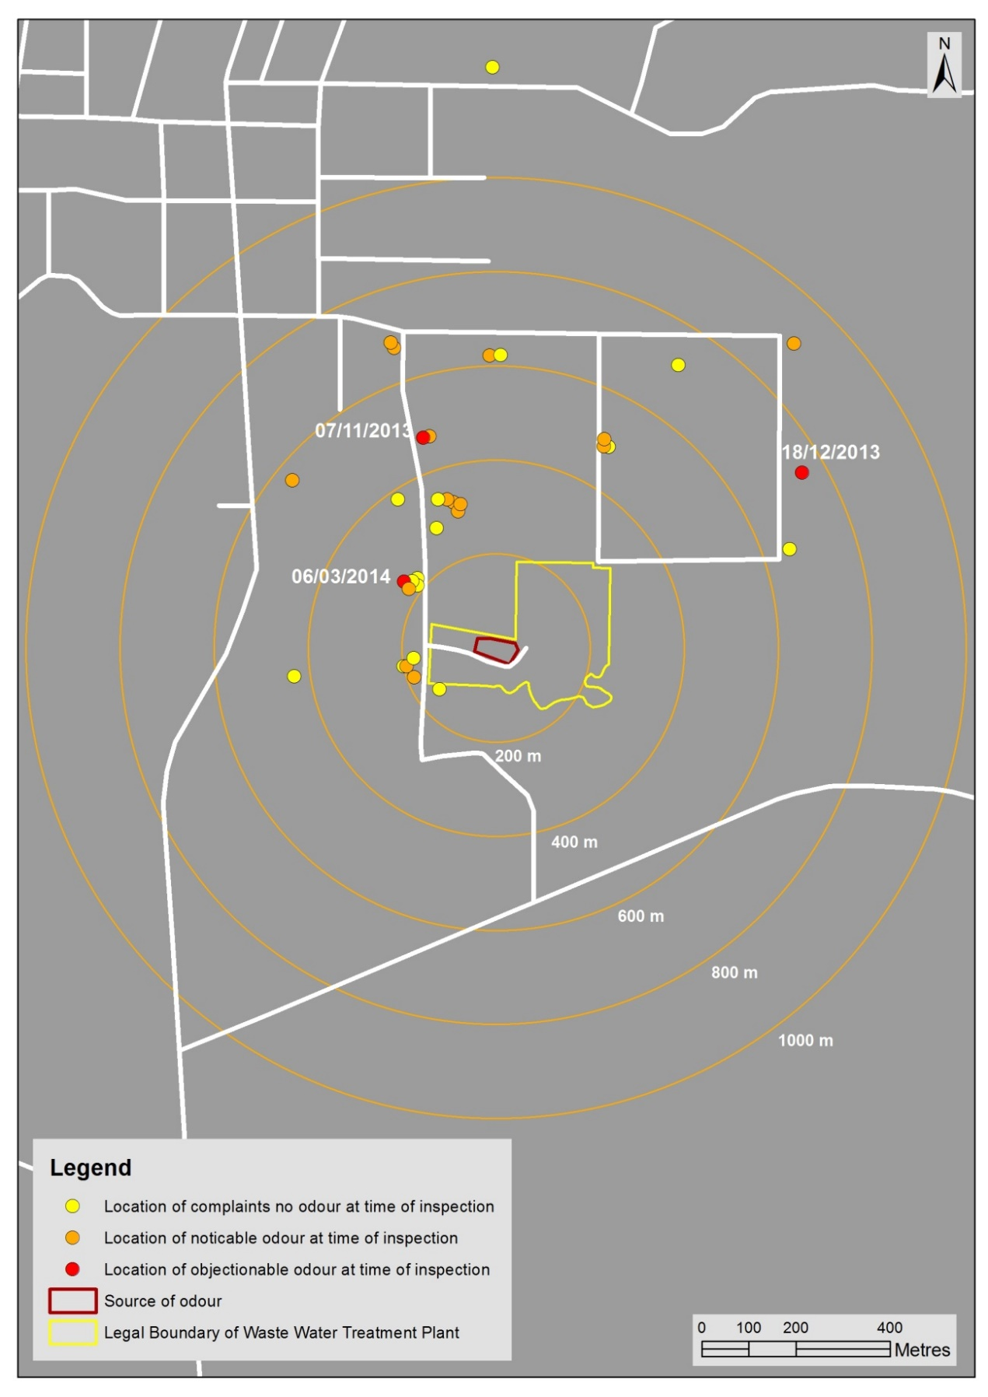

Figure 2: Example odour complaints summary

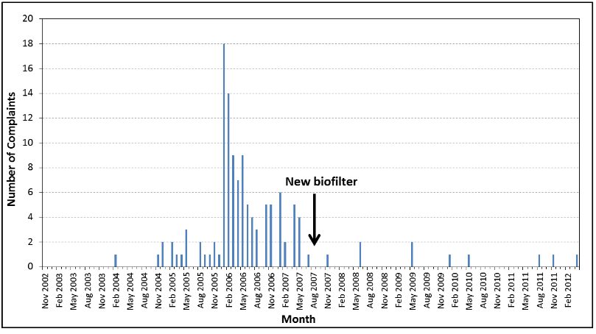

### 4.1.1 Investigating procedures for council officers and independent assessors

This section outlines good practice for investigating odour complaints. These procedures apply to both council officers and independent assessors, and additional considerations for council officers are noted where relevant.

Odour complaint investigations have two primary aims, both equally important. These are to:

1. form an objective opinion as to whether the odour is having an offensive or objectionable effect on that specific occasion, and to determine the cumulative effect, if any, of the odour
2. comprehensively document the odour assessment to assist with resolving the odour.

Council officers may also be looking to gather evidence for future prosecution, or to make decisions on resource consent applications, but in all instances consistent procedures for odour complaint investigation and reporting are critical. The recommended complaint investigation and recording procedure is provided in table 6. An example complaint investigation form is given in Appendix 3.

### 4.1.2 Adaptive management

There is an inherent difficulty in validating odour complaints. Adapative management is an iterative approach to decision-making in the face of uncertainty, with an aim to reducing uncertainty over time via system monitoring. However, a staged approach may not always work for odour management, for two primary reasons:

* it does not always provide sufficient certainty that there would be no objectionable or offensive effects from odour
* it can put heavy pressure on and relies on the co-operation of the neighbours to undertake monitoring in unreasonable circumstances.

Table 6: Complaint investigation and recording procedure

| Step | Action |
| --- | --- |
| Step 1: Receive the complaint | 1 Record the date, time and location of the complaint and the complainant’s description of the alleged odour event, including frequency (continuous or intermittent), perceived intensity (refer table 1), duration, description of the character of the odour and hedonic tone (refer table 2). If possible, record complainant’s name and their estimate of wind direction and wind speed (or just general weather conditions). |
| Step 2: Visit the location of the complaint for at least 10 minutes | 2 Record the time of arrival on investigation form (refer Appendix 3).  3 Assess and record the FIDOL factors, including intensity (refer table 1), character, frequency (continuous or intermittent), duration and hedonic tone (refer table 2) of the odour.  4 Record the wind direction and strength, and weather conditions throughout the investigation and how these were determined.  5 Determine the type of effect that the odour has from table 7, considering the location and observations recorded. Also record any other details to help in assessing level of effect, including descriptions of the pleasantness (hedonic tone), how it made the complainant and the assessor feel (eg, made me what to vomit, close windows etc) and any description of the type of odour (eg, rubbish-like, earthy, cut grass).  6 Assess the width of the odour plume by moving at right angles to the wind direction, where possible.  7 Record the time of departure from the complainant’s location. |
| Step 3: If there is an effect from odour and the source is identified | 8 Assess the odour upwind of the suspected source. Where practicable, conduct a 360o sweep around the source to eliminate other possible sources of odour.  9 Record any observations of recognisable odour at other locations surrounding the alleged source, including times of observations at each location.  10 Visit the site suspected of causing the odour and explain the findings of the investigation to site staff.  11 Confirm the site operations taking place at the time of the complaint and any other operations that may have occurred recently that may be related to the odour discharge.  12 Request an explanation for the odour discharge (if appropriate, warn that their statement may be used in evidence).  13 Record the name(s) of persons spoken to at the site and their comments.  14 Review monitoring and compliance with any consent conditions or rules in plans and take any samples, records or other evidence necessary to support any findings.  15 Investigate whether odours are from abnormal or normal operations and record evidence to support the conclusions made. |
| Step 4: Make overall assessment | 16 Make an overall assessment of adverse effects beyond the boundary, as illustrated in figure 3. |

Table 7: Assessment of odour effect

|  |  |
| --- | --- |
|  | I did not detect any odour |
|  | I did detect odour and consider it would not be objectionable at any location for any duration or frequency |
|  | I did detect odour and consider it would not be objectionable, UNLESS it became continuous |
|  | I did detect odour and consider it would be objectionable if it occurred on a regular or frequent basis |
|  | I did detect odour and consider it to be objectionable even in periods of short duration. |

Figure 3: Factors to consider when determining adverse effect from odour



When investigating a complaint it is important to complete all off-site investigations before going onto the site of the alleged odour source. This is for two reasons:

1. (All assessors): It prevents an assessor from becoming desensitised from exposure to strong odours at the source before investigating the nature of the effects in the receiving environment.
2. (Council officers): Under section 332 of the RMA, an enforcement officer can only enter a site to investigate if a breach is occurring – not to gather evidence of a confirmed contravention (this requires a search warrant).

Therefore, the recommended procedure is to do a FIDOL assessment offsite, undertake a 360 degree investigation and then enter the site to determine or confirm that the source of the odour is on the site. While not always practicable (eg, due to terrain), the 360 degree investigation is critical in areas where other sources of odour may be present.

There will be circumstances where following each step in the procedure is unnecessary. Assessors should use their judgement to decide what is appropriate to the circumstances; for example, when an odour is extremely intense, 10-minute observations may not be required to determine that an adverse effect is occurring. In a case like this, it is more important to go on site to determine the source of the odour, perhaps with an expectation that it may be able to be stopped. Departures from procedures should be documented, and the reasons stated.

Where there is an obvious shift in wind direction between the time the complaint was received and the time of the assessment, it may be more appropriate to go to the current position of the plume. If the wind is fluctuating, remain at the complainant’s location and carry out the 10-minute intensity assessment to obtain a picture of frequency and intensity as the complainant experiences it.

Measurements of plume width can help identify sections of the community that are likely to be affected, and whether complaints could be expected from elsewhere. Plume width assessment can help determine if odour is fluctuating due to plume movement or emission variation. This helps to develop a general understanding of the nature of dispersion from the odour source, and may be used to identify whether there is odour from other sources. Plume width should be assessed by moving at right angles to the wind direction through the anticipated plume of odour.

Note that where an assessment is being carried out as part of routine monitoring and there is no offensive or objectionable odour, a traverse across the wind direction is sufficient, with a note made of the direction, time and location of the inspection.

It is important that assessment of potential odour *effects* accounts for the potential for human exposure. This means that assessments should be carried out at locations close to where people are likely to be exposed (noting that this may not be immediately at the boundary of the premises).

#### Special considerations – council complaint response

Council officers (or nominated representatives) should carry out a site investigation in response to an odour complaint. Good practice is for officers to respond within 90 minutes of the complaint being made. In larger regions these response times may be impractical, and training other council staff or employing independent assessors should be considered.

It is nearly impossible to validate complaints in every instance, because odour emissions are typically highly variable with time. For example, an odour’s intensity may lessen or disappear by the time an officer arrives to investigate a complaint, irrespective of the response time. This may be due to a varying odour emission, varying wind speed or atmospheric stability, or simply the time elapsed since the odour complaint was received and when the officer makes it to the site.

Council officers should always provide a copy of their report to the site management of the alleged odour source. This allows site management to check the details of the report, note the problem and make any response necessary. Complainants often want to remain confidential, so this needs to be considered when passing information to site management. Complainants should be encouraged to be identified and reassured that complaints are a means of gathering information that can help to diagnose a problem on site.

Some councils have adopted an approach of carrying out proactive investigations. This involves visiting a site at times when odours are likely to occur, and is based on previous complaint records, weather conditions and/or time of day when odour effects are more likely to occur. This approach is particularly useful for batch processes (eg, coffee roasting, asphalt plants) and for situations where the officer has had difficulty validating complaints due to response time after a complaint is logged. Usually validation problems are due to changing weather conditions or short-duration odour events. This approach is also useful for determining whether complainants may be being vexatious (ie, meritless or an abuse of process). Some examples of proactive monitoring are given in the case studies below.

Given resource constraints, councils may need to adopt a strategic approach to responding to odour complaints. For example, it may be not be productive to repeatedly investigate complaints from a site that is in the process of upgrading. Efforts could be concentrated elsewhere until the site has completed its upgrade (refer to Appendix 1 for odour management plans). Similarly, while it may initially be resource intensive to educate a site about the importance of swiftly addressing odour complaints, ultimately it may get results with improved performance in the long term.

|  |
| --- |
| Case studies: proactive monitoring |
| In one case where the council was having difficulty validating complaints, proactive monitoring gave the council confidence to go to the parties with a case that they did not consider the odour was causing an objectionable effect. A review of this case by the Parliamentary Commissioner, the local MP, and the ombudsman resulted in the council’s position being accepted and no further action was needed, saving resources in the long run.  In another case proactive monitoring allowed the council to quickly confirm that there was a legitimate problem and the council was able to convince the discharger to take action to resolve the problem, again saving time and resources. |

Key points

Follow the complaint investigation and reporting procedure specified in table 6 to investigate reported odour complaints.

Complete all beyond-the-boundary observations before going on to the site of the odour source.

### 4.1.3 Investigating procedures for site workers

Where the site has a resource consent to discharge contaminants to air, good practice is for a condition of the consent to require records of odour complaints be kept, and to investigate and report any odour complaints received. This can be particularly useful if council officers are unable to respond quickly or complaints come directly to site staff. Similarly, odour management plans often require site personnel to undertake routine odour monitoring and/or ad hoc proactive odour investigations.

In all cases, odour investigations by the site workers should generally follow the same approach as outlined in table 6. While site staff should still objectively determine whether an adverse effect is occurring, their additional driver is often be to undertake a course of action to remedy any identified problem(s).

In responding to odour complaints, site workers need to be keenly aware of potential desensitisation because they work at the site in question. Where feasible, site workers investigating odour complaints should not be working regularly in close proximity to odour sources. Site workers should also:

* undertake a 360 degree assessment before visiting the complainant
* be prompt and courteous when talking to the public
* take complaints seriously
* keep in mind that odour effects are perception based; people’s perceptions may be different, but are equally valid
* understand that acute odour effects can be very difficult to validate (depending on the vagaries of the wind).

Key points

Where practicable, assessors should complete all beyond-the-boundary observations before going on to the site of the odour source.

Consent holders should:

* take complaints seriously and respond promptly and courteously
* keep records of odour complaints
* follow the procedures outlined in table 6 when investigating a complaint or undertaking routine monitoring.

### 4.1.4 Vexatious complaints

Councils have a duty under section 35(5)(i) of the RMA to record a summary of all written complaints received of alleged breaches of the RMA, and details of how the complaint was dealt with. Given the potential seriousness of adverse effects from odour (as outlined in section 2.3), complaints should be taken seriously and responded to as promptly as possible.

Vexatious complaints are complaints that are:

* frivolous, meritless, or otherwise made without sufficient grounds, or
* made for an improper or illegitimate purpose or made as an abuse of process, ie, solely to harass, obstruct, cause financial burdern, or annoy.

Vexatious complaints can be extraordinarily difficult for councils to address, and can be made more difficult by the intense emotional responses evoked by offensive and objectionable odours.

If feasible, good practice is to adopt the approach used by district health boards and designate a member of staff as the point of contact to establish a relationship with the complainant. This can defuse tensions and prevent ‘cherry picking’ amongst officers by the complainant.

However, councils (or even district health boards) may not have sufficient resources to implement this approach.

|  |
| --- |
| Case study: Wellington Regional Council’s reduced response protocol |
| In 2010, the Wellington Regional Council developed a ‘reduced response protocol’ for addressing repeated failures in complainants’ expectations. This follows a staged approach using communication guidelines established by the Environmental Risk Management Authority (now the Environmental Protection Authority) with respect to 1080. Potentially vexatious complainants are identified as follows:  A notifier will be considered a candidate for reduced response if it is identified through their patterns of reporting incidents to the Environmental Regulation Department, that they have expectations of our response service which exceed our jurisdiction under the Resource Management Act 1991 (RMA), or if repeated responses determine that there is no cause for concern in terms of environmental effects.  The protocol allows officers to scale down their response to incidents of a certain type from a particular caller. The response team may request that a notifier sends all incidents to council in writing and to notify council if any new information is available regarding their health or environmental effects, so that further assistance may be provided.[9] |

Appendix 4 outlines how to identify and establish that it is appropriate to apply the protocol to a notifier. If you require further information contact Greater Wellington Regional Council.

## 4.2 Odour surveys

Odour surveys are useful for assessing odours from existing facilities. Three tools are discussed here:

* odour annoyance surveys
* odour diaries
* community meetings.

These methods can be adapted to or supplemented by the use of social media (eg, the use of Facebook, Twitter, etc), but the principles remain the same. All forms of social engagement have some limitations and will miss some sections of the population (eg, communication by email or Facebook will miss non-users, community meetings at night may miss shift workers). Remember these limitations when engaging with the community, particularly when assessing acute or chronic effects of odours.

### 4.2.1 Odour annoyance surveys

Odour surveys typically measure ‘population annoyance’ due to all sources of odour. As such, odour surveys directly measure the extent of adverse effects resulting from repeated odour impacts in a community.

The results can be used to rank odour sources by their contribution to cumulative stress in a community. Odour surveys are limited as they are only useful in areas where there is sufficient population density to achieve statistically significant results. In low population areas, therefore, odour diaries, questionnaires and complaint records are recommended instead.

The steps when undertaking an odour survey are as follows.

1. Identify sub-areas within the community to be surveyed by reviewing historical complaint records and wind data.

Within each sub-area, the population should be exposed to a similar amount of odour, considering distance from the source and prevailing winds. If the sub-area is too large, exposure will vary too much among the group and there will be a wide range of responses that may dilute the results from the affected area with those unaffected. The survey areas should be agreed in consultation with council air quality staff.

2. Select the population size for the survey.

A minimum target of 50–70 respondents from any one sub-group of the community provides a margin of error for the survey in the order of 5–10 per cent.

3. Conduct the survey using either survey method outlined in *Project Field - Comparison of Two Methods for Odour Annoyance Surveying* (Beca Infrastructure, 2008).[10]

This may be done by telephone or by door knocking. When surveying by telephone, randomly select phone numbers from a number listing for the area being surveyed. It is usually necessary to obtain three times the number of phone numbers as the sample size. Phone numbers can be purchased from Spark to order, or for a small township can be obtained by scanning the phone directory. Consider conducting the survey during a two-hour period in one evening. This prevents people in the neighbourhood talking about the survey, which may skew the results. It will prevent the inclusion of work places, however.

4. Calculate the percentage of people who were ‘annoyed’ by odour for each sub-area.

Where there are multiple sources, break the survey results down according to the main source(s) identified by respondents.

5. Compare the survey results to those for a control population.

6. Calculate survey margins of error using statistical methods as described by McCullagh and Nelder (1983) or by Perry and Green (1984).

Control data should be gathered by surveying, in parallel with the affected population, a population that is not affected by any significant odour. The control population should have similar demographics and culture to the affected population being surveyed and similar exposure to any background odours, such as mudflats or geothermal odours.

The same survey method employed to survey annoyance around the target population must be used for the control population (particularly if using historical survey data). Historical control surveys are available from the following councils:

* Auckland Council
* Waikato Regional Council
* Bay of Plenty Regional Council.

Historical control surveys in New Zealand have shown that a fraction of the community can report some annoyance due to industrial odours, even when there are no significant industrial odours. However, this fraction can vary from only 1% up to 20% depending on, *inter alia*, the survey method used and the presence or otherwise of industrial odours (see for example, Emission Impossible Ltd, 2011 and Aurora Environmental, 2000).

To draw meaningful conclusions it is essential that a control population survey be used to distinguish the true level of per cent annoyed (due to odours discharged from the target site) from background.

Key points

Odour annoyance surveys should only be conducted in areas where there is sufficient population density to achieve statistically significant results.

Target and control populations should be identified in consultation with council air quality staff.

Odour impacts can only be established with reference to a control population.

### 4.2.2 Odour questionnaires

In circumstances where there is insufficient population for a full population annoyance survey, it may be possible to gather useful information on the FIDOL factors from a smaller group of residents using a questionnaire via letter drop, with questions such as:

* How often do you notice an odour?
* Is there a particular time of day, time of year or weather conditions when you think that odour is more noticeable?
* When you notice an odour, how strong is it normally? (provide intensity scale in table 1)
* Could you describe the character of the smell? (provide descriptors)
* How would you describe your overall feelings about the odour from the site?

### 4.2.3 Odour diaries

Odour diaries are used by people in affected communities to record their daily exposure to odour. Diaries can be useful for determining particular conditions under which people are affected by odour from a particular source or sources. When considered with the FIDOL factors, they can also help determine the overall level of adverse effect that is occurring from the odour. Odour diaries generally need to be completed for at least three to four months to provide meaningful information.[11]

Fatigue is a major obstacle in completing a diary for anything other than a very short time and frequent contact and encouragement should be given. Careful consideration should be given to the purpose of the diary, what subsequent analysis will be undertaken, how long analysis will take, and what resources are available for analysis. Diaries should not be used to simply stop a person calling the council.

An example of an odour diary record sheet is provided in Appendix 5.

A diary programme can be useful for collecting data on the frequency and strength of odour impacts at various locations over a given period. The resulting data can be used to calculate the percentage of time (hours/year) that people are exposed to odours from a specific source, as well as the typical strength and character of the impacts. The information recorded in a comprehensive diary programme includes:

* date and time of day
* duration of the event
* continuity of the odour during the event
* character and strength of odour
* likely source of odour
* wind direction and strength.

Dischargers should give diarists instructions on how to record information so it is as consistent as possible. Diarists should also be given feedback on the programme as a courtesy in return for their efforts. Information such as when diarists were absent from the location is also helpful.

A less comprehensive diary programme may be sufficient. For example, diaries can be useful to investigate whether an odour source is still creating some impacts in a community following some improvement in odour control, such as in the case study below.

|  |
| --- |
| Case Study: Meat processing plant odour diary programme |
| A diary programme was used as a monitoring tool for odour at a meat processing plant in a large North Island town. The plant has a large rendering facility, with a history of odour problems. The firm undertook substantial upgrades to its extraction and odour treatment system in 1998, and wanted to establish whether the new system was effective in eliminating rendering plant odours.  The firm had undertaken an odour annoyance survey during 1997 to establish the extent of adverse effects on the neighbouring community. An odour diary programme was considered an appropriate tool for the second study in 1998, because a further survey could be affected by a lag between the reduced odour levels and any decrease in the level of annoyance measured in the community. A diary programme was used to establish if rendering odours were still occurring as a result of the firm’s activity, bearing in mind there were other sources of industrial and commercial odour present in the community.  Five residential properties downwind of the rendering plant were used for the programme. Consultation with the community liaison group (which had existed for a number of years) helped to select diarists.  Six months of diary records were used, along with plant operating status and wind records, which confirmed that the predominant rendering odours had been eliminated. The results also helped identify other sources of odour within the community and their relative significance. |

### 4.2.4 Community meetings

Community meetings are sometimes used to gauge the extent of any dissatisfaction due to exposure to odours. Holding an open public meeting is generally a first step, and meeting attendees may establish a community liaison sub-group from the meeting. This group can be used as a forum to negotiate solutions and to provide direct and ongoing community input on odour issues. The community should decide membership of the liaison sub-group in a democratic and transparent manner. It must be noted that the views of the group are only indicative of those in the wider community, and other tools such as newsletters may be useful to ensure the wider community is kept informed on an ongoing basis.

In situations where there are only one or two complainants, open public meetings can be used to see whether there is a more widespread problem. This can indicate whether complainants may be vexatious, or are particularly sensitive; that is, not representative of the ‘ordinary reasonable person’, a common law concept.

Community consultation is useful to investigate whether people consider that any odours are of an acceptable level. Sometimes concerns are raised during consultation such as at the consent renewal time, even though there have been no formal complaints made. Ongoing, honest and transparent dialogue between odour producers and potentially affected communities is recommended to allow dischargers to deal with issues as they arise. This can prevent ill feelings building up in the community.

Community liaison groups normally include:

* management and engineering staff from the site producing the odour
* members of the local community
* council officers.

An independent mediator/chairperson may chair the group meetings. Normal meeting rules and standard procedures should be followed to ensure meetings run smoothly. Minutes, and matters arising from the minutes, should be recorded and discussed.

Further guidance on running community consultation can be found on the [Quality Planning website](http://www.qp.org.nz/).

Key points

Community meetings and liaison groups can provide a useful forum to provide community input into odour issues.

Community liaison groups should include management and engineering staff from the site, members of the local community, and council officers.

## 4.3 Measuring odour

Odour can be measured in a number of ways. Electronic noses are used by the food, beverage and perfume industries, however, these are less sensitive than the human nose. They cannot match the reliability, sensitivity and all-important perceptiveness of a trained odour scout undertaking an investigation in accordance with the procedures outlined in section 4.1.

The ‘nasal ranger’, also known as a ‘scentometer’ or ‘odour scope’ has been promoted as a mobile olfactometry device that can be used to measure ambient concentrations of odour. There is limited support for their use in New Zealand to date.

The only method of quantifying odour that is robust and repeatable (within approximately ±25%) is olfactometry. This is a laboratory-based method that can be used to determine the concentration of odour in a sample, which is then used to determine odour emission rates from an odour source (rather than ambient concentrations). Measurement of odour using olfactometry is discussed further below. Odour emission rate measurement is discsussed further in Section 4.4.1 and is illustrated in photos 1, 2 and 3.

### 4.3.1 Olfactometry

Odour emissions can be measured in odour units (OU) using dynamic dilution olfactometry (DDO). DDO is a laboratory measurement of the concentration of an odour. The method uses a panel of observers to identify whether an odour is present through sniffing ports.

The concentration of the odour is determined by using odour-free air to dilute the sample to a level where 50 per cent of a panel of people smelling the odour can just detect it. This point is given the concentration of 1 OU and the number of dilutions required to reach 1 OU determines the original concentration of the sample. The concentration of odour in air, as measured by DDO, is expressed as the number of odour units per cubic metre (OU/m3). These data can then be used as an input into atmospheric dispersion modelling to predict downwind odour effects, for comparison against odour modelling guidelines (see section 4.4).

The recommended method for DDO in *New Zealand is AS/NZS 4323.3:2001 Stationary Source Emissions – Determination of Odour Concentration by Dynamic Olfactometry*.[12]

DDO in Australasia and Europe was only standardised around the turn of this century. Variabilities in measurement methods before standardisation means earlier published data are not necessarily comparable to the current measurements. This has implications for published odour thresholds, because there are differences in the way measurements are reported.

This guide recommends that, where practicable, any historical odour concentration data used for assessment purposes should be supported by experimentally determined relationships between the methodology used and that of AS/NZS 4323.3:2001. As a minimum, a discussion of the implications of differing measurement methods should be provided.

Primary literature refers to the ‘detection threshold’ of a compound as the lowest concentration of that compound that can just be detected by a certain percentage of the population. Primary literature also refers to the certainty or ‘recognition threshold’ as the lowest concentration of a compound that can be recognised with certainty as having a characteristic odour quality. In general, recognition thresholds are higher than the detection threshold. Recognition thresholds are not widely used in New Zealand.

When measuring using AS/NZS 4323.3:2001, however, the detection threshold is the point where the panel registers a positive and sure response to the presence of an odour (when compared with clean air). This is above the point where the panel may detect an odour but be unsure (inkling response), but will be well below the point where the odour may be recognised. The panel detection threshold as measured under AS/NZS 4323.3:2001 is therefore:

The highest dilution factor at which the sample has a probability of 0.5 of eliciting with certainty, the correct perception that an odour is present.[13]

As such, AS/NZS 4323.3:2001 is more like a certainty threshold than a detection threshold as those terms are used in the primary literature.

### 4.3.2 Odour thresholds

When using odour threshold data, it is important to understand and be clear about which type of threshold is being reported. It is recommended that the lowest reported detection thresholds are used when referencing olfactometry results for individual compounds from the primary literature.

The recommended odour threshold publication is the American Industrial Hygiene Association’s 2013 *Odour Thresholds for Chemicals with Established Occupational Health Standards, 2nd edition* (American Industrial Hygiene Association, 2013).

This is an excellent compendium of published threshold values. It is based on data collected from a wide variety of countries and disciplines, and encompasses a century of research.

The previous (1989) edition summarised the result of a technical critique of primary odour threshold literature references and presented the best estimate of odour thresholds for 182 chemicals that had experimental data satisfying the evaluation criteria. The updated 2013 edition is for 295 odorous chemicals. It includes a methods review for those articles published after 1989 that could be acquired, but these references were not critiqued as the authors chose to report all of the data available and recommend the use of the lowest value when needed. This reflects improvements in odour detection methodologies and recent research that indicates that human odour thresholds can be highly reliable, reproducible and with low variance if important parameters are controlled.[14] In light of this, the American Industrial Hygiene Association generalised that the most accurate estimate of a chemical’s odour detection threshold would tend to be the lowest concentration reported using good methodology.

Despite its usefulness, the American Industrial Hygiene Association compendium is by no means exhaustive. Other useful references include:

* INCHEM – [Chemical safety information from intergovernmental organisations](http://www.inchem.org/)
* OEHHA – [California Office of Environmental Hazard Assessment](http://oehha.ca.gov/air)
* [European Commission](http://ec.europa.eu)
* NOAA – [US National Oceanic and Atmospheric Administration CAMEO Chemicals](http://cameochemicals.noaa.gov/)
* NIH – [US National Institute of Health HAZ-MAP](http://hazmap.nlm.nih.gov/index.php)
* Ruth J. 1986. “Odour Thresholds and Irritation Levels of Several Chemical Substances: A Review”. *American Industrial Hygiene Association Journal* 47 March (A-142) A-151.

Key points

Refer to the 2013 American Industrial Hygiene Association compendium of odour thresholds in the first instance.

The lowest reported detection thresholds should be used when referencing olfactometry results for individual compounds from the primary literature.

Understand and be clear about which type of threshold is being reported when using odour threshold data.

#### Odour thresholds for assessment of odour

Published odour thresholds may provide some indication (as a lower bound only) of the likely level of a specific chemical (ie, if you can smell it then it is likely at least xx µg/m3). Unfortunately, this is an inherently limited approach because:

* almost all odours are a complex mixture of chemicals
* some chemicals smell the same, so one or both may be present
* most compounds must be present at significantly higher levels than their odour threshold (which is determined in a laboratory with reference against odour-free air) to be detected in ambient air. This means that the chemical being detected is likely present at significantly higher concentrations than the published odour threshold.

In the absence of any chemical analysis or DDO measurement, however, published odour thresholds may provide some useful contextual information.

Photo 1: Source monitoring of odour from a biofilter for subsequent analysis by DDO

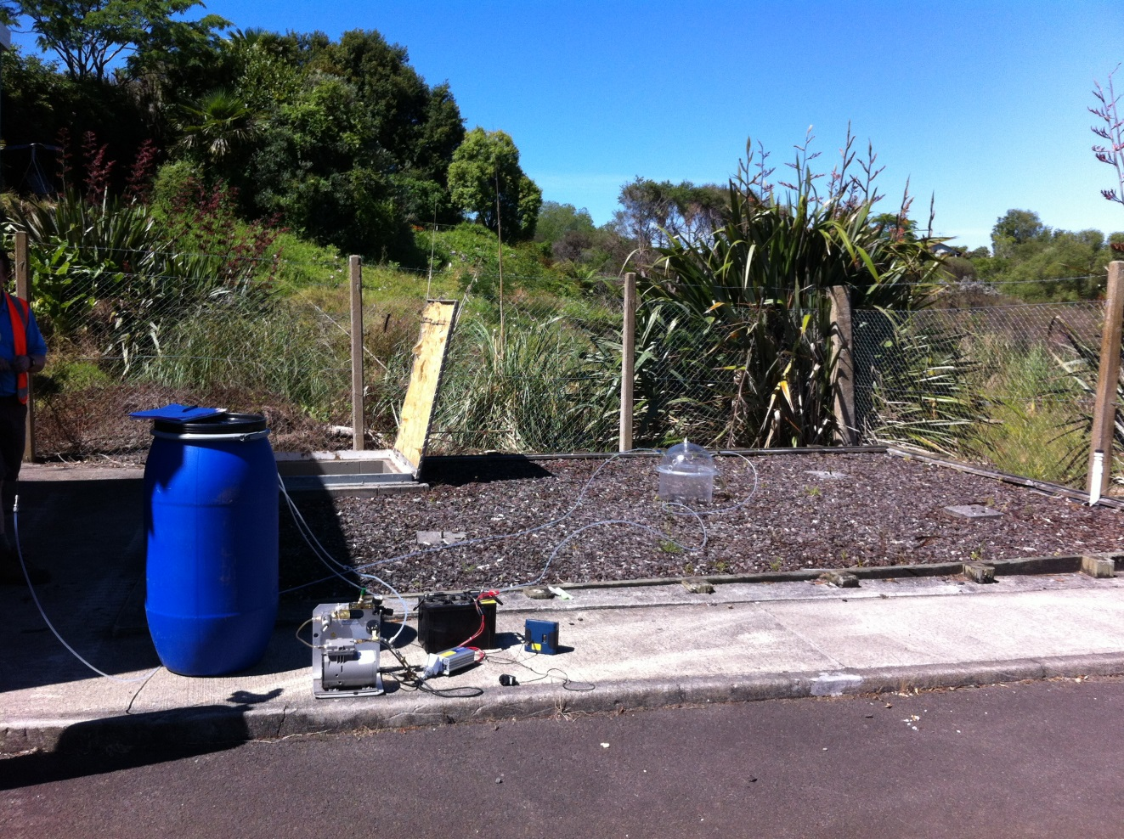

Source: Louise Wickham, Emission Impossible Ltd

Photo 2: Source monitoring of odour from a wastewater treatment tank for subsequent analysis by DDO

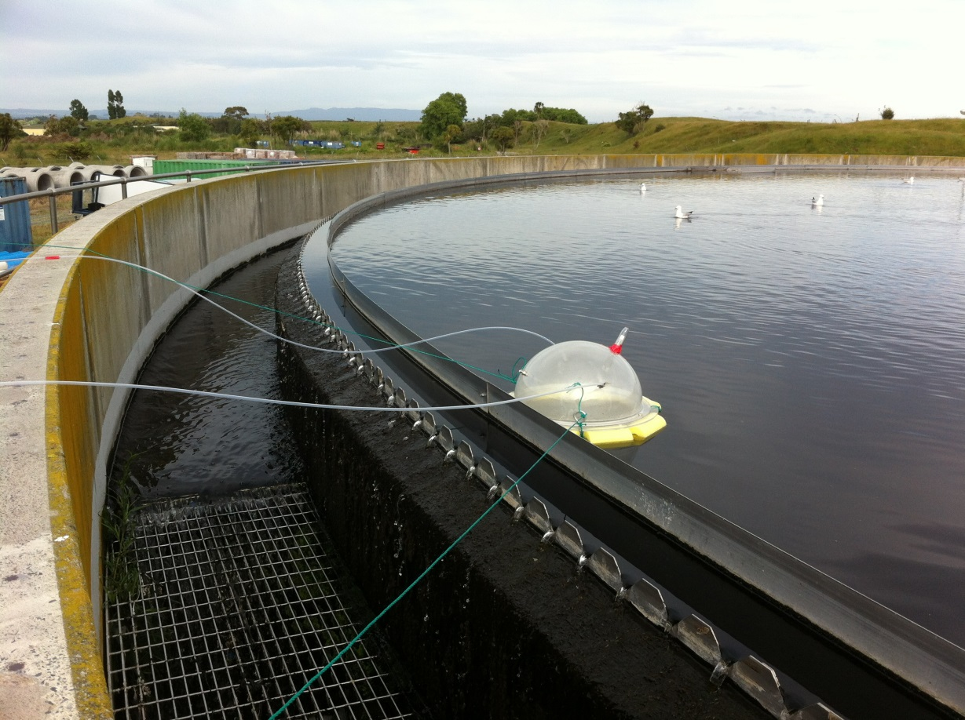

Source: Louise Wickham, Emission Impossible Ltd

Photo 3: Source monitoring for odour and subsequent analysis by DDO

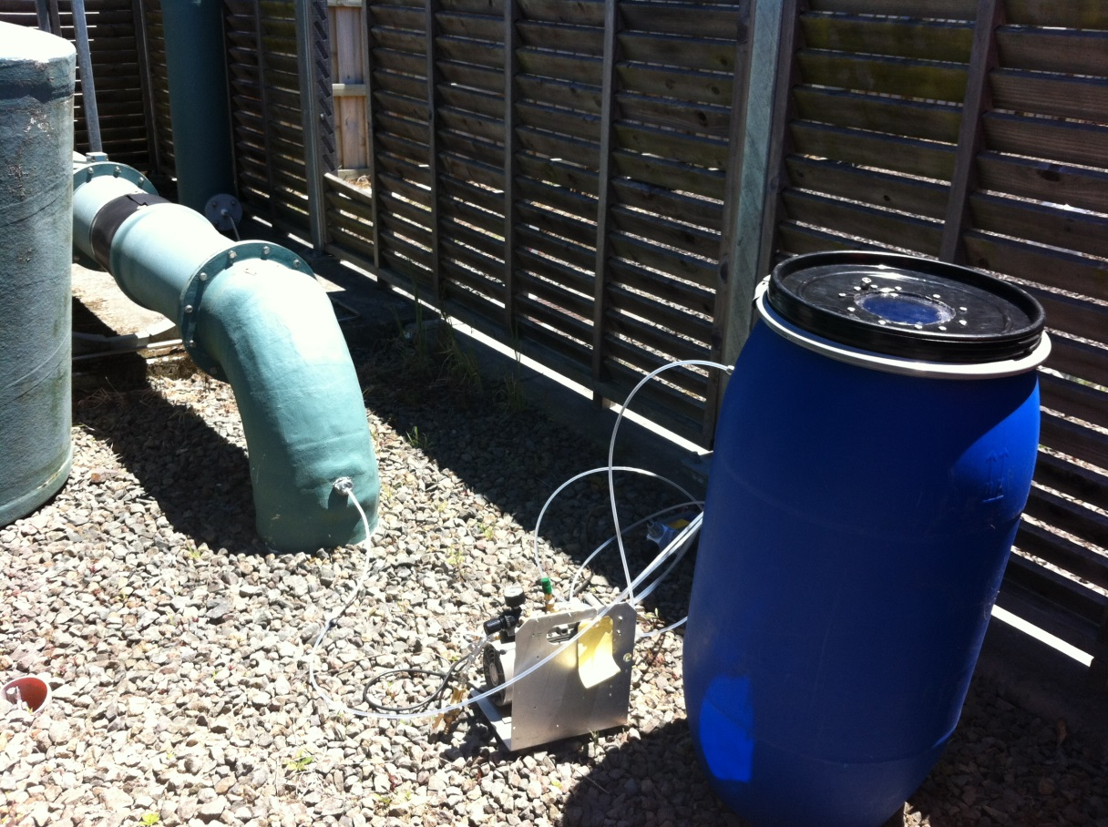

Source: Louise Wickham, Emission Impossible Ltd

### 4.3.3 Intensity versus concentration

The Queensland Environmental Protection Agency has published an odour intensity guideline (Queensland Environmental Protection Agency, 2013) based on the logarithmic correlation between intensity and odour concentration, as described mathematically in section 2.2.

The method requires an odour intensity study to determine the relationship between odour concentration and odour intensity to specify the odour concentration equivalent to the intensity level of ‘weak’ (I = 2 on intensity scale in table 1). Queensland EPA requires the proponent then undertake dispersion modelling to compare results with published criteria.

This approach requires a considerable amount of work by a proponent or industry group to establish the intensity versus concentration relationships for a particular odour type. Queensland EPA is confident that the necessary research has been undertaken for the intensive chicken growing industry in Australia. It is primarily applicable to new facilities, for which odour modelling will be used to assess potential downwind impacts.

With exception of intensive poultry farming – where it may be appropriate – this approach is not generally recommended for application in New Zealand. You should refer to the Queensland guidance for further information.

### 4.3.4 Nose calibration

Nose calibration uses DDO to determine where on the distribution curve a person’s sense of smell sits in comparison with a normal population. The procedure for individual calibration is described in AS/NZS 4323.3. It is typically carried out with comparison against n-butanol as a reference. Results are considered satisfactory (ie, an individual fits within the normal distribution curve and is neither overly sensitive nor has no appreciable sense of smell) if the individual threshold estimate is between 20 and 80 ppb (n-butanol) and variability (standard deviation) is less than 2.3. AS 4323.3 indicates that individuals should be screened in sessions spread over a number of days, with rest days in between sessions.

Nose calibration is an essential quality control measure for panellists performing DDO in the laboratory.

The usefulness of calibration for individual field assessors is debateable. It is not typically practicable for nose calibration to be repeated immediately before each investigation. Therefore, nose calibration is not a mandatory requirement for complaint investigators or people undertaking routine monitoring. Individual sensitivity can vary significantly on a daily basis (ie, people’s results vary markedly in between testing rounds) but this will not be reflected in field staff undergoing calibration on only one day. Numerous studies have observed a decrease in the ability to detect odours as age increases (children have lower odour thresholds than adults). This would only be picked up, however, if field assessors were calibrated repeatedly. Repeated, regular nose calibration can be expensive, particularly for field staff located outside Auckland (the location of New Zealand’s only current accredited DDO laboratory).

It is good practice is to use more than one person (even if only periodically) to undertake odour assessments to account for variability in individual sensitivity.

## 4.4 Assessing odour by dispersion modelling

Odour dispersion modelling predicts the concentration of an odour downwind of the source using a computer programme. Modelling inputs include:

* characteristics of the discharge
* local terrain characteristics
* meteorological conditions
* location of people and environments downwind who may be impacted
* (most importantly) odour emission rates.

Odour dispersion modelling is often used to predict the potential effects of a new odour-emitting activity.

This section briefly covers the key issues and limitations of odour modelling methods and uses, and highlights some things to watch out for when preparing or auditing an assessment of odour effects based on dispersion modelling. Detailed guidance on general dispersion modelling is provided in the [*Good Practice Guide for Atmospheric Dispersion Modelling*](http://www.mfe.govt.nz/publications/air/good-practice-guide-atmospheric-dispersion-modelling)(Ministry for the Environment, 2004). It is important to recognise that odour modelling is a complex technique, and those carrying it out should be appropriately trained.

Dispersion modelling of odour emissions should generally only be used where the emission sources can be quantified, and where the discharge is continuous or semi-continuous. In other words, modelling should only be applied to discharges with potential chronic odour effects, rather than acute odour effects as may occur from abnormal operations.

### 4.4.1 Odour emission rate measurement

Dispersion modelling requires odour emission rate estimates. Both the concentration and the volumetric flow of the emission must be measured to estimate the odour emission rate. For a point source, the odour emission rate is expressed as odour units per second (OU/s) and for area sources the rate is expressed per unit area per second (OU/m2/s).

It is often difficult to determine odour emission rates for diffuse or fugitive sources of odour and/or where the flow rate is low, because it is hard to estimate the discharge flow rate and the limit of detection for DDO measurement is relatively high. In such cases, dispersion modelling is not recommended (see a cautionary note for dispersion modelling for further examples).

It is not appropriate to determine odour emission rates for the purposes of dispersion modelling from published odour thresholds. This is because of the inherent limitations of this approach, outlined in section 4.3.1.

Key point

Odour emission rates should be measured using dynamic dilution olfactometry carried out in accordance with the joint Australian/New Zealand standard AS/NZS 4323.3:2001 *Stationary Source Emissions – Determination of Odour Concentration by Dynamic Olfactometry*.

### 4.4.2 Model applicability versus community feedback

Atmospheric dispersion modelling predictions should be given less weight than community feedback on odour effects. In particular, if sufficient community data is available to demonstrate that there is an odour problem, then that data should carry more weight than odour modelling.

Dispersion models may be helpful to diagnostically identify sources of odour from existing activities that are contributing to off-site effects. Models allow individual sources of odour to be ‘switched off’ to investigate the contribution of the remaining sources to the overall odour impact, and help to identify which sources should be controlled and to what level.

### 4.4.3 Multiple sources and background odour

For dispersion model scenarios with one or two sources, the maximum measured emission rate from each source is typically used for dispersion calculations. For multiple sources, however, this may result in overly conservative and unrealistic results. To prevent this, assessors should consider whether the different sources are likely to be additive, or if one is likely to mask others when more than one is present. Average emission rates are sometimes preferred for multiple sources when not all the sources discharge at the peak rate at the same time. The assessors must understand the emission characteristics of the processes they are modelling, and if peak emissions are likely to coincide, these scenarios should be accounted for in the model set-up.

The effect of background odours and multiple sources should be considered on a case-by-case basis. If the odour being modelled is quite different to, or much stronger than, any background odour (eg, a strong odour from a chemical manufacturing plant in a rural area), then background odour should probably not be included in the model but considered subjectively in terms of its potential influence.

### 4.4.4 Odour-modelling guideline values

Dispersion model outputs in odour units per cubic metre (OU/m3) can be compared to odour-modelling guideline values to estimate whether, and where, offensive or objectionable effects are likely to occur. The comparison should take into account the odour character and sensitivity of the proposed receiving environment as described in the relevant district plan or as a default in table 4.

The recommended odour-modelling guideline values are summarised in table 9. Other values can be used on a case-by-case basis where they are justified for specific odour sources and the work has been adequately peer reviewed.

Note that:

* atmospheric stability has been accounted for in high-sensitivity receiving environments (stability refers to the degree of mixing that occurs)
* odour concentration percentiles were developed from dose/effect-based research correlating modelled concentrations with population annoyance.; readers are referred to the [*Review of Odour Management in New Zealand: Technical Report*](http://www.mfe.govt.nz/publications/air/review-odour-management-new-zealand-technical-report) (Ministry for the Environment, 2002)
* the concentration components in the table already include the peak-to-mean ratio adjustment for all source types, and should be used as design ground-level concentrations for one-hour modelling averages
* the guideline values are most applicable to odours of an unpleasant character. Odours which are less offensive in character (eg, odours from food processing) may not be found as offensive in practice even if predicted to exceed the guideline values.

Table 9: Recommended odour-modelling guideline values

|  |  |  |
| --- | --- | --- |
| Sensitivity of the receiving environment | Concentration | Percentile |
| **High**  (worst-case impacts during unstable to semi-unstable conditions) | 1 OU/m3 | 0.1% and 0.5% |
| **High**  (worst-case impacts during neutral to stable conditions) | 2 OU/m3 | 0.1% and 0.5% |
| **Moderate**  (all conditions) | 5 OU/m3 | 0.1% and 0.5% |
| **Low**  (all conditions) | 5–10 OU/m3 | 0.5% |

Two approaches were used to develop these odour modelling guideline values for New Zealand:

* the annoyance threshold method
* the dose–response method.

The former is more theoretically based, while the latter is empirically based using odour surveys. More detailed information on how surveys can be used to define guideline values and the rationale behind the recommended guideline values is provided in Chapter 9 of the *Review of Odour Management in New Zealand: Technical Report* (Ministry for the Environment, 2002).

Key points

The guideline values in table 9 should be used when considering the sensitivity of the receiving environment to assess modelling results and to determine whether the odour is likely to cause an adverse effect.

The guidelines should be treated as design ground-level concentrations for one-hour modelling averages, as they already include the peak-to-mean ratio adjustment for all source types.

### 4.4.5 Model interpretation and limitations

Odour-modelling guideline values should not be interpreted as a ‘pass or fail’ test. The evaluation of the potential for offensive or objectionable effects must be on the basis of probability. The conservatism in the model predictions should be considered. Factors influencing the level of conservatism include:

* odour emission rate data
* land use and activities where guideline exceedances are predicted to occur
* model assumptions
* meteorological data file used.

A number of serious limitations are inherent in dispersion modelling of odours as outlined here. Depending on the level of conservatism, predicted guideline value breaches do not necessarily mean that adverse odour effects will occur. Likewise, being within the guideline value does not mean there will be no adverse effects.

The model assumes that the wind direction remains constant throughout the hour, but wind directions can fluctuate within an hour. This means that predictions during unstable conditions are much less reliable. The model also assumes that the rate of odour emission from each source is constant from hour-to-hour, but the emission rate will vary over time.

Factors called peak-to-mean ratios are applied to models to help account for the short-term peaks versus the hourly average model outputs, but the science is uncertain. Using annoyance surveys (odour dose–response studies) to calibrate the model accounts for many of the limitations inherent in the theoretical approach to developing guidelines.

Odour modelling can further be limited in its application due to:

* variability in odour emission rates, which may not be adequately characterised by ‘one-off’ odour measurements
* lack of a meteorological data set representing local conditions
* odours being not simply additive in their effect – there are complex masking and synergistic effects that vary for each mixture of odorants
* the fact that intensity of odour does not vary linearly with concentration.

Model results should therefore be just one of the indicators of the potential for adverse effects, and other tools should be used in conjunction with modelling when assessing potential effects.

Key points

Odour-modelling guideline values should not be interpreted as a ‘pass or fail’ test. Predicted guideline value breaches do not necessarily mean that adverse odour effects will occur. Likewise, being within the guideline value does not mean there will be no adverse effects.

Modelling is best applied to situations where the odour emission rate can be measured and where the odour emissions are reasonably constant, causing potential chronic effects.

If sufficient community data are available to demonstrate that there is an odour problem, odour modelling should not be used to try to argue the contrary.

# 5 Odour management and control

Odour is an effect of an individual’s perception. The first step to successfully managing odour, therefore, is to build a positive relationship with the community experiencing the odour effects. In doing so, the importance and benefits of open, honest communication cannot be overstated.

The following sections detail how regulators and industry can manage and control the effects of odour. Figure 4 outlines how abatement can help mitigate or remedy adverse odour effects downwind.

Figure 4: Industry/odour treatment schematic example: sewage treatment plant

**< 5 OU**

**At plume touchdown**

Final dilution

Discharge

**Stage  
1**

**Stage   
2**

Odour collection

**eg,  
 11,000 OU**

**eg,  
 600–1,000 OU**

**eg,   
< 200 OU**

Odour treatment

Distance  
to neighbours

**Process odour source**

**Stack dilution  
eg, 200–400 times or more**



Source: Ken Holyoake, Armatec Environmental Ltd

## 5.1 Management options for regulators

Regulators manage odour emissions through policies and rules in regional and district plans. The rules typically specify those discharges that are permitted (usually subject to certain conditions), and those that require a resource consent. Monitoring and responses to odour complaints also play a significant role in managing potential odour impacts of existing activities. The options available to regulators are largely provided under the Resource Management Act 1991 (RMA), as discussed in section 1.3. Resource consents may be granted subject to conditions.

### 5.1.1 Internalisation of odour effects

In the first instance, the principle of ‘internalisation’ states that those who create adverse effects must confine them within their own sites rather than force society to bear the burden of dealing with them. This principle has its origins in common law associated with property rights and nuisances. While case law is evolving, and practitioners should seek to apply the latest development in law, seven general principles have developed from High Court decisions[15] for considering how to mitigate odour effects:

(i) In every case activities should internalise their effects unless it is shown that they cannot do so.

(ii) There is a greater expectation of internalisation of effects of newly established activities than of older activities.

(iii) Having done all that is reasonably achievable, total internalisation of effects within the site boundary will not be feasible in all cases and there is no requirement in the RMA that that must be achieved.

(iv) That the test for odour is objective (ie, reasonable person test).

(v) That there is a duty to internalise adverse effects as much as reasonably possible.

(vi) That it is accepted that in respect of odour the concern is to ensure that odour levels beyond the boundary are not unreasonable (being the same as offensive or objectionable or significant adverse effects).

(viii) That in assessing what is reasonable one must look into the context of the environment into which the odour is being introduced as well as the planning and other provisions (location).

### 5.1.2 Separation distances

Separation distances (buffers) are primarily intended to manage any:

* effects of unintended or accidental discharges
* adverse effects of activities that cannot always be adequately avoided, remedied or mitigated without a separation distance, even with the adoption of best practice (eg, landfills)
* reverse sensitivity effects (see section 3.3.4).

Separation distances are not intended as an alternative to source control. Instead they are implemented in addition to pollution controls that are consistent with the best practicable option.

Maintenance of appropriate separation distances is primarily a land-use planning issue that is managed through district plan provisions, which may include:

* appropriate location of industry within an area that is zoned for industry in the district plan and is adequately separated from more sensitive zones, with provisions to exclude sensitive activities from the buffer area
* graduated zoning from heavy industry through to light industry and finally to highly sensitive land uses such as residential. Councils have to balance this against making sure that the availability of industrially zoned land is not eroded over time
* creation of zones and zone provisions (or other planning provisions such as overlays) that alert prospective owners, developers and decision-makers to the potential for reverse sensitivity effects if new sensitive activities are established in particular locations.

Regional and district plans can also include buffer distances to determine activity status   
(eg, the Auckland Operative Air, Land and Water Plan specifies new poultry farms with more than 180,000 birds and a buffer distance of less than 400 metres as discretionary)[16].

When considering an appropriate separation distance for a site, the assessor should always review the relevant guidance and ensure the basis of the recommended separation distance is clearly understood.

Key point

Relevant separation distances should be considered when assessing odorous discharges to air to address unintended or accidental releases, and/or effects that cannot be internalised even with adoption of the best practicable option.

### 5.1.3 Monitoring and enforcement

As noted above, local authorities are required to monitor, respond to, and keep records of complaints to effectively carry out their functions under the RMA. Guidance on methods for monitoring to assess compliance and for responding to complaints is provided in section 4.1.

Community assessment techniques (complaints, diaries, surveys and meetings, as described in section 4.2) are the highest priority for assessing existing odour sources. These should be used as the primary information source in decisions about what action to take. Tools typically used to determine potential adverse effects, such as modelling, and the existence of management procedures should not be a consideration, although modelling may be help interpret complaint and survey data.

Odour complaint response generally tells an officer on a particular occasion whether he or she observed an odour that could be considered to have an impact (such as the ratings in table 7). Diaries, surveys and complaint history can give an indication of the cumulative impact over time (chronic effects).

If there are repeated valid complaints and non-cooperation, a council should embark on investigation to gather evidence of the situation, and it is important this is done with an open mind. Complaint records and odour diaries (if supported by signed statements) demonstrating the adverse effect of the odour are admissible evidence in court, particularly those validated by officers.

Ongoing complaint response may involve considerable council resources and/or be drawn out over many months. This can make the process frustrating for all concerned. Practical response times will often mean that an officer is unable to get to the site in time to validate the complaint. Proactive monitoring, which involves visiting a site frequently over a short period of time at times when odour is expected to occur (eg, early morning) is recommended. This has the effect of building up a better picture over a shorter timeframe, and provides the ability to take appropriate action more quickly than would otherwise be possible. Sometimes the action may be to do nothing, because the council has not substantiated any odour problems and more resources are not justified.

Where a problem is acknowledged by a discharger, community liaison can be useful to work through a solution and negotiate timeframes that are realistic for all parties. If timeframes are not met, councils should seriously consider enforcement action.

The ultimate action a council takes will depend on a number of factors including:

* the policy of that council
* the history of the site
* the degree of adverse effect
* how much co-operation there is from the discharger.

Enforcement action is usually the last resort, and usually has complaint data to support it. Enforcement is an increasingly specialist area. Councils are advised to consult expert RMA investigations staff and, if necessary, a suitably experienced lawyer before embarking on enforcement.

Odour court cases can be lengthy and leave the community dissatisfied, particularly for chronic effects. Some councils have been quick to take enforcement action on the basis of relatively few complaints – this is generally easier for acute effects or where the discharger has clearly been negligent. In other cases, it is more appropriate to provide a warning and allow the discharger time to rectify problems.

Councils should be aware that, in the absence of any regional plan rule under section 15(2), enforcement options for non-consented activities that cause odour issues (eg, burning dead animals, application of poultry manure) defaults to issuing an abatement notice under section 17. This gives the offender seven days to comply, which is not ideal if the effect will only last a few hours or even days.

Where a community is not satisfied with the actions of the council and/or the discharger, some RMA enforcement tools and common law actions are available.

Key points

Community assessment techniques are the highest priority for assessing existing odour sources.

Carry out proactive monitoring when odour is prolonged, low-level or recurring (ie, chronic effect).

Councils should determine the appropriate response to an odour nuisance based on a graduated scale.

## 5.2 Management options for industry

The first rule for any activity that discharges odours is to be nice to your neighbours. Effective and open communication with the local community is important for building a good relationship and trust, which are a helpful foundation for times when odour problems do occur. It is important to bring the community on side as part of the problem-solving process, both to help identify where problems lie and to negotiate solutions, including timeframes for implementation.

Abnormal odour events can occur without warning or may be from planned maintenance. Letting people surrounding the site know about such events as early as possible helps reduce annoyance in the community. The discharger should also inform people about what is being done to remedy the problem and to prevent its recurrence, and how long the problem will take to fix. The level of annoyance may reduce if people see that the discharger is genuinely addressing adverse effects in a proactive manner.

Methods for communication include public meetings, community working parties, mail drops, and a phone line for complaints and enquiries.

If the site is well operated and having very little impact, it may be difficult to get people to attend a community meeting. In these cases a less formal approach, such as hosting an annual social event, can provide a useful opportunity for community feedback.

The importance and benefits of open, honest communication cannot be overstated. Refer to *Taranaki Regional Council v Glencore Grain*[17]for an example of the consequences if dischargers do show good faith. In this case, three odour events cost the discharger $67,500As noted by Judge Dwyer:

*Those undertaking industrial activities have no right to make their neighbours sick, for however short a period.*

The case study below illustrates how improvement in community engagement, and further process improvements under a new consent, can help reduce odour complaints.

|  |
| --- |
| Case study: Asphalt plant |
| A large asphalt plant, located in close proximity to a residential area, experienced odour complaints. Management promptly implemented mitigation measures, including the enclosure of asphalt load-out, addition of an asphalt storage blue-smoke return system, and installation of carbon filters for bitumen tanks. This significantly reduced complaints, but did not eliminate them.  The firm started consultation at least a year before the expiry of their existing air discharge consent. This involved proactively talking with residential neighbours and inviting them to an open day, with a barbecue and digger rides, to provide the community with information about their processes. Fridge magnets with an 0800 number were distributed, to prompt neighbours to notify the site of any concerns such as bitumen odours.  The firm commissioned a number of emissions tests from different sources using dynamic dilution olfactometry (DDO) for input to dispersion modelling. This predicted a maximum downwind odour concentration of 2 OU/m3 at neighbouring residential properties. The complaint history supported this prediction, as offensive odours had been identified in the residential area on a few occasions. The assessment supporting the application for (renewed) consent, however, mostly involved consideration of complaints and community feedback. This was appropriate for an existing facility.  The consent was lodged, and requested public notification for further consultation with those who considered themselves affected. A pre-hearing meeting and hearing were held, which allowed further community input. The hearing commissioners decided to grant the consent with a range of conditions, including a twice-annual community liaison group meeting. A report detailing recent compliance testing results is distributed and discussed at each community meeting.  Through the combination of community engagement and further process improvements under the new consent, complaints regarding odour from the site have markedly decreased. |

The following sections outline options for avoiding, reducing and managing odours at a specific site. The mitigation method that is appropriate depends on site and process requirements, and one or a combination of approaches may be needed. The appropriate solution depends on the nature of the odour, the contaminants present, the characteristics of the source, and the control efficiency required. When considering what controls might be needed, consider both normal and abnormal conditions. In many cases a high level of specialist engineering input is required to develop the most appropriate solution.

### 5.2.1 Site selection and design

Site planning is the key consideration for all odour sources, particularly those that are diffuse and difficult to capture and control, such as intensive agricultural activities and waste management activities. Consider the:

* designated land use of the site and the surrounding land under the district plan
* location of activities within the site, their orientation to prevailing winds, and the sensitivity of people and land-use environments downwind
* presence (or lack thereof) of separation distances to the site boundary and to sensitive land uses
* need for screening, such as by earth bunds, shelter belts, or natural topography.

For individual sites that are not protected from the effects of reverse sensitivity through plan requirements, and cannot feasibly ‘internalise’ their effects, maintenance of an appropriate separation distance through property ownership or other legal instruments (eg, covenants) may be necessary. Further guidance on separation distances is provided in the *Good Practice Guide for Assessing Discharges to Air from Industry* (Ministry for the Environment, 2016b).

When selecting a site it is also important to assess reverse sensitivity effects that may be generated *by* grant of consent. For example, separation distances in a district plan may restrict neighbours from undertaking residential subdivision within 300 metres of an established intensive poultry industry. This means that after the intensive poultry industry has been established, it will generate reverse sensitivity restrictions on its neighbours.

### 5.2.2 Process design and management

Good design and operating procedures can prevent and minimise odour problems. They avoid or reduce the need for ‘end-of-pipe’ controls in some cases. The design should consider:

* raw materials
* waste handling
* processing plant
* instrumentation and control
* plant buildings.

Monitoring of processes allows potential failures to be recognised early, and action to be taken to avoid system failure. It is essential to:

* select or change raw materials to reduce the potential for odours (eg, for low volatile organic compound (VOC) paints, or improving raw material quality for rendering)
* ensure odour sources are adequately enclosed, and that equipment is accessible for cleaning
* adopt, and monitor, process operating conditions such as temperatures and pressures that will minimise odour, and monitor parameters that are important for good performance (eg, dissolved oxygen in oxidation ponds, pressure drop and gas temperature in a biofilter, and chemical concentration for a chemical scrubber)
* begin a preventative maintenance programme to decrease the chance of equipment failure and unplanned downtime
* educate staff about the importance of complying with regulations and good management for achieving compliance
* have a regime of good housekeeping
* carry out odorous operations during weather conditions that are most favourable for dispersion, if possible, where no other mitigation option is available (eg, avoid early morning and evenings, consider wind direction in relation to sensitive areas, avoid hot humid weather).

All procedures and controls should be documented in a management plan. An example outline of a management plan is in Appendix 2.

Key point

Operating conditions, controls, monitoring and maintenance documented in a management plan. This should be structured as in the example in Appendix 2.

### 5.2.3 Odour treatment and control

Odour sources that require treatment need to be captured and ducted to control equipment. Some gas streams require pre-treatment steps, including removal of particulate, and cooling or condensation to remove moisture and reduce temperature, depending on the final control option.

Condensation reduces the volume of gas to be treated and therefore the size of control equipment required, but it also creates a liquid waste stream. On the other hand, pre-treatment may require humidification (eg, before a biofilter). Installation of control technologies can be staged over a number of years, with gradual improvements being made as technology advances.

Odour control equipment is generally limited to a small range of technologies that have been used for many years. Most technologies are well understood and have proven performance. The following sections outline the available technologies, and more information on the systems and their application is provided in the *Good Practice Guide for Assessing Discharges to Air from Industry*, Ministry for the Environment (2016b).

#### Biofilters and bioreactors

Biofiltration is where organic contaminants in a gas stream pass through a bed of material and adsorb to the surface, where they are broken down by micro-organisms. Volatile compounds break down to carbon dioxide, water, mineral salts, and other harmless products. The bed material may be soil, bark, compost or any mixture of these components. Synthetic bed materials are also used.

Bed material is contained in a structure or in a depression in the ground, and the gas stream is distributed through slotted pipes or hollow pre-cast concrete blocks placed under the filter bed. Destruction efficiencies for the removal of odour can be difficult to set and monitor, because of the difficulty of measuring odours at low concentrations using olfactometry. In addition, odour of a different (non-offensive) nature can be present in the discharge from a biofilter (eg, an earthy smell that does not relate to the compounds that were removed in the filter), but olfactometry cannot distinguish between the two in terms of odour units measured.

Bioreactors operate in a similar way to biofilters but use an inert support medium such as plastic rings, scoria or pumice. Micro-organisms are cultured as a biofilm on the surface of support media, where volatile compounds are absorbed and broken down.

Biological filtration and bioreactors are often the least-costly option for large gas volumes, and have been successful for rendering plants, wastewater treatment plants, and for some VOC control. Design and operation of residence time, temperature, moisture content, and nutrient balance are critical to ensure good operation of biofilters.

|  |
| --- |
| Case Study: Fish by-product rendering plant |
| A fish by-product rendering plant caused significant odour problems soon after it was installed, due to a combination of the process, odour control methods, and plant location. The plant consisted of a low-temperature fish-rendering process followed by meal-drying in a direct fired drier. Odour control consisted of a hood over the render vessel and direct ventilation of the meal drier to a rudimentary hypochlorite scrubber.  A comprehensive option for reducing odour was proposed, involving:   * a process change to replace the existing drier with a steam-heated indirect drier * improvements to ventilation of the rendering area * replacing the scrubber with a biological filter.   Plant management agreed a staged upgrade, and ongoing odour monitoring in the form of community surveys.  While the upgrade cost a substantial amount of money, the new indirect drier provided a benefit to the company by allowing production to increase and improving product quality, thereby increasing company returns. The upgrade has also benefited the community by reducing annoyance and complaints. |

Photo 4: Biofilter at a wastewater treatment plant

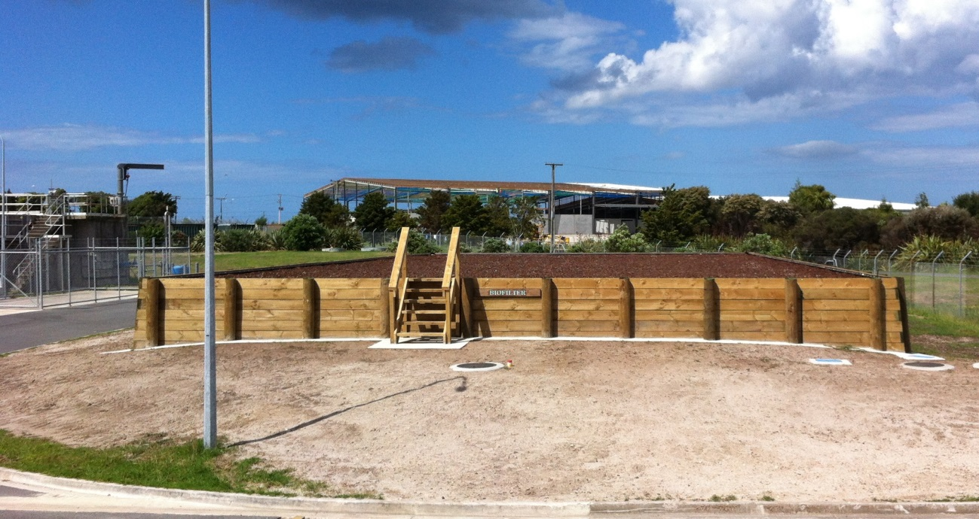

Source: Louise Wickham, Emission Impossible Ltd

#### Incineration

Incineration is the destruction of odorous pollutants by thermal oxidation into carbon dioxide and water. Incineration is best applied to carbon- and hydrogen-containing odorants, such as

VOCs and landfill gas. There are several types of incinerator or thermal oxidiser equipment design including:

* thermal
* recuperative
* catalytic
* regenerative
* flares.

Incineration has high capital and operating costs, but generally high treatment efficiencies can be achieved.

Refer to Regulations 11 and 12 of the Air Quality NES for standards related to the use of incinerators.[18]

|  |
| --- |
| Case study: Web offset printing |
| A web offset printing firm started to receive odour complaints relating to ‘burnt’ VOCs. In response, biofilters were installed. The biofilters were not effective, however, due to:   * a dry, hot air stream (even though a humidifier was used) * inadequate maintenance of the biofilters * sensitivity of the micro-organisms to the VOC-laden waste stream.   After ongoing complaints, thermal oxidisers were installed to incinerate the VOCs. This was successful in eliminating adverse odour effects (and complaints). |

#### Scrubbing and adsorption systems

Wet-gas scrubbing, gas-to-gas oxidation, or solid-phase systems can remove or change the chemical composition of odorous contaminants.

Wet-gas scrubbing or absorption contacts the gas with a liquid phase. The contaminant either reacts with or dissolves in the liquid and is removed in the liquid phase. The most common types of wet-gas scrubbers are packed tower or plate absorbers. Careful selection of scrubber liquors is needed, and usually involves trials. Scrubbers require regular maintenance and daily tests of active agents, and pH control in some cases. There is also a liquid waste to dispose of.

Oxidation is the most common reaction in both liquid and gas treatment methods. Oxidising agents include hypochlorite, chlorine gas, permanganate, and ozone. Generally accepted practice is multi-stage chemical scrubbing or catalysed chemical scrubbing. In some applications chemical scrubbing also employs an activated carbon or adsorption stage. Gas-to-gas oxidation systems, including ozonation, are no longer widely used.

It should be noted that some of the reagents, particularly those that are oxidising or reducing, have their own odour and may result in a visible plume, which may be an issue in some areas.

With adsorption systems, contaminants attach or condense onto the surface of an adsorbent, which is a porous solid. Carbon, zeolite, bentonite and polymer adsorbents have been used to adsorb VOCs and other pollutants from relatively dilute discharge concentrations. Other adsorbents used include alumina, activated clay, silica gel, and molecular sieves. Some adsorbents can be regenerated by desorption and the media used again. The compounds emitted can sometimes be recovered and reused.

#### Chemical dosing (wastewater treatment)

A range of techniques can be applied to reduce odour potential at source, including the use of chemical additives or stabilising agents (note: good practice is for chemical additives to be shown to have no adverse effects on the environment). For wastewater treatment systems and sewers, a range of chemicals can be added to the effluent to control odour or reduce odour potential. Chemicals such as hydrogen peroxide, potassium permanganate, or sodium/calcium nitrate can be directly added to oxidation ponds that have become anaerobic.

Ferric salts and magnesium hydroxide can also be added to wastewater to make the sulphur unavailable for forming odorous compounds. These techniques would typically form part of an odour control regime and are not adequate on their own.

Photo 5: Biological scrubber at wastewater treatment plant

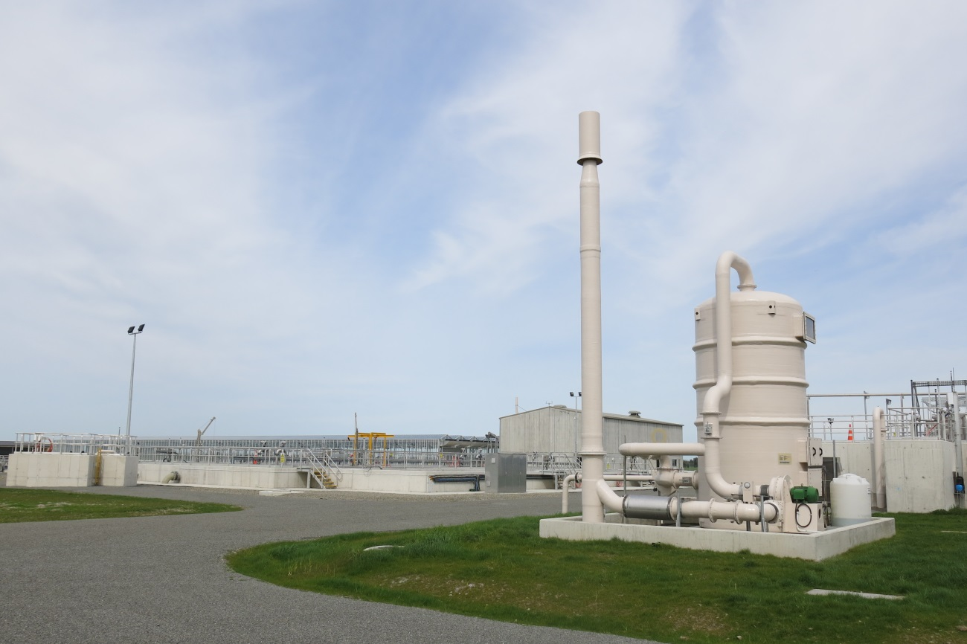

Source: Ken Holyoake, Armatec Environmental Ltd

Photo 6: Air abatement system featuring air collection ducting, scrubber to remove particulate and odour, fan to move air, and stack for final dispersion

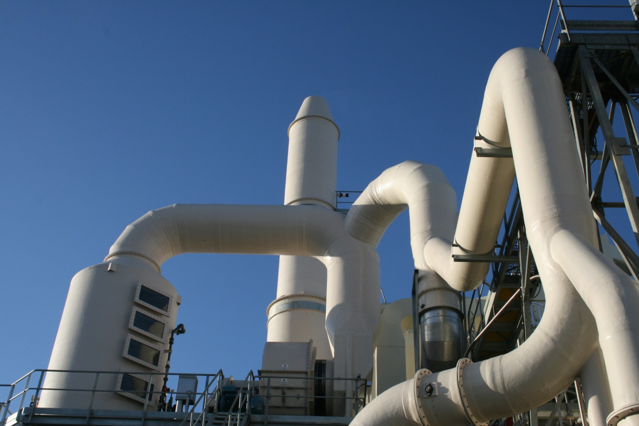

Source: Ken Holyoake, Armatec Environmental Ltd

#### Dilution and dispersion

Dilution and dispersion are usually achieved via emission through a tall stack. A stack is generally only appropriate for very low-intensity or non-offensive odours, discharged at low rates and as a final step following treatment of an odorous gas stream.

The stack should be appropriately designed to ensure it is an adequate height above buildings in the vicinity, and this may require dispersion modelling. Guidance on appropriate stack design is available from the United States Environmental Protection Agency (1985).

Efflux velocity is an important consideration and there should be an unrestricted final vertical discharge (ie, hooked vents or rain caps that restrict flow should be avoided). Dispersion has a moderate capital cost but low running costs.

#### Masking compounds and ‘neutralising’ agents

Masking compounds and neutralising agents are products available for treating fugitive odours such as from landfill working faces, fellmongeries, intensive farming of animals, and wastewater treatment plants.

The systems to apply these compounds can require significant capital expenditure and ongoing costs. Few (if any) agents are well proven. Certain agents should not be used for specific activities (such as use of certain chemicals in poultry sheds, which cause residue issues).

Available products can be classified as follows:

* *Masking agents* are mixtures of aromatic oils that cover up an objectionable odour with a more desirable one. Take extreme care with the use of masking agents, because the combination of chemicals can result in an odour that is even more offensive or objectionable.
* *Chemical neutralising agents* are typically proprietary mixtures containing oxidising or other chemically reactive agents that purport to neutralise certain odorous compounds. Neutralising agents can also contain fragrances (and therefore have some masking effect) or can be non-odorous. These products are typically designed to be diluted with water and applied using fine sprays or fogging units above, or downwind of, fugitive odour sources.
* *Digestive deodorants* contain bacteria or enzymes that eliminate odour through biochemical digestive processes. These are usually added to wastewater treatment systems to promote biological activity and to prevent the release of the odorous compounds into air (ie, a preventative treatment as compared to the above, which are air sprays that modify or remove the odorant once it is in the air).

Use of masking agents is not generally recommended. Experience has shown that masking agents often cause more complaints as people worry about the ‘chemical odour’ of the perfumes.

Masking and neutralising agents should be considered a ‘last line of defence’ after stringent management practices and adequate separation distances.

### 5.2.4 Risk assessment approach

For air quality assessments, the term risk assessment can be used to describe two different assessment techniques:

* Assessing the risk of unplanned emissions – a method of estimating the frequency or probability with which a hazardous event (unplanned discharge to air) can occur, and the consequence of that event
* Human health risk assessment – a method of estimating the nature and probability of adverse health effects in people who may be exposed to chemicals in contaminated environmental media, now or in the future.

In this guide, the term ‘risk assessment’ is used to describe the first approach, that is, assessing the risks associated with potential incidents that may discharge odorous contaminants into air.

A risk assessment framework can be helpful with assessment of odour mitigation measures, system reliability and setting mitigation priorities. The basic concept of risk assessment is that the overall risk depends on the probability of the event, together with the likely consequence if that event were to occur.

Qualitative risk-based odour assessments look at the probability (ie, the likelihood or chance) of an impact occurring at a location and the likely magnitude of the effect resulting from the exposure. Qualitative risk-based odour assessments do not, however, predict with certainty that any given impact/exposure will occur at a particular time.

As such, a qualitative risk-based approach is appropriate for:[19]

a. screening of odour impacts

b. development proposals with a low risk of adverse effects

c. situations where there is insufficient information to carry out detailed predictive dispersion modelling

d. situations where the information has wide uncertainties, and using it in a detailed predictive dispersion model would be waste of time, money and effort or could even lead to a false impression of accuracy and precision in the numbers generated

e. when the model is not able to properly show the reality of the situation being assessed, eg, if the odour effects are likely to be significantly influenced by accidental, unexpected, or unknown releases. In this case, a qualitative estimate may be more appropriate, on the basis that it is better to be broadly correct than precisely wrong.

Many (though not all) fugitive/diffuse sources fall into the last three categories and it may not be practicable to model these because reliable quantitative emissions data are often not available.

While standard AS/NZS 4360:999 Risk Management provides general guidance, there is no standard method for either qualitative or quantitative risk-based odour assessment. Institute of Air Quality Management (2014) provides an example framework, and readers are referred to this document for further information (see Appendix A of the Institute of Air Quality Management guidelines).

|  |
| --- |
| Case Study: Odour risk-based assessment approach |
| A large manufacturing plant with diverse sources of odour reviewed odour complaint and process records in an unsuccessful attempt to identify activities that had caused complaint.  A risk assessment approach was used to gain a greater understanding of the potential causes of odour, which enabled better odour management regardless of whether the odours had resulted in offsite effects or not.  A site-wide audit was undertaken, which involved site walk over, staff interviews, and reviews of process and incident data.  Sources of odour were identified and all fault and failure mechanisms were identified. Probabilities were assigned to the risk of failure, and the scale of the potential event that could occur was quantified using descriptors.  The risk analysis provided a ranking of the potential odour sources, which was based on the summed consequences from each possible source, of extreme, high, moderate and low.  This allowed the facility to better identify priorities and improve management at the site for reducing the possibility of unwanted odours and minimising the likelihood of odour impacts. |

# 

# Appendix 1: Odour management plans

This appendix outlines the issues that should be included in a management plan designed to address odour. In cases where companies already have documented procedures, some sections (for instance, staff training) may simply be cross-referenced.

Title and purpose of the plan

* Define the environmental effect to be managed under the plan, and the objective in relation to that effect.
* Identify the company and the site location, and briefly describe the company’s activities.

Key personnel and contact addresses/numbers

* Company general manager and/or respondent to questions from the general public.
* Site manager.
* Environmental manager.
* Staff responsible for implementing the management system.

Complaints

* Complaint contact persons for community.
* Complaint procedure for staff.
* External reporting.

Process description and method of operation

* A general description of the activities – describe the main potential sources of odour emission.

Methods of mitigation and operating procedures

* Fully describe the odour mitigation system.
* Identify relevant operating procedures and parameters that need to be controlled to minimise emissions.
* Inventory of mitigation equipment and materials.
* Details and reporting on equipment maintenance programmes, including measures to minimise failure.
* Contingency procedures.

Monitoring

Identify:

* types, places and frequencies of monitoring, including weather
* records to be kept, including documentation of maintenance and control parameters.

Staff training

* Areas staff are to be trained in.
* Methods used.
* Frequency of training.
* How and where training records are to be kept.

System review and reporting procedures

* The process for reviewing the overall system performance.
* Types and frequency of reports to council, including complaints records, site upgrades, etc.
* External audits and ISO certification (optional).

# Appendix 2: Odour assessment tools

Note: Before beginning any assessment, the location should be considered in light of district plan and/or acceptable amenity level requirements.

Table A2.1: Selecting odour assessment tools for preparing or evaluating resource consents  
for an existing industrial or trade activity

|  |  |  |  |
| --- | --- | --- | --- |
| Assessment tool | Priority based on effects | | Comments |
| Chronic | Acute |
| Community consultation | High | High | Periodic meetings with community representatives from community associations. Look for anecdotal evidence of community feeling about odour effects. |
| Complaint records | High | High | Complaints that have been validated by an enforcement officer should be clearly identified. Complaints may also be substantiated (verified) based on wind direction or process records, or as simply registered but not confirmed. |
| Industry/council experience | High | High | Experiences of the industry or regional council with other similar discharges. |
| Odour annoyance survey | High | – | Urban and semi-urban areas. Assess against per cent annoyed criterion. |
| – | Low | If the acute effects are infrequent, surveys may not reflect the impact of the effect on the surrounding environment. |
| Meteorology and terrain assessment | Moderate to high | Low | Use to assess the potential for downwind adverse effects as a result of poor dispersion around terrain features or in particular meteorological conditions. |
| Review emission control system(s) | Moderate | Low | Look for compliance with best practicable option (BPO) or industry codes of practice. |
| Odour diaries and weather monitoring | Moderate | – | Isolated areas with low population densities. Assess the frequency, duration, and strength of odour impact events and associated experiences over six months, or a longer time period if necessary, to encompass a specific season. |
| – | Low | If the acute effects are infrequent, diaries may not reflect the impact of the effect on the surrounding environment. |
| Review of odour management plan and contingency procedures, risk assessment | Not applicable | High | What is the level of acceptable risk for uncontrolled odour discharges? Consider high-probability/low-impact events, and low probability/high-impact events. Is BPO being used? |
| Olfactometry and modelling of odour sources | Low | – | **Generally not recommended** unless assessing potential effect of proposed plant changes, confirming actual emission rate changes following new procedures and/or new plant commissioning etc, or distinguishing the activity in question from other similar activities in the region. |
| – | Low | **Not recommended** as an assessment tool for occasional or periodic releases of odour. |

Table A2.2: Selecting odour assessment tools for preparing or evaluating resource consents for proposed modifications to existing industrial or trade activity

|  |  |  |  |
| --- | --- | --- | --- |
| Assessment tool | Priority based on effects | | Comments |
| Chronic | Acute |
| Community consultation | High | – | Periodic meetings with community representatives from community associations. Look for anecdotal evidence of community feeling about odour effects. |
| – | High | Assess how the proposed changes will affect plant performance. |
| Complaint records | High | – | Complaints that have been validated by an enforcement officer should be clearly identified. Complaints may also be substantiated (verified) based on wind direction or process records, or as simply registered but not confirmed. Assess how proposed changes might assist in reducing the level of complaint. |
| – | High | Have any complaints been attributed to acute events? Assess how proposed changes will affect plant performance. |
| Industry/council experience | High | High | Experiences of the industry or regional council with other similar discharges. |
| Odour annoyance survey | High | Not applicable | Urban and semi-urban areas. Assess against per cent annoyed criterion. Assess how the proposed changes will reduce level of annoyance. |
| Meteorology and terrain assessment | High | High | Use to assess the potential for downwind adverse effects as a result of poor dispersion around terrain features, or in particular meteorological conditions. |
| Review emission control system(s) | Moderate | Low | Look for compliance with best practicable option (BPO), or industry codes of practice. Assess how proposed changes will affect plant performance. |
| Odour diaries | Moderate | Not applicable | Isolated areas with low population densities. Assess the frequency, duration, and strength of odour impact events and associated experiences over six months, or a longer time period if necessary, to encompass a specific season. Assess how the proposed changes will reduce level of annoyance. |
| Review of odour management plan and contingency procedures, risk assessment | Not applicable | High | What is the level of acceptable risk for uncontrolled odour discharges? Consider high-probability/low-impact events, and low probability/high-impact events. Is BPO being used? Assess how the proposed changes will affect plant performance. |
| Olfactometry and modelling of odour sources | Moderate | – | May use results of complaints analysis, community consultation, and any surveys or diaries to identify the scale of problem then use modelling to assess the effect of proposed plant changes. |
| – | Low | **Not recommended** as an assessment tool for occasional or periodic releases of odour. |

Table A2.3: Selecting odour assessment tools for preparing or evaluating resource consents for new industrial or trade activity

|  |  |  |  |
| --- | --- | --- | --- |
| Assessment tool | Priority based on effects | | Comments |
| Chronic | Acute |
| Community consultation | High | High | Meet with community to discuss proposal. Gauge community receptiveness and likely sensitivity to odour effects. |
| Industry/council experience and records | High | High | Experiences of the industry or regional council with other similar discharges. Typical separation distances and nature of emissions including variability and character. Also assess the applicability of assumed separation distances based on comparison of the key wind conditions that have the potential to cause odour impacts. |
| Meteorology and terrain assessment | High | High | Establish the prevalent seasonal wind patterns, topographical features and likely cold air drainage patterns at the site. Rank different areas in terms of 'relative’ potential for odour impacts to occur ie, highest, medium and lowest. |
| Olfactometry and modelling of odour sources | Moderate to high | – | Use an odour-modelling guideline from a similar installation if applicable, or standard guidelines for new activities. Consider offensiveness of odour and sensitivity of the receiving environment. |
| – | Low | **Not recommended** as an assessment tool for occasional or periodic releases of odour. |
| Review of process emission control system(s) | Moderate | Low | Look for compliance with best practicable option (BPO), or industry codes of practice. |
| Review of odour management plan and contingency procedures, risk assessment | Not applicable | High | What is the level of acceptable risk for uncontrolled odour discharges? Consider high-probability/low-impact events, and low probability/high-impact events. Is BPO being used? |

# Appendix 3: Complaint investigation form[20]



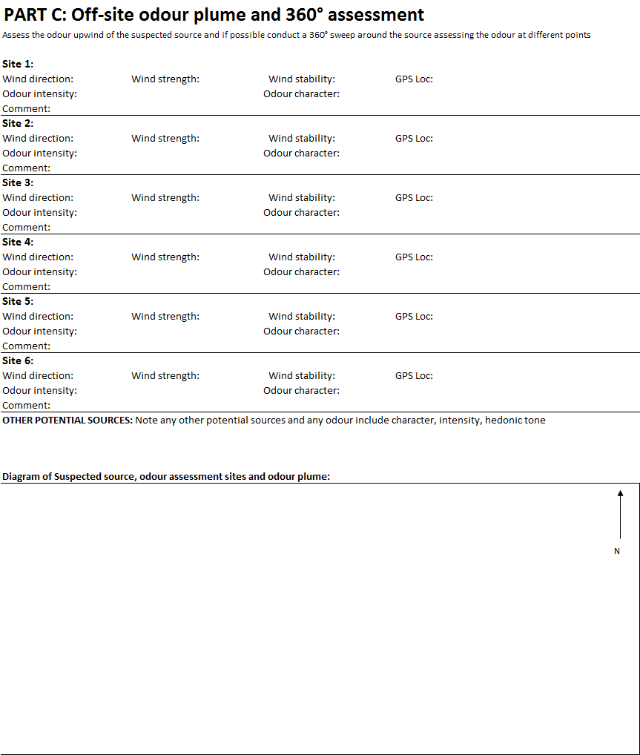

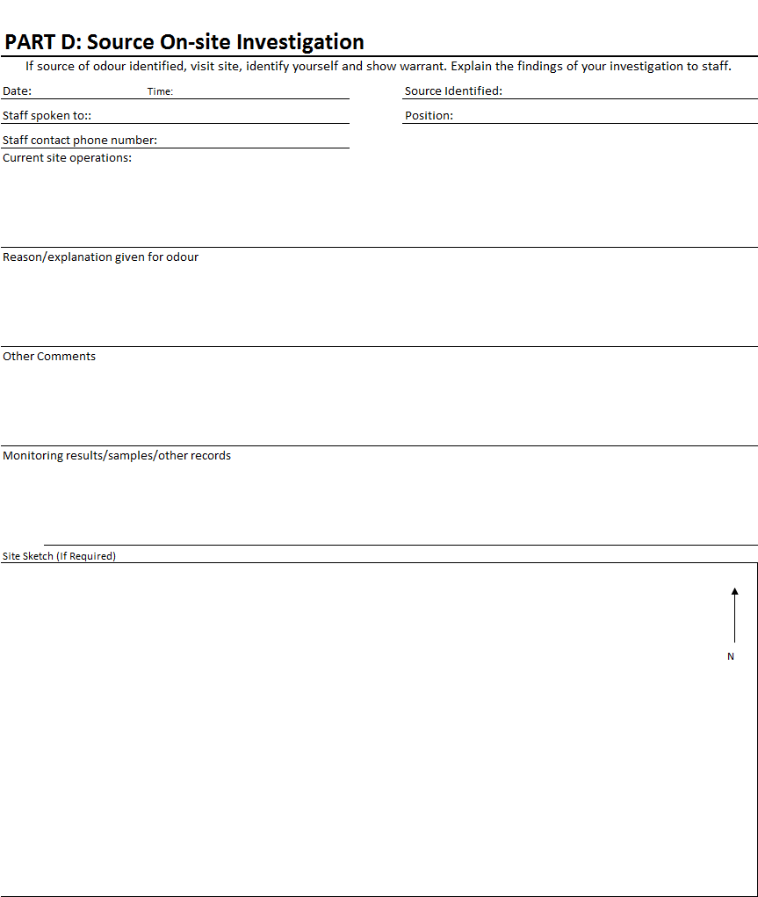

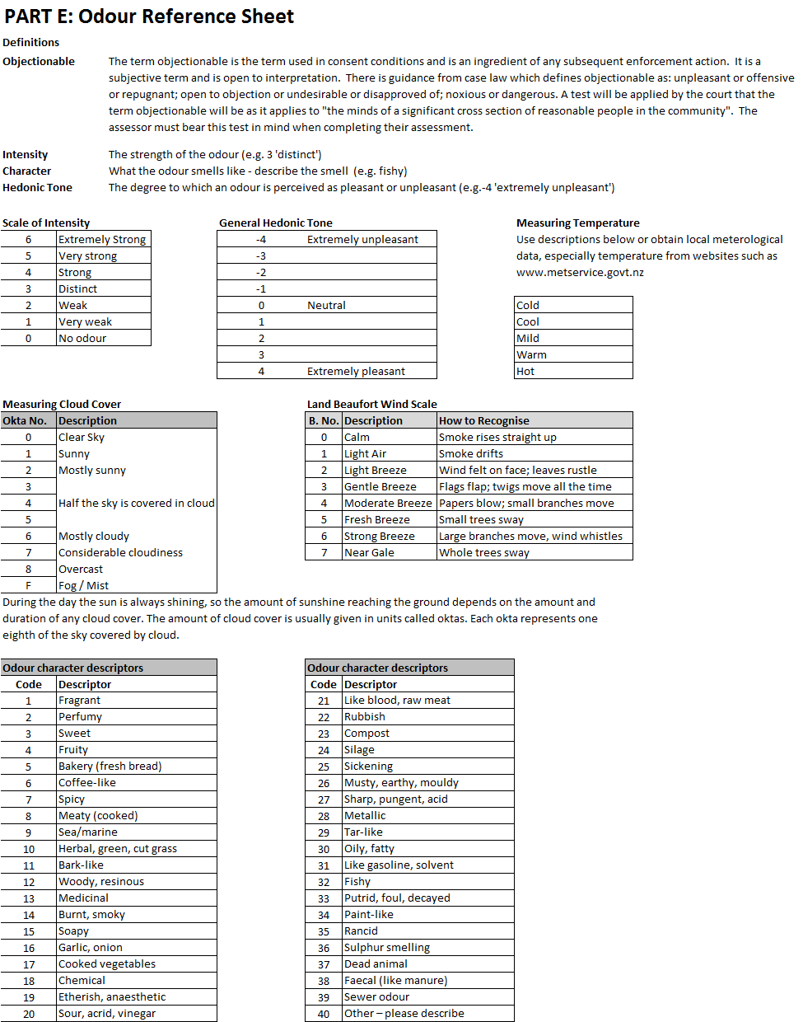

# Appendix 4: Reduced response protocol for vexatious complainants

Greater Wellington Reduced Response Protocol (abridged)[21]

The Environmental Regulation Department has determined the need to formalise a procedure for reducing our level of response to certain notifiers. This memo explains the rationale for determining when the protocol should be applied, and outlines the process for adding a new notifier to the reduced response list.

### When would a notifier be considered for reduced response?

A notifier will be considered a candidate for reduced response if it is identified through their patterns of reporting incidents to the Environmental Regulation Department, that they have expectations of our response service which exceed our jurisdiction under the Resource Management Act 1991 (RMA), or if repeated responses determine that there is no cause for concern in terms of environmental effects.

### When will the Reduced Response Protocol apply?

Factors leading to the application of the Reduced Response Protocol include:

* Environmental Protection Officers attend multiple incidents in response to the caller’s notifications where they are unable to confirm a breach of our rules or the RMA.
* Notifications of incidents outside our role under the RMA (for example, they may be reporting something that should be dealt with under the Health Act).
* The notifier may have a sensitivity to certain environmental stimuli. This sensitivity may trigger extreme physical/nervous system reactions in the person, but may not affect the general public or the officer(s) attending the incident.

### Why apply the protocol in these circumstances?

Environmental Regulation Officers have recognised that when a person is presenting health effects they can become irrational or volatile, putting the responding officer at risk or under stress. When officers are responding to incidents where there is no confirmed breach (of the RMA), it consumes limited resources and diverts attention away from legitimate notifications of environmental incidents. There are often other agencies that are appropriately equipped and informed to provide a service to these individuals. (This is especially relevant where health effects or concerns are presented to Greater Wellington).

### How will this affect our response to these incident notifications?

The protocol allows officers to scale down their response to incidents of a certain type from a particular caller. Environmental Regulation may request that a notifier sends all incidents to Greater Wellington (GW) in writing and to notify GW if any new information is available regarding their health or environmental effects, so that further assistance may be provided.

Each new notifier will be allocated a legally privileged file. Incidents sent in writing will not be logged individually, but will be added to the notifier’s file and will help build a history to allow officers to detect anything (out of the ordinary) that may require a response. GW will need to make it clear to each notifier in writing that the reduced response *only applies to incidents of the type specified to them in writing after a reduced response decision has been made*.

In cases where a notifier is not asked to send notifications in writing, and continues to call, GW officers will need to use their discretion to decide what level of response is required for each incident reported.

### What procedure needs to be followed in considering a notifier for reduced response?

1. To scale down a response to a notifier, officers need to demonstrate that the processes for making that decision are robust and consistently followed and that we have taken all reasonable steps to detect effects and investigate environmental incidents at the location identified by the notifier. Officers may take certain actions such as issuing educational material to the surrounding community to advise them of their responsibilities under the RMA, to prevent breaches occurring. This could take the form of a mail out or a brief press release.

2. It is important that officers do not risk missing valid environmental effects as a result of a decision not to attend a notification regarding an environmental incident. There are a number of tools available to prevent this happening, including scheduling proactive monitoring events or random inspections of the area, for example if the incident is smoke or odour related. This also includes undertaking environmental monitoring where appropriate such as air or soil testing (where environmental effects are considered likely or have been detected).

3. A documented history of all involvement with the notifier and their situation is required. It is essential that accurate and clear records are kept of all correspondence and interactions as these may be reviewed at a later date by the notifier or an external party such as the Parliamentary Commission for the Environment or Ombudsman. The information to be collected should include:

* how many incident notifications have been received
* what the notifications have been for
* how many of those led to a confirmation of breach of RMA or regional plans.
* how we have responded to breaches
* further action taken, including proactive measures (such as sending of educational material to neighbourhood), environmental monitoring etc
* the reasoning for our opinion that a person’s expectations are beyond our jurisdiction
* a history of any inter-agency meetings and the outcomes of any relevant discussions.

4. Once collected, a Reduced Response Recommendation (RRR) will be written and presented to the Enforcement Decision Group (EDG) for a decision.

5. When a decision is reached at an EDG meeting, the RRR will be signed by the team leader, and circulated to the Manager, Environmental Regulation (E-Reg) and the Group Manager, to be initialled. A template for the RRR will be required and will be added to EP standard documents. It should include a summary of our involvement with the notifier and the recommended reduction in Environmental Protection (EP) incident response service.

6. Once the RRR is approved a letter will be sent to the notifier and signed off by the team leader with the decision and rationale, including any advice regarding matters such as future mode of contact. A template for this letter will be required and will be added to EP standard documents.

7. Once a notifier has been advised in writing, the new status will be applied. It is important that all GW officers then act in a consistent manner, so as not to create an expectation that the person may be contacted or visited if they continue to notify GW of the same incident type. To ensure this happens it is important that everyone in the E-Reg department is informed about their status and any reduced service. An email will be sent to the following staff (including regular updates):

* all E-Reg staff, as they may receive calls from the person while on help desk or for other reasons
* GWRC reception
* GW afterhours call centre (PNCC)
* executive secretary to the CEO
* councillors, where necessary (for example, if it is known that they are currently involved in a certain case).

### Which other agencies may need to be involved?

If the notifier appears to have health related concerns for their ongoing notifications, the EHO of the local TA should be involved, and Regional Public Health should be notified. If the proposed source of the environmental incident is a workplace then the Ministry of Business, Innovation and Employment may also need to be informed.

The NZ Fire Service, Police and local Members of Parliament may also need to be informed, on a case-by-case basis.

# Appendix 5: Odour diary record sheet

The following page is an example odour diary record sheet.

## 

|  |  |  |  |  |  |  |  |  |  |  |  |  |  |  |
| --- | --- | --- | --- | --- | --- | --- | --- | --- | --- | --- | --- | --- | --- | --- |
| Name: |  | | | | | Location of observations | | |  |  |  |  |  |  |
| Month: |  | | | | |  | | | | | | | | |
| Date | Time | Odour event duration (hours/mins) | Continuity of the odour for this event  (tick one) | | | | | **Character of odour** (Codes 1–40, see over and use all that apply) | Likely source of odour | Intensity  (0–6, see over) | Description of effect odour has on you | Wind direction (see over) | Wind strength(Codes  0–7, see over) | Additional comments? |
| Contin-uous | Most of the time | <50% of the time | | Intermittent |
|  |  |  |  |  |  | |  |  |  |  |  |  |  |  |
|  |  |  |  |  |  | |  |  |  |  |  |  |  |  |
|  |  |  |  |  |  | |  |  |  |  |  |  |  |  |
|  |  |  |  |  |  | |  |  |  |  |  |  |  |  |
|  |  |  |  |  |  | |  |  |  |  |  |  |  |  |
|  |  |  |  |  |  | |  |  |  |  |  |  |  |  |
|  |  |  |  |  |  | |  |  |  |  |  |  |  |  |
|  |  |  |  |  |  | |  |  |  |  |  |  |  |  |
|  |  |  |  |  |  | |  |  |  |  |  |  |  |  |
|  |  |  |  |  |  | |  |  |  |  |  |  |  |  |
|  |  |  |  |  |  | |  |  |  |  |  |  |  |  |
|  |  |  |  |  |  | |  |  |  |  |  |  |  |  |
|  |  |  |  |  |  | |  |  |  |  |  |  |  |  |
|  |  |  |  |  |  | |  |  |  |  |  |  |  |  |
|  |  |  |  |  |  | |  |  |  |  |  |  |  |  |
|  |  |  |  |  |  | |  |  |  |  |  |  |  |  |
|  |  |  |  |  |  | |  |  |  |  |  |  |  |  |

|  |  |  |  |  |  |  |
| --- | --- | --- | --- | --- | --- | --- |
| ODOUR DIARY REFERENCE SHEET | | | | | | |
| Odour character descriptors | |  | Scale of odour intensity | | |  |
| Code | Descriptor |  | No. | | Intensity |  |
| 1 | Fragrant |  | 6 | | Extremely strong |  |
| 2 | Perfumy |  | 5 | | Very strong |  |
| 3 | Sweet |  | 4 | | Strong |  |
| 4 | Fruity |  | 3 | | Distinct |  |
| 5 | Bakery (fresh bread) |  | 2 | | Weak |  |
| 6 | Coffee-like |  | 1 | | Very weak |  |
| 7 | Spicy |  | 0 | | No odour |  |
| 8 | Meaty (cooked) |  |  | |  |  |
| 9 | Sea/marine |  | Land Beaufort wind scale | | | |
| 10 | Herbal, green, cut grass |  | B. No. | | Description | How to recognise |
| 11 | Bark-like |  | 0 | | Calm | Smoke rises straight up |
| 12 | Woody, resinous |  | 1 | | Light air | Smoke drifts |
| 13 | Medicinal |  | 2 | | Light breeze | Wind felt on face; leaves rustle |
| 14 | Burnt, smoky |  | 3 | | Gentle breeze | Flags flap; twigs move all the time |
| 15 | Soapy |  | 4 | | Moderate breeze | Papers blow; small branches move |
| 16 | Garlic, onion |  | 5 | | Fresh breeze | Small trees sway |
| 17 | Cooked vegetables |  | 6 | | Strong breeze | Large branches move, wind whistles |
| 18 | Chemical |  | 7 | | Near gale | Whole trees sway |
| 19 | Etherish, anaesthetic |  |  | |  |  |
| 20 | Sour, acrid, vinegar |  |  | |  |  |
| 21 | Like blood, raw meat |  |  | |  |  |
| 22 | Rubbish |  |  | |  |  |
| 23 | Compost |  |  | |  |  |
| 24 | Silage |  |  | |  |  |
| 25 | Sickening |  |  | |  |  |
| 26 | Musty, earthy, mouldy |  |  | |  |  |
| 27 | Sharp, pungent, acid |  |  | |  |  |
| 28 | Metallic |  |  | |  |  |
| 29 | Tar-like |  |  | |  |  |
| 30 | Oily, fatty |  |  | |  |  |
| 31 | Like gasoline, solvent |  |  | |  |  |
| 32 | Fishy |  |  | |  |  |
| 33 | Putrid, foul, decayed |  |  | |  |  |
| 34 | Paint-like |  |  | |  |  |
| 35 | Rancid |  |  | |  |  |
| 36 | Sulphur smelling |  |  | |  |  |
| 37 | Dead animal |  |  | |  |  |
| 38 | Faecal (like manure) |  |  | |  |  |
| 39 | Sewer odour |  |  | |  |  |
| 40 | Other – please describe |  | |  |  |  |

# Glossary

| **Term** | **Definition** | |
| --- | --- | --- |
| Acute | Short-term exposure (eg, one hour). | |
| Acute odour | High-intensity, highly unpleasant odours occurring infrequently or for short periods. | |
| Adaptation | Long-term process during which people become increasingly tolerant of a particular source of odour. | |
| Anosmic | Unable to smell. | |
| BPO | Best practicable option. See section 3.2.2 for an explanation. | |
| Chronic | Long-term exposure (eg, over the period of a year). | |
| Chronic odour | Low-intensity, moderately unpleasant odours occurring frequently or continuously over a long period. | |
| Compliance | A range of activities usually carried out by agencies with regulatory functions to ensure people and other organisations adhere to rules and regulations for the public good. | |
| Concentration | An amount of a pollutant (or odour) per unit of volume. | |
| Desensitisation | Reduced ability to detect odour, usually due to prolonged exposure to it. | |
| Dispersion modelling | Calculations of concentrations of an airborne pollutant downwind of a source. | |
| Dynamic dilution olfactometry (DDO) | Method for measuring odour precisely. | |
| Effects | The consequences of the changes in airborne concentrations for a recipient. This may be amenity related or more serious, such as adverse health effects. The term ‘effect’ has a legal definition under the Resource Management Act 1991 (RMA) (see section 3.3.2). | |
| Emission | Discharge to air. | |
| FIDOL factors | Frequency, Intensity, Duration, Offensiveness/Character and Location. These factors determine whether an odour has an offensive or objectionable effect. | |
| Hyperosmic | Acute sense of smell. | |
| Hyposmic | Reduced ability to smell. | |
| Impacts | The changes in airborne concentrations. An activity can have an ‘impact’ without having any ‘effects’, for instance, if there is no one downwind to experience the impact. This is particularly true for odour, which is entirely perception based. | |
| Intensity | Strength of odour, rated on a scale from 0 (no odour) to 6 (extremely strong). | |
| m3 | Cubic metres. | |
| National environmental standard (NES) | Tools used to set nationwide standards for the state of a natural resource such as air quality. | |
| NES for air quality | Resource Management (National Environmental Standards for Air Quality) Regulations 2004. | | |
| Olfactometer | Instrument for measuring odour (utilises dynamic dilution olfactometry). | |
| Olfactometry | The measurement of odour. | |
| Receptor | A location that may be affected by odours. Human receptors include locations where people spend time. Ecological receptors are not generally considered sensitive to odour. | |
| Reverse sensitivity | Newer, more sensitive, activities constraining the ability of established activities to continue. |
| Risk | The likelihood of an adverse effect occurring. | |
| RMA | Resource Management Act 1991. | |
| Sensitisation | Ability to detect odour at lower and lower levels. | |
| Separation distance | Distance between an odorous activity and a sensitive activity. | |
| µg | Microgram, one millionth of a gram. | |
| VOC | Volatile organic compound. | |

# References

Air and Waste Management Association. 1992. *Air Pollution Engineering Manual*. New York: Van Nostrand Reinhold.

American Industrial Hygiene Association. 2013. *Odor Thresholds for Chemicals with Established Health Standards*, 2nd Edition. Virginia: American Industrial Hygiene Association.

Aurora Environmental. 2000. *Environmental Standards for Industrial Odour Effects*. Christchurch: Aurora Pacific.

Beca Infrastructure Ltd. 2008. *Project Field - Comparison of Two Methods for Odour Annoyance Surveying*. Prepared for Auckland Regional Council (Client) by Beca Infrastructure Ltd (Beca). Peer reviewed by Ms Deborah Ryan from Sinclair Knight Merz. 3 September 2008.

Department of Natural Resources. 1997. *Planning Guidelines, Separating Agricultural and Residential Land Uses*. Brisbane: Department of Natural Resources. Retrieved 24 September 2015 from [www.dip.qld.gov.au/resources/policy/plng-guide-sep-ag.pdf](http://www.dip.qld.gov.au/resources/policy/plng-guide-sep-ag.pdf).

Emission Impossible Ltd. 2011. *Landfill Odour Survey*. Report prepared for Auckland Council by Surekha Sridhar and Jayne Metcalfe. October.

Emission Impossible Ltd. 2012. *Separation Distances: A Discussion Document*. Prepared for Auckland Council. Auckland: Auckland Council. Retrieved 24 September 2015 from [www.aucklandcouncil.govt.nz/EN/planspoliciesprojects/plansstrategies/unitaryplan/Documents/Section32report/Appendices/Appendix%203.45.2.pdf](http://www.aucklandcouncil.govt.nz/EN/planspoliciesprojects/plansstrategies/unitaryplan/Documents/Section32report/Appendices/Appendix%203.45.2.pdf).

Environment Protection Authority Victoria. 2013. *Recommended Separation Distances for Industrial Residual Air Emissions – Guideline*, *Publication No. 1518*. Melbourne: Environment Protection Authority Victoria. Retrieved 24 September 2015 from [www.epa.vic.gov.au/our-work/publications/publication/2013/march/1518](http://www.epa.vic.gov.au/our-work/publications/publication/2013/march/1518).

Freeman, T. 2011. “Comparison of two methods for community odour annoyance surveys – project field paper”. In *Proceedings of the Clean Air Society of Australia and New Zealand Conference*. Auckland.

Institute of Air Quality Management. 2014. *Guidance on the assessment of odour for planning*. London: Institute of Air Quality Management. Retrieved 24 September 2015 from <http://www.iaqm.co.uk/text/guidance/odour-guidance-2014.pdf>.

Middleton, N. Unpublished. *Internal memo from Naomi Middleton to Al Cross 21 October 2010 Ref: ENV/17/01/08*. Greater Wellington Regional Council.

Ministry for the Environment. 2002. *Review of Odour Management in New Zealand: Technical Report*. Wellington: Ministry for the Environment. Available at [www.mfe.govt.nz](http://www.mfe.govt.nz/).

Ministry for the Environment. 2003. *Good Practice Guide for Assessing and Managing Odour in New Zealand.* Wellington: Ministry for the Environment.

Ministry for the Environment. 2004. *Good Practice Guide for Atmospheric Dispersion Modelling.* Wellington: Ministry for the Environment. Available at [www.mfe.govt.nz](http://www.mfe.govt.nz/).

Ministry for the Environment. 2015. “Enforcement” in *An Everyday Guide to the RMA.* Wellington: Ministry for the Environment. Available at www.mfe.govt.nz

Ministry for the Environment. 2016a. *Good Practice Guide for Assessing and Managing Dust.* Wellington: Ministry for the Environment. Available at [www.mfe.govt.nz](http://www.mfe.govt.nz/).

Ministry for the Environment. 2016b. *Good Practice Guide for Assessing Discharges to Air from Industry*. Wellington: Ministry for the Environment. Available at [www.mfe.govt.nz](http://www.mfe.govt.nz/).

New Zealand Water and Waste Association. 1999. *Manual for Wastewater Odour Management*. Auckland: New Zealand Water and Waste Association.

Office of Environmental Health Hazard Assessment. 1999. *Appendix D.2 Acute RELs and toxicity summaries using the previous version of the Hot Spots Risk Assessment guidelines.* Retrieved 24 September 2015 from [www.oehha.ca.gov/air/hot_spots/2008/AppendixD2_final.pdf#page=8](http://www.oehha.ca.gov/air/hot_spots/2008/AppendixD2_final.pdf%23page=8).

Perry RH, Green D. 1984. *Perry’s Chemical Engineers’ Handbook, Sixth Edition*. New York: McGraw-Hill.

McGullagh P, Nelder JA. 1983. *Generalized linear models*. London-New York: Chapman and Hall.

Queensland Environmental Protection Agency. 2013*. Guideline Odour Impact Assessments from Development.* Brisbane: Queensland Environmental Protection Agency. Retrieved 24 September 2015 from [www.ehp.qld.gov.au/licences-permits/business-industry/pdf/guide-odour-impact-assess-developments.pdf](http://www.ehp.qld.gov.au/licences-permits/business-industry/pdf/guide-odour-impact-assess-developments.pdf).

Ruth J. 1986. “Odour Thresholds and Irritation Levels of Several Chemical Substances: A Review”. In *American Industrial Hygiene Association Journal* 47 March (A-142) A-151.

United States Environmental Protection Agency. 1985. *Guideline for Determination of Good Engineering Practice Stack Height (Technical Support Document for the Stack Height Regulations) (Revised)*. North Carolina: United States Environmental Protection Agency. Retrieved 24 September 2015 from [www.epa.gov/scram001/guidance/guide/gep.pdf](http://www.epa.gov/scram001/guidance/guide/gep.pdf).

*Web references accessed 26 June 2015.

1. For example, overseas guidance may not necessarily reflect the best practicable option under the Resource Management Act 1991.
2. However, hormonal activities (eg, ovulation, pregnancy) can make women more sensitive to odorants.
3. American Industrial Hygiene Association (2013).
4. For example, an association has been found between odour detection threshold and degree of dementia in Alzheimer disease cases.
5. Based on Verein Deutscher Ingenieure 3882 (Part 1) October 1992 Olfactometry - Determination of odour intensity.
6. The odour threshold of ammonia is 30 µg/m3 (American Industrial Hygiene Association, 2013) but the acute reference exposure level for the avoidance of health effects is 3.2 µg/m3 as a one-hour average (http://www.oehha.ca.gov/air/hot_spots/2008/AppendixD2_final.pdf#page=8).
7. It is preferable to refer to the character of an odour, rather than its ‘offensiveness’ to avoid confusion between the inherent characteristics of an odour (ie, whether it is pleasant or unpleasant) and whether there is an ‘objectionable or offensive’ *effect* occurring as a result of exposure to odour.
8. See for example *Crown vs Interclean* CRI 2011-092-016845 at paragraph 31.
9. (Middleton, 2010).
10. This provides two example odour surveys. The first survey method has an eight-level classification scale ranging from ‘not at all annoying’ to ‘extremely annoying’. The second survey method has a five-level classification scale ranging from ‘don’t know’ to ‘very annoying’.
11. This may not be the case in the event of severe, prolonged odours.
12. The standard can be downloaded (for a fee) from the Standards Australia website, <http://www.standards.com.au>.
13. In forced choice mode on an olfactometer, the detection threshold value is exactly half way between a YES and NO response.
14. For example control over odorant dilution, measuring the odorant’s airborne concentration at the person, delivering ‘blanks’ to the person to control for false positive responses, delivering enough air to the person so no over-breathing dilution occurs, and use of ‘forced-choice’ responses.
15. *Waikato Env Protection Soc. v WRC* (W 060/2007) in turn references two other key odour cases (*Winstone Aggregates and Others v Matamata Piako District Council* (W 055/2004) and *Wilson and Rickerby v Selwyn District Council*(C 23/204).
16. Auckland Council published a review of separation distances applied across Australasia in 2012 (Emission Impossible Ltd, 2012). At the time of writing, EPA Victoria has the most up to date guidance considered appropriate for New Zealand (EPA Victoria, 2013).
17. CRI-2014-043-000778.
18. Certain types of incineration are regulated under the [Resource Management (National Environmental Standards for Air Quality) Regulations 2004](http://www.legislation.govt.nz/regulation/public/2004/0309/latest/DLM286835.html?search=ts_act%40bill%40regulation%40deemedreg_Resource+Management+(National+Environmental+Standards+for+Air+Quality)+Regulations+2004+_resel_25_a&p=1).
19. Institute of Air Quality Management (2014).
20. Modified from forms courtesy of Greater Wellington Regional Council and Environment Canterbury.
21. Middleton, Unpublished.